CHAPTER

UNIT – II

Unit Objectives:

- To study basics of Virtualization and its importance.
- To learn Cloud architecture, types and various challenges concerned.
- To study and work on Aneka cloud platform.

Virtualization

Virtualization technology is one of the fundamental components of cloud computing, especially in regard to infrastructure-based services. Virtualization allows the creation of a secure, customizable, and isolated execution environment for running applications, even if they are untrusted, without affecting other users’ applications. The basis of this technology is the ability of a computer pro-gram—or a combination of software and hardware—to emulate an executing environment separate from the one that hosts such programs. For example, we can run Windows OS on top of a virtual machine, which itself is running on Linux OS. Virtualization provides a great opportunity to build elastically scalable systems that can provision additional capability with minimum costs. Therefore, virtualization is widely used to deliver customizable computing environments on demand.

This chapter discusses the fundamental concepts of virtualization, its evolution, and various models and technologies used in cloud computing environments.

Introduction

Virtualization is a large umbrella of technologies and concepts that are meant to provide an abstract environment—whether virtual hardware or an operating system—to run applications. The term virtualization is often synonymous with hardware virtualization, which plays a fundamental role in efficiently delivering Infrastructure-as-a-Service (IaaS) solutions for cloud computing. In fact, virtualization technologies have a long trail in the history of computer science and have been available in many flavors by providing virtual environments at the operating system level, the programming lan-guage level, and the application level. Moreover, virtualization technologies provide a virtual environ-ment for not only executing applications but also for storage, memory, and networking.

Since its inception, virtualization has been sporadically explored and adopted, but in the last few years there has been a consistent and growing trend to leverage this technology. Virtualization technologies have gained renewed interested recently due to the confluence of several phenomena:

- Increased performance and computing capacity. Nowadays, the average end-user desktop PC is powerful enough to meet almost all the needs of everyday computing, with extra capacity that is rarely used. Almost all these PCs have resources enough to host a virtual machine manager and execute a virtual machine with by far acceptable performance. The same consideration applies to the high-end side of the PC market, where supercomputers can provide immense compute power that can accommodate the execution of hundreds or thousands of virtual machines.

- Underutilized hardware and software resources. Hardware and software underutilization is occurring due to (1) increased performance and computing capacity, and (2) the effect of

limited or sporadic use of resources. Computers today are so powerful that in most cases only a fraction of their capacity is used by an application or the system. Moreover, if we consider the IT infrastructure of an enterprise, many computers are only partially utilized whereas they could be used without interruption on a 24/7/365 basis. For example, desktop PCs mostly devoted to office automation tasks and used by administrative staff are only used during work hours, remaining completely unused overnight. Using these resources for other purposes after hours could improve the efficiency of the IT infrastructure. To transparently provide such a service, it would be necessary to deploy a completely separate environment, which can be achieved through virtualization.

- Lack of space. The continuous need for additional capacity, whether storage or compute power, makes data centers grow quickly. Companies such as Google and Microsoft expand their infrastructures by building data centers as large as football fields that are able to host thousands of nodes. Although this is viable for IT giants, in most cases enterprises cannot afford to build

another data center to accommodate additional resource capacity. This condition, along with hardware underutilization, has led to the diffusion of a technique called server consolidation,¹ for which virtualization technologies are fundamental.

- Greening initiatives. Recently, companies are increasingly looking for ways to reduce the amount of energy they consume and to reduce their carbon footprint. Data centers are one of the major power consumers; they contribute consistently to the impact that a company has on the environment. Maintaining a data center operation not only involves keeping servers on, but a great deal of energy is also consumed in keeping them cool. Infrastructures for cooling have a significant impact on the carbon footprint of a data center. Hence, reducing the number of servers through server consolidation will definitely reduce the impact of cooling and power consumption of a data center. Virtualization technologies can provide an efficient way of consolidating servers.

- Rise of administrative costs. Power consumption and cooling costs have now become higher than the cost of IT equipment. Moreover, the increased demand for additional capacity, which translates into more servers in a data center, is also responsible for a significant increment in administrative costs. Computers—in particular, servers—do not operate all on their own, but they require care and feeding from system administrators. Common system administration tasks include hardware monitoring, defective hardware replacement, server setup and updates, server resources monitoring, and backups. These are labor-intensive operations, and the higher the number of servers that have to be managed, the higher the administrative costs. Virtualization can help reduce the number of required servers for a given workload, thus reducing the cost of the administrative personnel.

These can be considered the major causes for the diffusion of hardware virtualization solutions as well as the other kinds of virtualization. The first step toward consistent adoption of virtualiza-tion technologies was made with the wide spread of virtual machine-based programming languages: In 1995 Sun released Java, which soon became popular among developers. The ability to integrate small Java applications, called applets, made Java a very successful platform, and with the

beginning of the new millennium Java played a significant role in the application server market segment, thus demonstrating that the existing technology was ready to support the execution of managed code for enterprise-class applications. In 2002 Microsoft released the first version of .NET Framework, which was Microsoft’s alternative to the Java technology. Based on the same principles as Java, able to support multiple programming languages, and featuring complete integra-tion with other Microsoft technologies, .NET Framework soon became the principal development platform for the Microsoft world and quickly became popular among developers. In 2006, two of the three “official languages” used for development at Google, Java and Python, were based on the virtual machine model. This trend of shifting toward virtualization from a programming language perspective demonstrated an important fact: The technology was ready to support virtualized solu-tions without a significant performance overhead. This paved the way to another and more radical form of virtualization that now has become a fundamental requisite for any data center management infrastructure.

Characteristics of virtualized environments

Virtualization is a broad concept that refers to the creation of a virtual version of something, whether hardware, a software environment, storage, or a network. In a virtualized environment there are three major components: guest, host, and virtualization layer. The guest represents the system component that interacts with the virtualization layer rather than with the host, as would normally happen. The host represents the original environment where the guest is supposed to be managed. The virtualization layer is responsible for recreating the same or a different environment where the guest will operate (see Figure 3.1).

Such a general abstraction finds different applications and then implementations of the virtuali-zation technology. The most intuitive and popular is represented by hardware virtualization, which also constitutes the original realization of the virtualization concept.² In the case of hardware vir-tualization, the guest is represented by a system image comprising an operating system and installed applications. These are installed on top of virtual hardware that is controlled and managed by the virtualization layer, also called the virtual machine manager. The host is instead represented by the physical hardware, and in some cases the operating system, that defines the environment where the virtual machine manager is running. In the case of virtual storage, the guest might be cli-ent applications or users that interact with the virtual storage management software deployed on top of the real storage system. The case of virtual networking is also similar: The guest— applications and users—interacts with a virtual network, such as a virtual private network (VPN), which is managed by specific software (VPN client) using the physical network available on the node. VPNs are useful for creating the illusion of being within a different physical network and thus accessing the resources in it, which would otherwise not be available.

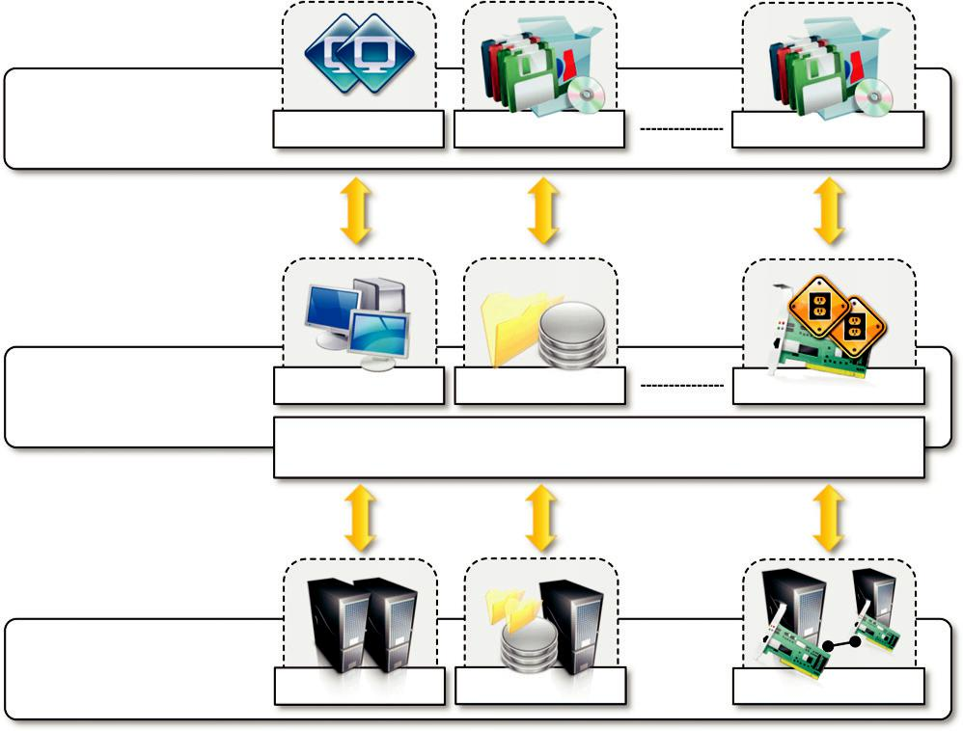

Guest | Virtual Image | Applications | Applications

Virtual Hardware Virtual Storage Virtual Networking

Virtualization Layer

Software Emulation

_{Host} Physical Hardware Physical Storage Physical Networking

FIGURE 3.1

The virtualization reference model.

The main common characteristic of all these different implementations is the fact that the vir-tual environment is created by means of a software program. The ability to use software to emulate such a wide variety of environments creates a lot of opportunities, previously less attractive because of excessive overhead introduced by the virtualization layer. The technologies of today allow profitable use of virtualization and make it possible to fully exploit the advantages that come with it. Such advantages have always been characteristics of virtualized solutions.

Increased security

The ability to control the execution of a guest in a completely transparent manner opens new pos-sibilities for delivering a secure, controlled execution environment. The virtual machine repre-sents an emulated environment in which the guest is executed. All the operations of the guest are generally performed against the virtual machine, which then translates and applies them to the host. This level of indirection allows the virtual machine manager to control and filter the activity of the guest, thus preventing some harmful operations from being performed. Resources exposed by the host can then be hidden or simply protected from the guest. Moreover, sensitive
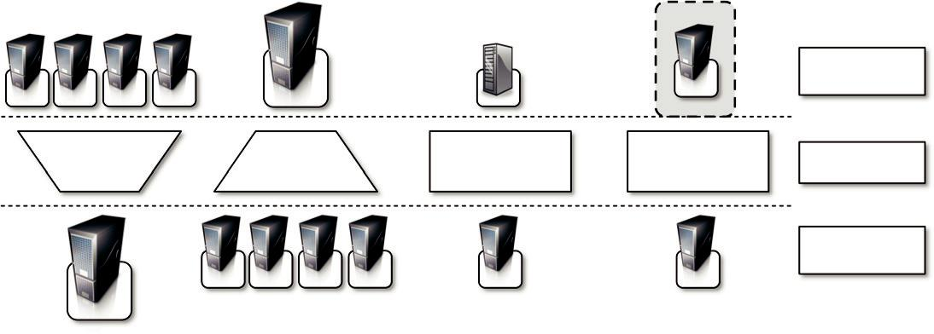

Virtual

Resources

Sharing Aggregation Emulation Isolation Virtualization

Physical

Resources

FIGURE 3.2

Functions enabled by managed execution.

information that is contained in the host can be naturally hidden without the need to install com-plex security policies. Increased security is a requirement when dealing with untrusted code. For example, applets downloaded from the Internet run in a sandboxed³ version of the Java Virtual Machine (JVM), which provides them with limited access to the hosting operating system resources. Both the JVM and the .NET runtime provide extensive security policies for customiz-ing the execution environment of applications. Hardware virtualization solutions such as VMware Desktop, VirtualBox, and Parallels provide the ability to create a virtual computer with custom-ized virtual hardware on top of which a new operating system can be installed. By default, the file system exposed by the virtual computer is completely separated from the one of the host machine. This becomes the perfect environment for running applications without affecting other users in the environment.

Managed execution

Virtualization of the execution environment not only allows increased security, but a wider range of features also can be implemented. In particular, sharing, aggregation, emulation, and isolation are the most relevant features (see Figure 3.2).

- Sharing. Virtualization allows the creation of a separate computing environments within the same host. In this way it is possible to fully exploit the capabilities of a powerful guest, which would otherwise be underutilized. As we will see in later chapters, sharing is a particularly important feature in virtualized data centers, where this basic feature is used to reduce the number of active servers and limit power consumption.

³The term sandbox identifies an isolated execution environment where instructions can be filtered and blocked before being translated and executed in the real execution environment. The expression sandboxed version of the Java Virtual Machine (JVM) refers to a particular configuration of the JVM where, by means of security policy, instructions that are considered potential harmful can be blocked.

Aggregation. Not only is it possible to share physical resource among several guests, but virtualization also allows aggregation, which is the opposite process. A group of separate hosts can be tied together and represented to guests as a single virtual host. This function is naturally implemented in middleware for distributed computing, with a classical example represented by cluster management software, which harnesses the physical resources of a homogeneous group of machines and represents them as a single resource.

Emulation. Guest programs are executed within an environment that is controlled by the virtualization layer, which ultimately is a program. This allows for controlling and tuning the environment that is exposed to guests. For instance, a completely different environment with respect to the host can be emulated, thus allowing the execution of guest programs requiring specific characteristics that are not present in the physical host. This feature becomes very useful for testing purposes, where a specific guest has to be validated against different platforms or architectures and the wide range of options is not easily accessible during development. Again, hardware virtualization solutions are able to provide virtual hardware and emulate a particular kind of device such as Small Computer System Interface (SCSI) devices for file I/O, without the hosting machine having such hardware installed. Old and legacy software that does not meet the requirements of current systems can be run on emulated hardware without any need to change the code. This is possible either by emulating the required hardware architecture or within a specific operating system sandbox, such as the MS-DOS mode in Windows 95/98. Another example of emulation is an arcade-game emulator that allows us to play arcade games on a normal personal computer.

Isolation. Virtualization allows providing guests—whether they are operating systems, applications, or other entities—with a completely separate environment, in which they are executed. The guest program performs its activity by interacting with an abstraction layer, which provides access to the underlying resources. Isolation brings several benefits; for example, it allows multiple guests to run on the same host without interfering with each other. Second, it provides a separation between the host and the guest. The virtual machine can filter the activity of the guest and prevent harmful operations against the host.

Besides these characteristics, another important capability enabled by virtualization is perfor-mance tuning. This feature is a reality at present, given the considerable advances in hardware and software supporting virtualization. It becomes easier to control the performance of the guest by finely tuning the properties of the resources exposed through the virtual environment. This capability provides a means to effectively implement a quality-of-service (QoS) infrastructure that more easily fulfills the service-level agreement (SLA) established for the guest. For instance, software-implementing hardware virtualization solutions can expose to a guest operating system only a fraction of the memory of the host machine or set the maximum frequency of the proces-sor of the virtual machine. Another advantage of managed execution is that sometimes it allows easy capturing of the state of the guest program, persisting it, and resuming its execution. This, for example, allows virtual machine managers such as Xen Hypervisor to stop the execution of a guest operating system, move its virtual image into another machine, and resume its execution in a completely transparent manner. This technique is called virtual machine migration and constitu-tes an important feature in virtualized data centers for optimizing their efficiency in serving application demands.

Portability

The concept of portability applies in different ways according to the specific type of virtualization con-sidered. In the case of a hardware virtualization solution, the guest is packaged into a virtual image that, in most cases, can be safely moved and executed on top of different virtual machines. Except for the file size, this happens with the same simplicity with which we can display a picture image in differ-ent computers. Virtual images are generally proprietary formats that require a specific virtual machine manager to be executed. In the case of programming-level virtualization, as implemented by the JVM or the .NET runtime, the binary code representing application components (jars or assemblies) can be run without any recompilation on any implementation of the corresponding virtual machine. This makes the application development cycle more flexible and application deployment very straightfor-ward: One version of the application, in most cases, is able to run on different platforms with no changes. Finally, portability allows having your own system always with you and ready to use as long as the required virtual machine manager is available. This requirement is, in general, less stringent than having all the applications and services you need available to you anywhere you go.

Taxonomy of virtualization techniques

Virtualization covers a wide range of emulation techniques that are applied to different areas of computing. A classification of these techniques helps us better understand their characteristics and use (see Figure 3.3).

The first classification discriminates against the service or entity that is being emulated. Virtualization is mainly used to emulate execution environments, storage, and networks. Among these categories, execution virtualization constitutes the oldest, most popular, and most developed area. Therefore, it deserves major investigation and a further categorization. In particular we can divide these execution virtualization techniques into two major categories by considering the type of host they require. Process-level techniques are implemented on top of an existing operating sys-tem, which has full control of the hardware. System-level techniques are implemented directly on hardware and do not require—or require a minimum of support from—an existing operating system. Within these two categories we can list various techniques that offer the guest a different type of virtual computation environment: bare hardware, operating system resources, low-level programming language, and application libraries.

Execution virtualization

Execution virtualization includes all techniques that aim to emulate an execution environment that is separate from the one hosting the virtualization layer. All these techniques concentrate their inter-est on providing support for the execution of programs, whether these are the operating system, a binary specification of a program compiled against an abstract machine model, or an application. Therefore, execution virtualization can be implemented directly on top of the hardware by the operating system, an application, or libraries dynamically or statically linked to an application image.
 |  |  |  |  |  |  |  | How it is done? |  |  | Technique |  |  | Virtualization Model
 |  |  |  |  |  |  |  |  |  |  | Emulation |  |  |  | Application
 |  |  |  |  | Execution |  |  | Process Level |  |  | High-Level VM |  |  |  | Programming
 |  |  |  |  | Environment |  |  | Process Level |  |  | High-Level VM |  |  |  | Language
 |  |  |  |  | Storage
 |  |  |  |  | Storage |  |  |  |  |  | Multiprogramming |  |  |  | Operating
 | Virtualization |  |  |  |  |  |  |  |  |  | Multiprogramming |  |  |  | System
 |  |  |  |  | Network
 |  |  |  |  | Network |  |  |  |  |  | Hardware-Assisted
 |  |  |  |  |  |  |  |  |  |  | Virtualization
 |  |  |  |  |  |  |  |  |  |  | Full Virtualization
 |  |  |  |  |  |  |  | System Level |  |  |  |  |  |  | Hardware
 |  |  |  |  | …. |  |  |  |  |  | Paravirtualization
 |  |  |  |  |  |  |  |  |  |  | Partial Virtualization
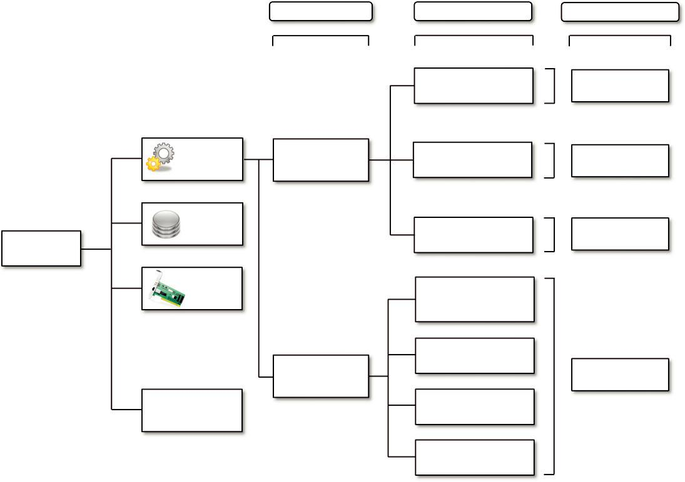

FIGURE 3.3

A taxonomy of virtualization techniques.

Machine reference model

Virtualizing an execution environment at different levels of the computing stack requires a refer-ence model that defines the interfaces between the levels of abstractions, which hide implementa-tion details. From this perspective, virtualization techniques actually replace one of the layers and intercept the calls that are directed toward it. Therefore, a clear separation between layers simplifies their implementation, which only requires the emulation of the interfaces and a proper interaction with the underlying layer.

Modern computing systems can be expressed in terms of the reference model described in Figure 3.4. At the bottom layer, the model for the hardware is expressed in terms of the Instruction Set Architecture (ISA), which defines the instruction set for the processor, registers, memory, and interrupt management. ISA is the interface between hardware and software, and it is important to the operating system (OS) developer (System ISA) and developers of applications that directly manage the underlying hardware (User ISA). The application binary interface (ABI) separates the operating system layer from the applica-tions and libraries, which are managed by the OS. ABI covers details such as low-level data types, align-ment, and call conventions and defines a format for executable programs. System calls are defined at this level. This interface allows portability of applications and libraries across operating systems that
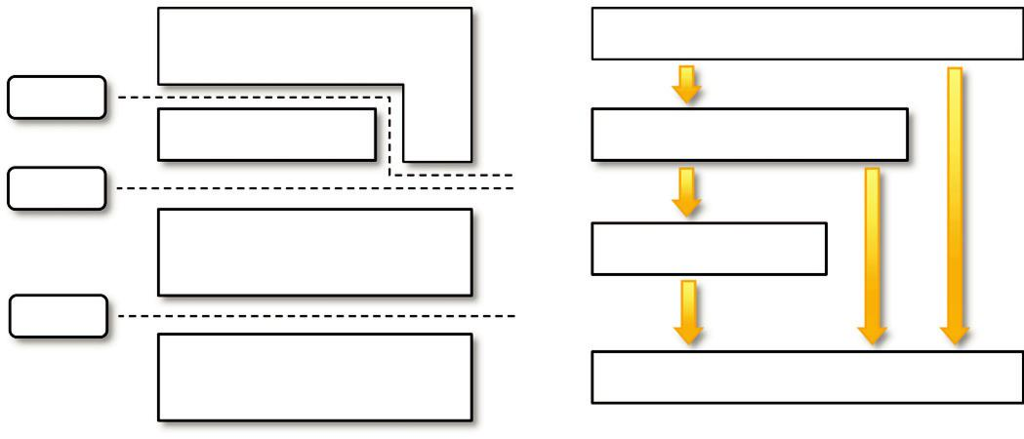

Applications | Applications
API | API calls
Libraries | Libraries
ABI | System calls |  | User
 |  | User | ISA
Operative System | Operative System | ISA
ISA | ISA
Hardware | Hardware

FIGURE 3.4

A machine reference model.

implement the same ABI. The highest level of abstraction is represented by the application programming interface (API), which interfaces applications to libraries and/or the underlying operating system.

For any operation to be performed in the application level API, ABI and ISA are responsible for making it happen. The high-level abstraction is converted into machine-level instructions to per-form the actual operations supported by the processor. The machine-level resources, such as proces-sor registers and main memory capacities, are used to perform the operation at the hardware level of the central processing unit (CPU). This layered approach simplifies the development and imple-mentation of computing systems and simplifies the implementation of multitasking and the coexis-tence of multiple executing environments. In fact, such a model not only requires limited knowledge of the entire computing stack, but it also provides ways to implement a minimal security model for managing and accessing shared resources.

For this purpose, the instruction set exposed by the hardware has been divided into different security classes that define who can operate with them. The first distinction can be made between privileged and nonprivileged instructions. Nonprivileged instructions are those instructions that can be used without interfering with other tasks because they do not access shared resources. This cate-gory contains, for example, all the floating, fixed-point, and arithmetic instructions. Privileged instructions are those that are executed under specific restrictions and are mostly used for sensitive operations, which expose (behavior-sensitive) or modify (control-sensitive) the privileged state. For instance, behavior-sensitive instructions are those that operate on the I/O, whereas control-sensitive instructions alter the state of the CPU registers. Some types of architecture feature more than one class of privileged instructions and implement a finer control of how these instructions can be accessed. For instance, a possible implementation features a hierarchy of privileges (see Figure 3.5) in the form of ring-based security: Ring 0, Ring 1, Ring 2, and Ring 3; Ring 0 is in the most privi-leged level and Ring 3 in the least privileged level. Ring 0 is used by the kernel of the OS, rings 1 and 2 are used by the OS-level services, and Ring 3 is used by the user. Recent systems support only two levels, with Ring 0 for supervisor mode and Ring 3 for user mode.

Least Privileged Mode
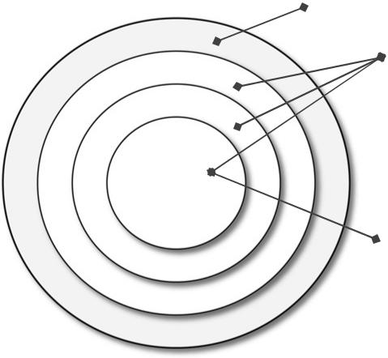
(User Mode)

Ring 3

Ring 2

Ring 1

Ring 0

Privileged Modes

Most Privileged Mode

(Supervisor Mode)

FIGURE 3.5

Security rings and privilege modes.

All the current systems support at least two different execution modes: supervisor mode and user mode. The first mode denotes an execution mode in which all the instructions (privileged and nonprivi-leged) can be executed without any restriction. This mode, also called master mode or kernel mode, is generally used by the operating system (or the hypervisor) to perform sensitive operations on hardware-level resources. In user mode, there are restrictions to control the machine-level resources. If code run-ning in user mode invokes the privileged instructions, hardware interrupts occur and trap the potentially harmful execution of the instruction. Despite this, there might be some instructions that can be invoked as privileged instructions under some conditions and as nonprivileged instructions under other conditions.

The distinction between user and supervisor mode allows us to understand the role of the hypervisor and why it is called that. Conceptually, the hypervisor runs above the supervisor mode, and from here the prefix hyper- is used. In reality, hypervisors are run in supervisor mode, and the division between privileged and nonprivileged instructions has posed challenges in designing virtual machine managers. It is expected that all the sensitive instructions will be executed in privileged mode, which requires supervisor mode in order to avoid traps. Without this assumption it is impossible to fully emulate and manage the status of the CPU for guest operating systems. Unfortunately, this is not true for the original ISA, which allows 17 sensitive instructions to be called in user mode. This prevents multiple operating systems managed by a single hypervisor to be isolated from each other, since they are able to access the privileged state of the processor and change it.⁴ More recent implementations of ISA (Intel VT and AMD Pacifica) have solved this problem by redesigning such instructions as privileged ones.

By keeping in mind this reference model, it is possible to explore and better understand the var-ious techniques utilized to virtualize execution environments and their relationships to the other components of the system.

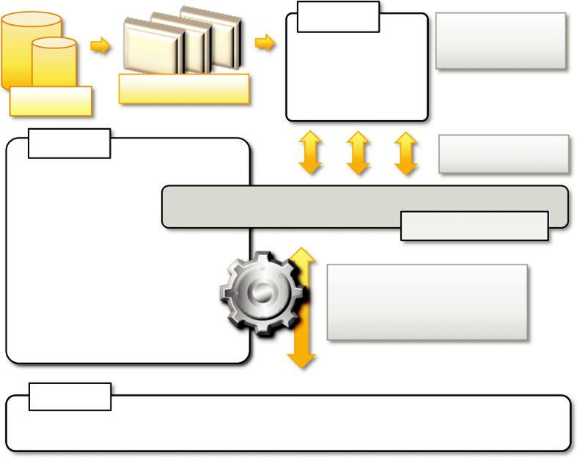

Guest

In-memory

representation

Virtual Image
Storage

VMM

Host emulation

Virtual Machine

Binary translation

Instruction mapping

Interpretation
……

Host

FIGURE 3.6

A hardware virtualization reference model.

Hardware-level virtualization

Hardware-level virtualization is a virtualization technique that provides an abstract execution envi-ronment in terms of computer hardware on top of which a guest operating system can be run. In this model, the guest is represented by the operating system, the host by the physical computer hardware, the virtual machine by its emulation, and the virtual machine manager by the hypervisor (see Figure 3.6). The hypervisor is generally a program or a combination of software and hardware that allows the abstraction of the underlying physical hardware.

Hardware-level virtualization is also called system virtualization, since it provides ISA to virtual machines, which is the representation of the hardware interface of a system. This is to differentiate it from process virtual machines, which expose ABI to virtual machines.

Hypervisors

A fundamental element of hardware virtualization is the hypervisor, or virtual machine manager (VMM). It recreates a hardware environment in which guest operating systems are installed. There are two major types of hypervisor: Type I and Type II (see Figure 3.7).

- Type I hypervisors run directly on top of the hardware. Therefore, they take the place of the operating systems and interact directly with the ISA interface exposed by the underlying hardware, and they emulate this interface in order to allow the management of guest operating systems. This type of hypervisor is also called a native virtual machine since it runs natively on hardware.

- Type II hypervisors require the support of an operating system to provide virtualization services. This means that they are programs managed by the operating system, which interact with it through the ABI and emulate the ISA of virtual hardware for guest operating systems. This type of hypervisor is also called a hosted virtual machine since it is hosted within an operating system.
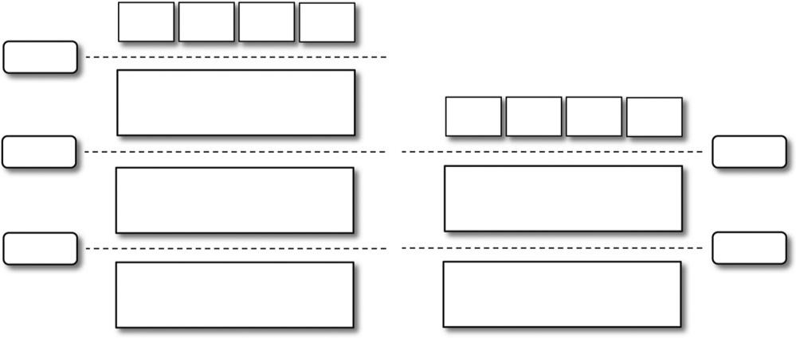

VM

VM

VM

VM

ISA

Virtual Machine Manager

VM

VM

VM

VM

ABI

ISA

Operative System

Virtual Machine Manager

ISA

ISA

Hardware

Hardware

FIGURE 3.7

Hosted (left) and native (right) virtual machines. This figure provides a graphical representation of the two types of hypervisors.

Conceptually, a virtual machine manager is internally organized as described in Figure 3.8. Three main modules, dispatcher, allocator, and interpreter, coordinate their activity in order to emulate the underlying hardware. The dispatcher constitutes the entry point of the monitor and reroutes the instructions issued by the virtual machine instance to one of the two other modules. The allocator is responsible for deciding the system resources to be provided to the VM: whenever a virtual machine tries to execute an instruction that results in changing the machine resources asso-ciated with that VM, the allocator is invoked by the dispatcher. The interpreter module consists of interpreter routines. These are executed whenever a virtual machine executes a privileged instruc-tion: a trap is triggered and the corresponding routine is executed.

The design and architecture of a virtual machine manager, together with the underlying hardware design of the host machine, determine the full realization of hardware virtualization, where a guest operating system can be transparently executed on top of a VMM as though it were run on the underly-ing hardware. The criteria that need to be met by a virtual machine manager to efficiently support vir-tualization were established by Goldberg and Popek in 1974 [23]. Three properties have to be satisfied:

- Equivalence. A guest running under the control of a virtual machine manager should exhibit the same behavior as when it is executed directly on the physical host.

- Resource control. The virtual machine manager should be in complete control of virtualized resources.

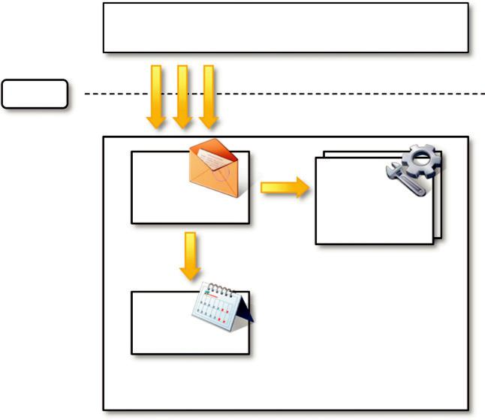

Virtual Machine Instance

ISA

Instructions (ISA)

_{Dispatcher} Interpreter

Routines

Allocator

Virtual Machine Manager

FIGURE 3.8

A hypervisor reference architecture.

- Efficiency. A statistically dominant fraction of the machine instructions should be executed without intervention from the virtual machine manager.

The major factor that determines whether these properties are satisfied is represented by the lay-out of the ISA of the host running a virtual machine manager. Popek and Goldberg provided a clas-sification of the instruction set and proposed three theorems that define the properties that hardware instructions need to satisfy in order to efficiently support virtualization.


THEOREM 3.1

For any conventional third-generation computer, a VMM may be constructed if the set of sensi-tive instructions for that computer is a subset of the set of privileged instructions.

This theorem establishes that all the instructions that change the configuration of the system resources should generate a trap in user mode and be executed under the control of the virtual machine manager. This allows hypervisors to efficiently control only those instructions that would reveal the presence of an abstraction layer while executing all the rest of the instructions without considerable performance loss. The theorem always guarantees the resource control property when the hypervisor is in the most privileged mode (Ring 0). The nonprivileged instructions must be exe-cuted without the intervention of the hypervisor. The equivalence property also holds good since the output of the code is the same in both cases because the code is not changed.
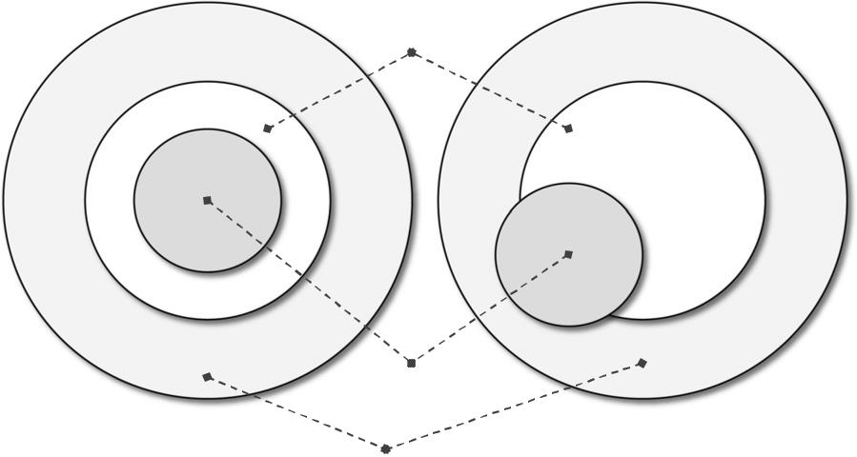

Privileged Instructions

Sensitive Instructions

User Instructions

FIGURE 3.9

A virtualizable computer (left) and a nonvirtualizable computer (right).


THEOREM 3.2

A conventional third-generation computer is recursively virtualizable if:

- It is virtualizable and

- A VMM without any timing dependencies can be constructed for it.

Recursive virtualization is the ability to run a virtual machine manager on top of another virtual machine manager. This allows nesting hypervisors as long as the capacity of the underly-ing resources can accommodate that. Virtualizable hardware is a prerequisite to recursive virtualization.

THEOREM 3.3

A hybrid VMM may be constructed for any conventional third-generation machine in which the set of user-sensitive instructions is a subset of the set of privileged instructions.

There is another term, hybrid virtual machine (HVM), which is less efficient than the virtual machine system. In the case of an HVM, more instructions are interpreted rather than being executed directly. All instructions in virtual supervisor mode are interpreted. Whenever there is an attempt to execute a behavior-sensitive or control-sensitive instruction, HVM controls the execution directly or gains the control via a trap. Here all sensitive instructions are caught by HVM that are simulated.

This reference model represents what we generally consider classic virtualization—that is, the ability to execute a guest operating system in complete isolation. To a greater extent, hardware-level virtualization includes several strategies that differentiate from each other in terms of which kind of support is expected from the underlying hardware, what is actually abstracted from the host, and whether the guest should be modified or not.

Hardware virtualization techniques

Hardware-assisted virtualization. This term refers to a scenario in which the hardware provides architectural support for building a virtual machine manager able to run a guest operating system in complete isolation. This technique was originally introduced in the IBM System/370. At present, examples of hardware-assisted virtualization are the extensions to the x86-64 bit architecture introduced with Intel VT (formerly known as Vanderpool) and AMD V (formerly known as Pacifica). These exten-sions, which differ between the two vendors, are meant to reduce the performance penalties experienced by emulating x86 hardware with hypervisors. Before the introduction of hardware-assisted virtualiza-tion, software emulation of x86 hardware was significantly costly from the performance point of view. The reason for this is that by design the x86 architecture did not meet the formal requirements introduced by Popek and Goldberg, and early products were using binary translation to trap some sensitive instructions and provide an emulated version. Products such as VMware Virtual Platform, introduced in 1999 by VMware, which pioneered the field of x86 virtualization, were based on this technique. After 2006, Intel and AMD introduced processor extensions, and a wide range of virtualiza-tion solutions took advantage of them: Kernel-based Virtual Machine (KVM), VirtualBox, Xen, VMware, Hyper-V, Sun xVM, Parallels, and others.

Full virtualization. Full virtualization refers to the ability to run a program, most likely an operating system, directly on top of a virtual machine and without any modification, as though it were run on the raw hardware. To make this possible, virtual machine managers are required to provide a complete emulation of the entire underlying hardware. The principal advantage of full virtualization is complete isolation, which leads to enhanced security, ease of emulation of different architectures, and coexistence of different systems on the same platform. Whereas it is a desired goal for many virtualization solutions, full virtualization poses important concerns related to perfor-mance and technical implementation. A key challenge is the interception of privileged instructions such as I/O instructions: Since they change the state of the resources exposed by the host, they have to be contained within the virtual machine manager. A simple solution to achieve full virtuali-zation is to provide a virtual environment for all the instructions, thus posing some limits on perfor-mance. A successful and efficient implementation of full virtualization is obtained with a combination of hardware and software, not allowing potentially harmful instructions to be executed directly on the host. This is what is accomplished through hardware-assisted virtualization.

Paravirtualization. This is a not-transparent virtualization solution that allows implementing thin virtual machine managers. Paravirtualization techniques expose a software interface to the vir-tual machine that is slightly modified from the host and, as a consequence, guests need to be modi-fied. The aim of paravirtualization is to provide the capability to demand the execution of performance-critical operations directly on the host, thus preventing performance losses that would otherwise be experienced in managed execution. This allows a simpler implementation of virtual machine managers that have to simply transfer the execution of these operations, which were hard to virtualize, directly to the host. To take advantage of such an opportunity, guest operating systems

need to be modified and explicitly ported by remapping the performance-critical operations through the virtual machine software interface. This is possible when the source code of the operating sys-tem is available, and this is the reason that paravirtualization was mostly explored in the open-source and academic environment. Whereas this technique was initially applied in the IBM VM operating system families, the term paravirtualization was introduced in literature in the Denali project [24] at the University of Washington. This technique has been successfully used by Xen for providing virtualization solutions for Linux-based operating systems specifically ported to run on Xen hypervisors. Operating systems that cannot be ported can still take advantage of paravirtualiza-tion by using ad hoc device drivers that remap the execution of critical instructions to the paravir-tualization APIs exposed by the hypervisor. Xen provides this solution for running Windows-based operating systems on x86 architectures. Other solutions using paravirtualization include VMWare, Parallels, and some solutions for embedded and real-time environments such as TRANGO, Wind River, and XtratuM.

Partial virtualization. Partial virtualization provides a partial emulation of the underlying hard-ware, thus not allowing the complete execution of the guest operating system in complete isolation. Partial virtualization allows many applications to run transparently, but not all the features of the operating system can be supported, as happens with full virtualization. An example of partial vir-tualization is address space virtualization used in time-sharing systems; this allows multiple appli-cations and users to run concurrently in a separate memory space, but they still share the same hardware resources (disk, processor, and network). Historically, partial virtualization has been an important milestone for achieving full virtualization, and it was implemented on the experimental IBM M44/44X. Address space virtualization is a common feature of contemporary operating systems.

Operating system-level virtualization

Operating system-level virtualization offers the opportunity to create different and separated execu-tion environments for applications that are managed concurrently. Differently from hardware virtua-lization, there is no virtual machine manager or hypervisor, and the virtualization is done within a single operating system, where the OS kernel allows for multiple isolated user space instances. The kernel is also responsible for sharing the system resources among instances and for limiting the impact of instances on each other. A user space instance in general contains a proper view of the file system, which is completely isolated, and separate IP addresses, software configurations, and access to devices. Operating systems supporting this type of virtualization are general-purpose, time-shared operating systems with the capability to provide stronger namespace and resource isolation.

This virtualization technique can be considered an evolution of the chroot mechanism in Unix systems. The chroot operation changes the file system root directory for a process and its children to a specific directory. As a result, the process and its children cannot have access to other por-tions of the file system than those accessible under the new root directory. Because Unix systems also expose devices as parts of the file system, by using this method it is possible to completely isolate a set of processes. Following the same principle, operating system-level virtualization aims to provide separated and multiple execution containers for running applications. Compared to hardware virtualization, this strategy imposes little or no overhead because applications directly use OS system calls and there is no need for emulation. There is no need to modify appli-cations to run them, nor to modify any specific hardware, as in the case of hardware-assisted

virtualization. On the other hand, operating system-level virtualization does not expose the same flexibility of hardware virtualization, since all the user space instances must share the same oper-ating system.

This technique is an efficient solution for server consolidation scenarios in which multiple application servers share the same technology: operating system, application server framework, and other components. When different servers are aggregated into one physical server, each server is run in a different user space, completely isolated from the others.

Examples of operating system-level virtualizations are FreeBSD Jails, IBM Logical Partition (LPAR), SolarisZones and Containers, Parallels Virtuozzo Containers, OpenVZ, iCore Virtual Accounts, Free Virtual Private Server (FreeVPS), and others. The services offered by these technol-ogies differ, and most of them are available on Unix-based systems. Some of them, such as Solaris and OpenVZ, allow for different versions of the same operating system to operate concurrently.

Programming language-level virtualization

Programming language-level virtualization is mostly used to achieve ease of deployment of applications, managed execution, and portability across different platforms and operating sys-tems. It consists of a virtual machine executing the byte code of a program, which is the result of the compilation process. Compilers implemented and used this technology to produce a binary format representing the machine code for an abstract architecture. The characteristics of this architecture vary from implementation to implementation. Generally these virtual machines con-stitute a simplification of the underlying hardware instruction set and provide some high-level instructions that map some of the features of the languages compiled for them. At runtime, the byte code can be either interpreted or compiled on the fly—or jitted⁵—against the underlying hardware instruction set.

Programming language-level virtualization has a long trail in computer science history and orig-inally was used in 1966 for the implementation of Basic Combined Programming Language (BCPL), a language for writing compilers and one of the ancestors of the C programming language. Other important examples of the use of this technology have been the UCSD Pascal and Smalltalk. Virtual machine programming languages become popular again with Sun’s introduction of the Java platform in 1996. Originally created as a platform for developing Internet applications, Java became one of the technologies of choice for enterprise applications, and a large community of developers formed around it. The Java virtual machine was originally designed for the execution of programs written in the Java language, but other languages such as Python, Pascal, Groovy, and Ruby were made available. The ability to support multiple programming languages has been one of the key elements of the Common Language Infrastructure (CLI), which is the specification behind

.NET Framework. Currently, the Java platform and .NET Framework represent the most popular technologies for enterprise application development.

Both Java and the CLI are stack-based virtual machines: The reference model of the abstract architecture is based on an execution stack that is used to perform operations. The byte code gen-erated by compilers for these architectures contains a set of instructions that load operands on the stack, perform some operations with them, and put the result on the stack. Additionally, specific instructions for invoking methods and managing objects and classes are included. Stack-based vir-tual machines possess the property of being easily interpreted and executed simply by lexical analysis and hence are easily portable over different architectures. An alternative solution is offered by register-based virtual machines, in which the reference model is based on registers. This kind of virtual machine is closer to the underlying architecture we use today. An example of a register-based virtual machine is Parrot, a programming-level virtual machine that was origi-nally designed to support the execution of PERL and then generalized to host the execution of dynamic languages.

The main advantage of programming-level virtual machines, also called process virtual machines, is the ability to provide a uniform execution environment across different platforms. Programs compiled into byte code can be executed on any operating system and platform for which a virtual machine able to execute that code has been provided. From a development life-cycle point of view, this simplifies the development and deployment efforts since it is not neces-sary to provide different versions of the same code. The implementation of the virtual machine for different platforms is still a costly task, but it is done once and not for any application. Moreover, process virtual machines allow for more control over the execution of programs since they do not provide direct access to the memory. Security is another advantage of managed programming languages; by filtering the I/O operations, the process virtual machine can easily support sandboxing of applications. As an example, both Java and .NET provide an infrastructure for pluggable security policies and code access security frameworks. All these advantages come with a price: performance. Virtual machine programming languages generally expose an inferior performance compared to languages compiled against the real architecture. This performance dif-ference is getting smaller, and the high compute power available on average processors makes it even less important.

Implementations of this model are also called high-level virtual machines, since high-level pro-gramming languages are compiled to a conceptual ISA, which is further interpreted or dynamically translated against the specific instruction of the hosting platform.

Application-level virtualization

Application-level virtualization is a technique allowing applications to be run in runtime environ-ments that do not natively support all the features required by such applications. In this scenario, applications are not installed in the expected runtime environment but are run as though they were. In general, these techniques are mostly concerned with partial file systems, libraries, and operating system component emulation. Such emulation is performed by a thin layer—a program or an operating system component—that is in charge of executing the application. Emulation can

also be used to execute program binaries compiled for different hardware architectures. In this case, one of the following strategies can be implemented:

- Interpretation. In this technique every source instruction is interpreted by an emulator for executing native ISA instructions, leading to poor performance. Interpretation has a minimal startup cost but a huge overhead, since each instruction is emulated.

- Binary translation. In this technique every source instruction is converted to native instructions with equivalent functions. After a block of instructions is translated, it is cached and reused. Binary translation has a large initial overhead cost, but over time it is subject to better performance, since previously translated instruction blocks are directly executed.

Emulation, as described, is different from hardware-level virtualization. The former simply allows the execution of a program compiled against a different hardware, whereas the latter emu-lates a complete hardware environment where an entire operating system can be installed.

Application virtualization is a good solution in the case of missing libraries in the host oper-ating system; in this case a replacement library can be linked with the application, or library calls can be remapped to existing functions available in the host system. Another advantage is that in this case the virtual machine manager is much lighter since it provides a partial emula-tion of the runtime environment compared to hardware virtualization. Moreover, this technique allows incompatible applications to run together. Compared to programming-level virtualization, which works across all the applications developed for that virtual machine, application-level virtualization works for a specific environment: It supports all the applications that run on top of a specific environment.

One of the most popular solutions implementing application virtualization is Wine, which is a software application allowing Unix-like operating systems to execute programs written for the Microsoft Windows platform. Wine features a software application acting as a container for the guest application and a set of libraries, called Winelib, that developers can use to compile applica-tions to be ported on Unix systems. Wine takes its inspiration from a similar product from Sun, Windows Application Binary Interface (WABI), which implements the Win 16 API specifications on Solaris. A similar solution for the Mac OS X environment is CrossOver, which allows running Windows applications directly on the Mac OS X operating system. VMware ThinApp, another product in this area, allows capturing the setup of an installed application and packaging it into an executable image isolated from the hosting operating system.

Other types of virtualization

Other than execution virtualization, other types of virtualization provide an abstract environment to interact with. These mainly cover storage, networking, and client/server interaction.

Storage virtualization

Storage virtualization is a system administration practice that allows decoupling the physical orga-nization of the hardware from its logical representation. Using this technique, users do not have to be worried about the specific location of their data, which can be identified using a logical path.

Storage virtualization allows us to harness a wide range of storage facilities and represent them under a single logical file system. There are different techniques for storage virtualization, one of the most popular being network-based virtualization by means of storage area networks (SANs). SANs use a network-accessible device through a large bandwidth connection to provide storage facilities.

Network virtualization

Network virtualization combines hardware appliances and specific software for the creation and management of a virtual network. Network virtualization can aggregate different physical networks into a single logical network (external network virtualization) or provide network-like functionality to an operating system partition (internal network virtualization). The result of external network virtualization is generally a virtual LAN (VLAN). A VLAN is an aggregation of hosts that commu-nicate with each other as though they were located under the same broadcasting domain. Internal network virtualization is generally applied together with hardware and operating system-level vir-tualization, in which the guests obtain a virtual network interface to communicate with. There are several options for implementing internal network virtualization: The guest can share the same net-work interface of the host and use Network Address Translation (NAT) to access the network; the virtual machine manager can emulate, and install on the host, an additional network device, together with the driver; or the guest can have a private network only with the guest.

Desktop virtualization

Desktop virtualization abstracts the desktop environment available on a personal computer in order to provide access to it using a client/server approach. Desktop virtualization provides the same out-come of hardware virtualization but serves a different purpose. Similarly to hardware virtualization, desktop virtualization makes accessible a different system as though it were natively installed on the host, but this system is remotely stored on a different host and accessed through a network con-nection. Moreover, desktop virtualization addresses the problem of making the same desktop envi-ronment accessible from everywhere. Although the term desktop virtualization strictly refers to the ability to remotely access a desktop environment, generally the desktop environment is stored in a remote server or a data center that provides a high-availability infrastructure and ensures the acces-sibility and persistence of the data.

In this scenario, an infrastructure supporting hardware virtualization is fundamental to provide access to multiple desktop environments hosted on the same server; a specific desktop environment is stored in a virtual machine image that is loaded and started on demand when a client connects to the desktop environment. This is a typical cloud computing scenario in which the user leverages the virtual infrastructure for performing the daily tasks on his computer. The advantages of desktop virtualization are high availability, persistence, accessibility, and ease of management. As we will discuss in Section 4.5.4 of the next chapter, security issues can prevent the use of this technology. The basic services for remotely accessing a desktop environment are implemented in software com-ponents such as Windows Remote Services, VNC, and X Server. Infrastructures for desktop virtua-lization based on cloud computing solutions include Sun Virtual Desktop Infrastructure (VDI), Parallels Virtual Desktop Infrastructure (VDI), Citrix XenDesktop, and others.

Application server virtualization

Application server virtualization abstracts a collection of application servers that provide the same services as a single virtual application server by using load-balancing strategies and providing a high-availability infrastructure for the services hosted in the application server. This is a particular form of virtualization and serves the same purpose of storage virtualization: providing a better qual-ity of service rather than emulating a different environment.

Virtualization and cloud computing

Virtualization plays an important role in cloud computing since it allows for the appropriate degree of customization, security, isolation, and manageability that are fundamental for delivering IT ser-vices on demand. Virtualization technologies are primarily used to offer configurable computing environments and storage. Network virtualization is less popular and, in most cases, is a comple-mentary feature, which is naturally needed in build virtual computing systems.

Particularly important is the role of virtual computing environment and execution virtualization techniques. Among these, hardware and programming language virtualization are the techniques adopted in cloud computing systems. Hardware virtualization is an enabling factor for solutions in the Infrastructure-as-a-Service (IaaS) market segment, while programming language virtualization is a technology leveraged in Platform-as-a-Service (PaaS) offerings. In both cases, the capability of offering a customizable and sandboxed environment constituted an attractive business opportunity for companies featuring a large computing infrastructure that was able to sustain and process huge workloads. Moreover, virtualization also allows isolation and a finer control, thus simplifying the leasing of services and their accountability on the vendor side.

Besides being an enabler for computation on demand, virtualization also gives the opportunity to design more efficient computing systems by means of consolidation, which is performed trans-parently to cloud computing service users. Since virtualization allows us to create isolated and con-trollable environments, it is possible to serve these environments with the same resource without them interfering with each other. If the underlying resources are capable enough, there will be no evidence of such sharing. This opportunity is particularly attractive when resources are underuti-lized, because it allows reducing the number of active resources by aggregating virtual machines over a smaller number of resources that become fully utilized. This practice is also known as server consolidation, while the movement of virtual machine instances is called virtual machine migration (see Figure 3.10). Because virtual machine instances are controllable environments, consolidation can be applied with a minimum impact, either by temporarily stopping its execution and moving its data to the new resources or by performing a finer control and moving the instance while it is run-ning. This second techniques is known as live migration and in general is more complex to imple-ment but more efficient since there is no disruption of the activity of the virtual machine instance.⁶

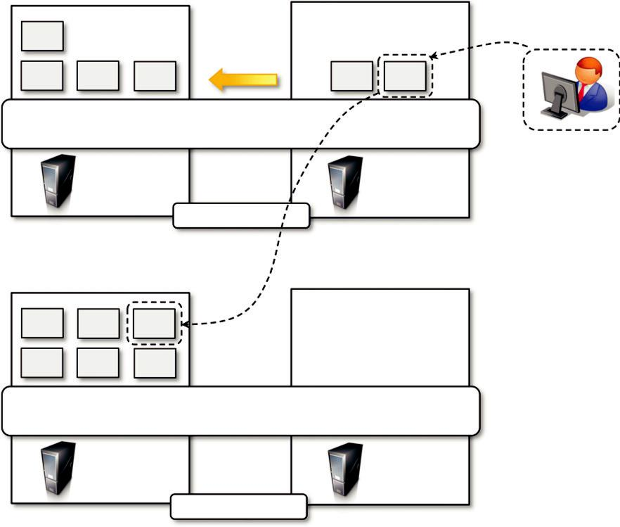

VM

VM

VM

VM

VM VM

Virtual Machine Manager

Server A

(running)

Server B

(running)

Before Migration

VM

VM

VM

VM

VM

VM

Virtual Machine Manager

Server A

(running)

Server B

(inactive)

After Migration

FIGURE 3.10

Live migration and server consolidation.

Server consolidation and virtual machine migration are principally used in the case of hardware virtualization, even though they are also technically possible in the case of programming language virtualization (see Figure 3.9).

Storage virtualization constitutes an interesting opportunity given by virtualization technologies, often complementary to the execution of virtualization. Even in this case, vendors backed by large computing infrastructures featuring huge storage facilities can harness these facilities into a virtual storage service, easily partitionable into slices. These slices can be dynamic and offered as a ser-vice. Again, opportunities to secure and protect the hosting infrastructure are available, as are meth-ods for easy accountability of such services.

Finally, cloud computing revamps the concept of desktop virtualization, initially introduced in the mainframe era. The ability to recreate the entire computing stack—from infrastructure to appli-cation services—on demand opens the path to having a complete virtual computer hosted on the infrastructure of the provider and accessed by a thin client over a capable Internet connection.

Pros and cons of virtualization

Virtualization has now become extremely popular and widely used, especially in cloud computing. The primary reason for its wide success is the elimination of technology barriers that prevented vir-tualization from being an effective and viable solution in the past. The most relevant barrier has been performance. Today, the capillary diffusion of the Internet connection and the advancements in computing technology have made virtualization an interesting opportunity to deliver on-demand IT infrastructure and services. Despite its renewed popularity, this technology has benefits and also drawbacks.

Advantages of virtualization

Managed execution and isolation are perhaps the most important advantages of virtualization. In the case of techniques supporting the creation of virtualized execution environments, these two characteristics allow building secure and controllable computing environments. A virtual execution environment can be configured as a sandbox, thus preventing any harmful operation to cross the borders of the virtual host. Moreover, allocation of resources and their partitioning among different guests is simplified, being the virtual host controlled by a program. This enables fine-tuning of resources, which is very important in a server consolidation scenario and is also a requirement for effective quality of service.

Portability is another advantage of virtualization, especially for execution virtualization techni-ques. Virtual machine instances are normally represented by one or more files that can be easily transported with respect to physical systems. Moreover, they also tend to be self-contained since they do not have other dependencies besides the virtual machine manager for their use. Portability and self-containment simplify their administration. Java programs are “compiled once and run every-where”; they only require that the Java virtual machine be installed on the host. The same applies to hardware-level virtualization. It is in fact possible to build our own operating environment within a virtual machine instance and bring it with us wherever we go, as though we had our own laptop. This concept is also an enabler for migration techniques in a server consolidation scenario.

Portability and self-containment also contribute to reducing the costs of maintenance, since the number of hosts is expected to be lower than the number of virtual machine instances. Since the guest program is executed in a virtual environment, there is very limited opportunity for the guest program to damage the underlying hardware. Moreover, it is expected that there will be fewer vir-tual machine managers with respect to the number of virtual machine instances managed.

Finally, by means of virtualization it is possible to achieve a more efficient use of resources. Multiple systems can securely coexist and share the resources of the underlying host, without inter-fering with each other. This is a prerequisite for server consolidation, which allows adjusting the number of active physical resources dynamically according to the current load of the system, thus creating the opportunity to save in terms of energy consumption and to be less impacting on the environment.

The other side of the coin: disadvantages

Virtualization also has downsides. The most evident is represented by a performance decrease of guest systems as a result of the intermediation performed by the virtualization layer. In addition, suboptimal use of the host because of the abstraction layer introduced by virtualization management software can lead to a very inefficient utilization of the host or a degraded user experience. Less evident, but perhaps more dangerous, are the implications for security, which are mostly due to the ability to emulate a dif-ferent execution environment.

Performance degradation

Performance is definitely one of the major concerns in using virtualization technology. Since vir-tualization interposes an abstraction layer between the guest and the host, the guest can experience increased latencies.

For instance, in the case of hardware virtualization, where the intermediate emulates a bare machine on top of which an entire system can be installed, the causes of performance degradation can be traced back to the overhead introduced by the following activities:

- Maintaining the status of virtual processors

- Support of privileged instructions (trap and simulate privileged instructions)

- Support of paging within VM

- Console functions

Furthermore, when hardware virtualization is realized through a program that is installed or exe-cuted on top of the host operating systems, a major source of performance degradation is repre-sented by the fact that the virtual machine manager is executed and scheduled together with other applications, thus sharing with them the resources of the host.

Similar consideration can be made in the case of virtualization technologies at higher levels, such as in the case of programming language virtual machines (Java, .NET, and others). Binary translation and interpretation can slow down the execution of managed applications. Moreover, because their execution is filtered by the runtime environment, access to memory and other physi-cal resources can represent sources of performance degradation.

These concerns are becoming less and less important thanks to technology advancements and the ever-increasing computational power available today. For example, specific techniques for hard-ware virtualization such as paravirtualization can increase the performance of the guest program by offloading most of its execution to the host without any change. In programming-level virtual machines such as the JVM or .NET, compilation to native code is offered as an option when perfor-mance is a serious concern.

Inefficiency and degraded user experience

Virtualization can sometime lead to an inefficient use of the host. In particular, some of the specific features of the host cannot be exposed by the abstraction layer and then become inaccessible. In the case of hardware virtualization, this could happen for device drivers: The virtual machine can sometime simply provide a default graphic card that maps only a subset of the features available in the host. In the case of programming-level virtual machines, some of the features of the underlying operating systems may become inaccessible unless specific libraries are used. For example, in the

first version of Java the support for graphic programming was very limited and the look and feel of applications was very poor compared to native applications. These issues have been resolved by providing a new framework called Swing for designing the user interface, and further improvements have been done by integrating support for the OpenGL libraries in the software development kit.

Security holes and new threats

Virtualization opens the door to a new and unexpected form of phishing.⁷ The capability of emu-lating a host in a completely transparent manner led the way to malicious programs that are designed to extract sensitive information from the guest.

In the case of hardware virtualization, malicious programs can preload themselves before the operating system and act as a thin virtual machine manager toward it. The operating system is then controlled and can be manipulated to extract sensitive information of interest to third parties. Examples of these kinds of malware are BluePill and SubVirt. BluePill, malware targeting the AMD processor family, moves the execution of the installed OS within a virtual machine. The orig-inal version of SubVirt was developed as a prototype by Microsoft through collaboration with Michigan University. SubVirt infects the guest OS, and when the virtual machine is rebooted, it gains control of the host. The diffusion of such kinds of malware is facilitated by the fact that origi-nally, hardware and CPUs were not manufactured with virtualization in mind. In particular, the existing instruction sets cannot be simply changed or updated to suit the needs of virtualization. Recently, both Intel and AMD have introduced hardware support for virtualization with Intel VT and AMD Pacifica, respectively.

The same considerations can be made for programming-level virtual machines: Modified ver-sions of the runtime environment can access sensitive information or monitor the memory locations utilized by guest applications while these are executed. To make this possible, the original version of the runtime environment needs to be replaced by the modified one, which can generally happen if the malware is run within an administrative context or a security hole of the host operating sys-tem is exploited.

Technology examples

A wide range of virtualization technology is available especially for virtualizing computing envir-onments. In this section, we discuss the most relevant technologies and approaches utilized in the field. Cloud-specific solutions are discussed in the next chapter.

Xen: paravirtualization

Xen is an open-source initiative implementing a virtualization platform based on paravirtualization. Initially developed by a group of researchers at the University of Cambridge in the United Kingdom, Xen now has a large open-source community backing it. Citrix also offers it as a com-mercial solution, XenSource. Xen-based technology is used for either desktop virtualization or server virtualization, and recently it has also been used to provide cloud computing solutions by means of Xen Cloud Platform (XCP). At the basis of all these solutions is the Xen Hypervisor, which constitutes the core technology of Xen. Recently Xen has been advanced to support full vir-tualization using hardware-assisted virtualization.

Xen is the most popular implementation of paravirtualization, which, in contrast with full vir-tualization, allows high-performance execution of guest operating systems. This is made possible by eliminating the performance loss while executing instructions that require special management. This is done by modifying portions of the guest operating systems run by Xen with reference to the execution of such instructions. Therefore it is not a transparent solution for implementing virtuali-zation. This is particularly true for x86, which is the most popular architecture on commodity machines and servers.

Figure 3.11 describes the architecture of Xen and its mapping onto a classic x86 privilege model. A Xen-based system is managed by the Xen hypervisor, which runs in the highest privileged mode and controls the access of guest operating system to the underlying hardware. Guest
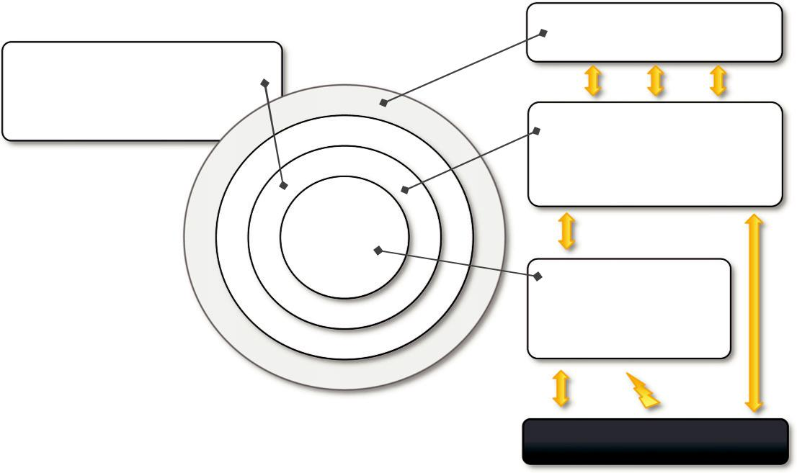

 |  | User Application
 |  | (Unmodified ABI)
Management Domain (Domain 0)
• VM Management | Ring 3
• HTTP interface | Ring 3
• Access to the Xen Hypervisor | Ring 2 | User Domains (Domain U)
 | Ring 2 | • Guest OS
 | Ring 1 | • Modified codebase
 | Ring 0 | • Hypercalls into Xen VMM
 |  | Privileged
 |  | instructions
 |  | Xen Hypervisor (VMM)
 |  | • Memory management
 |  | • CPU state registers
 |  | • Devices I/O
 |  | Hardware
 |  | trap
 |  | Hardware (x86)

FIGURE 3.11

Xen architecture and guest OS management.

operating systems are executed within domains, which represent virtual machine instances. Moreover, specific control software, which has privileged access to the host and controls all the other guest operating systems, is executed in a special domain called Domain 0. This is the first one that is loaded once the virtual machine manager has completely booted, and it hosts a HyperText Transfer Protocol (HTTP) server that serves requests for virtual machine creation, con-figuration, and termination. This component constitutes the embryonic version of a distributed vir-tual machine manager, which is an essential component of cloud computing systems providing Infrastructure-as-a-Service (IaaS) solutions.

Many of the x86 implementations support four different security levels, called rings, where Ring 0 represent the level with the highest privileges and Ring 3 the level with the lowest ones. Almost all the most popular operating systems, except OS/2, utilize only two levels: Ring 0 for the kernel code, and Ring 3 for user application and nonprivileged OS code. This provides the opportu-nity for Xen to implement virtualization by executing the hypervisor in Ring 0, Domain 0, and all the other domains running guest operating systems—generally referred to as Domain U—in Ring 1, while the user applications are run in Ring 3. This allows Xen to maintain the ABI unchanged, thus allowing an easy switch to Xen-virtualized solutions from an application point of view. Because of the structure of the x86 instruction set, some instructions allow code executing in Ring 3 to jump into Ring 0 (kernel mode). Such operation is performed at the hardware level and therefore within a virtualized environment will result in a trap or silent fault, thus preventing the normal operations of the guest operating system, since this is now running in Ring 1. This condition is generally trig-gered by a subset of the system calls. To avoid this situation, operating systems need to be changed in their implementation, and the sensitive system calls need to be reimplemented with hypercalls, which are specific calls exposed by the virtual machine interface of Xen. With the use of hyper-calls, the Xen hypervisor is able to catch the execution of all the sensitive instructions, manage them, and return the control to the guest operating system by means of a supplied handler.

Paravirtualization needs the operating system codebase to be modified, and hence not all operat-ing systems can be used as guests in a Xen-based environment. More precisely, this condition holds in a scenario where it is not possible to leverage hardware-assisted virtualization, which allows run-ning the hypervisor in Ring -1 and the guest operating system in Ring 0. Therefore, Xen exhibits some limitations in the case of legacy hardware and legacy operating systems. In fact, these cannot be modified to be run in Ring 1 safely since their codebase is not accessible and, at the same time, the underlying hardware does not provide any support to run the hypervisor in a more privileged mode than Ring 0. Open-source operating systems such as Linux can be easily modified, since their code is publicly available and Xen provides full support for their virtualization, whereas compo-nents of the Windows family are generally not supported by Xen unless hardware-assisted virtuali-zation is available. It can be observed that the problem is now becoming less and less crucial since both new releases of operating systems are designed to be virtualization aware and the new hardware supports x86 virtualization.

VMware: full virtualization

VMware’s technology is based on the concept of full virtualization, where the underlying hardware is replicated and made available to the guest operating system, which runs unaware of such abstrac-tion layers and does not need to be modified. VMware implements full virtualization either in the

desktop environment, by means of Type II hypervisors, or in the server environment, by means of Type I hypervisors. In both cases, full virtualization is made possible by means of direct execution (for nonsensitive instructions) and binary translation (for sensitive instructions), thus allowing the virtualization of architecture such as x86.

Besides these two core solutions, VMware provides additional tools and software that simplify the use of virtualization technology either in a desktop environment, with tools enhancing the inte-gration of virtual guests with the host, or in a server environment, with solutions for building and managing virtual computing infrastructures.

Full virtualization and binary translation

VMware is well known for the capability to virtualize x86 architectures, which runs unmodified on top of their hypervisors. With the new generation of hardware architectures and the introduction of hardware-assisted virtualization (Intel VT-x and AMD V) in 2006, full virtualization is made pos-sible with hardware support, but before that date, the use of dynamic binary translation was the only solution that allowed running x86 guest operating systems unmodified in a virtualized environment.

As discussed before, x86 architecture design does not satisfy the first theorem of virtualization, since the set of sensitive instructions is not a subset of the privileged instructions. This causes a dif-ferent behavior when such instructions are not executed in Ring 0, which is the normal case in a virtualization scenario where the guest OS is run in Ring 1. Generally, a trap is generated and the way it is managed differentiates the solutions in which virtualization is implemented for x86 hard-ware. In the case of dynamic binary translation, the trap triggers the translation of the offending instructions into an equivalent set of instructions that achieves the same goal without generating exceptions. Moreover, to improve performance, the equivalent set of instruction is cached so that translation is no longer necessary for further occurrences of the same instructions. Figure 3.12 gives an idea of the process.

This approach has both advantages and disadvantages. The major advantage is that guests can run unmodified in a virtualized environment, which is a crucial feature for operating systems for which source code is not available. This is the case, for example, of operating systems in the Windows family. Binary translation is a more portable solution for full virtualization. On the other hand, translating instructions at runtime introduces an additional overhead that is not present in other approaches (paravirtualization or hardware-assisted virtualization). Even though such disad-vantage exists, binary translation is applied to only a subset of the instruction set, whereas the others are managed through direct execution on the underlying hardware. This somehow reduces the impact on performance of binary translation.

CPU virtualization is only a component of a fully virtualized hardware environment. VMware achieves full virtualization by providing virtual representation of memory and I/O devices. Memory virtualization constitutes another challenge of virtualized environments and can deeply impact per-formance without the appropriate hardware support. The main reason is the presence of a memory management unit (MMU), which needs to be emulated as part of the virtual hardware. Especially in the case of hosted hypervisors (Type II), where the virtual MMU and the host-OS MMU are tra-versed sequentially before getting to the physical memory page, the impact on performance can be significant. To avoid nested translation, the translation look-aside buffer (TLB) in the virtual MMU directly maps physical pages, and the performance slowdown only occurs in case of a TLB miss.
Ring 3 | User Applications
Ring 3 | (Unmodified ABI)
Ring 2
Ring 1 | Guest Operating System
Ring 0 | Guest Operating System
Ring 0 | • Unmodified codebase
 | • VMM unaware
 | Hypervisor
 | • Binary translation
 | • Instruction caching
 | Hardware Trap
Dynamic / Cached Translation | (Sensitive
(Sensitive Instructions) | Instructions)
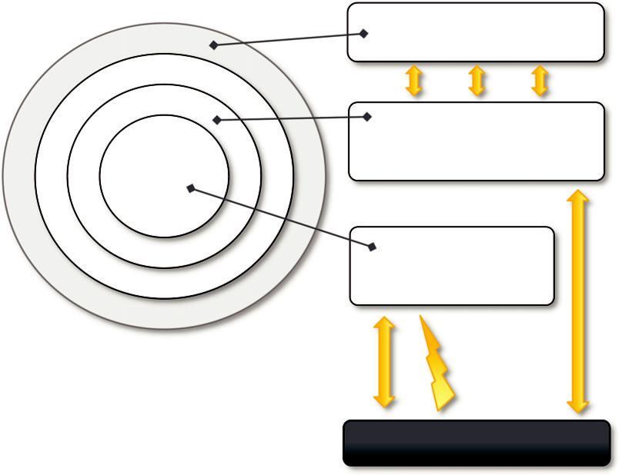

Hardware (x86)

FIGURE 3.12

A full virtualization reference model.

Finally, VMware also provides full virtualization of I/O devices such as network controllers and other peripherals such as keyboard, mouse, disks, and universal serial bus (USB) controllers.

Virtualization solutions

VMware is a pioneer in virtualization technology and offers a collection of virtualization solutions covering the entire range of the market, from desktop computing to enterprise computing and infra-structure virtualization.

End-user (desktop) virtualization

VMware supports virtualization of operating system environments and single applications on end-user computers. The first option is the most popular and allows installing a different operating systems and applications in a completely isolated environment from the hosting operating system. Specific VMware software—VMware Workstation, for Windows operating systems, and VMware Fusion, for Mac OS X environments—is installed in the host operating system to create virtual machines and manage their execution. Besides the creation of an isolated computing environment, the two products allow a guest operating system to leverage the resources of the host machine (USB devices, folder sharing, and integration with the graphical user interface (GUI) of the host operating system). Figure 3.13 provides an overview of the architecture of these systems.

The virtualization environment is created by an application installed in guest operating systems, which provides those operating systems with full hardware virtualization of the underlying
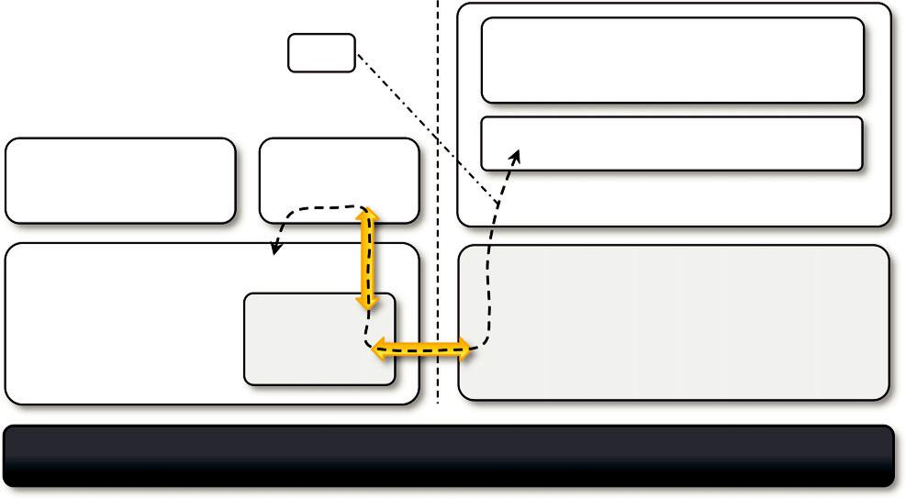

 | I/O | User Applications
 | VMware | Guest Operating System
User Applications | VMware
User Applications | Workstation
Virtual Machine Instance

Host Operating System | VMware Hypervisor (VMM)
VMware | • Direct access to hardware
VMware | • I/O, memory, networking for guests
Driver | • I/O, memory, networking for guests
Driver | • Save/Restore CPU state for host OS
Hardware (x86)
FIGURE 3.13

VMware workstation architecture.

hardware. This is done by installing a specific driver in the host operating system that provides two main services:

- It deploys a virtual machine manager that can run in privileged mode.

- It provides hooks for the VMware application to process specific I/O requests eventually by relaying such requests to the host operating system via system calls.

Using this architecture—also called Hosted Virtual Machine Architecture—it is possible to both iso-late virtual machine instances within the memory space of a single application and provide reasonable performance, since the intervention of the VMware application is required only for instructions, such as device I/O, that require binary translation. Instructions that can be directly executed are managed by the virtual machine manager, which takes control of the CPU and the MMU and alternates its activity with the host OS. Virtual machine images are saved in a collection of files on the host file system, and both VMware Workstation and VMware Fusion allow creation of new images, pause their execution, create snapshots, and undo operations by rolling back to a previous state of the virtual machine.

Other solutions related to the virtualization of end-user computing environments include VMware Player, VMware ACE, and VMware ThinApp. VMware Player is a reduced version of VMware Workstation that allows creating and playing virtual machines in a Windows or Linux operating envi-ronment. VMware ACE, a similar product to VMware Workstation, creates policy-wrapped virtual machines for deploying secure corporate virtual environments on end-user computers. VMware ThinApp is a solution for application virtualization. It provides an isolated environment for applica-tions in order to avoid conflicts due to versioning and incompatible applications. It detects all the changes to the operating environment made by the installation of a specific application and stores them together with the application binary into a package that can be run with VMware ThinApp.
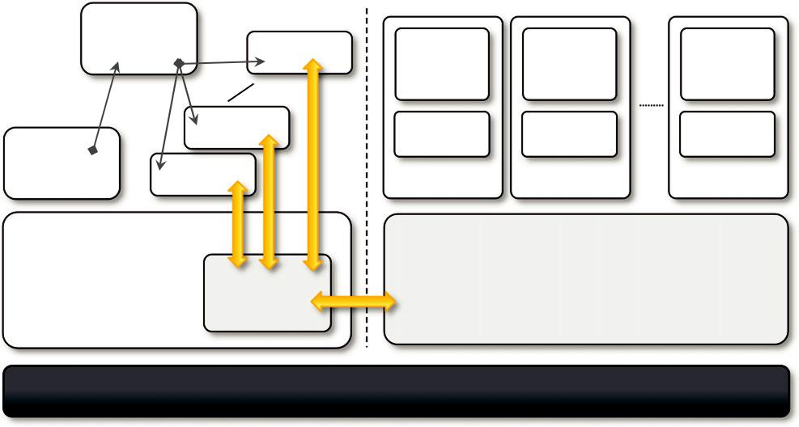

 | serverd
 | (daemon) | VMware
 |  | VMware
Web | VMware
Server |  |  | VM Instance VM Instance | VM Instance
Host Operating System |  |  | VMware Hypervisor (VMM)
 |  | VMware | • Direct access to hardware
 |  | VMware | • I/O, memory, networking for guests
 |  | Driver | • Save/Restore CPU state for host OS

Hardware (x86)

FIGURE 3.14

VMware GSX server architecture.

Server virtualization

VMware provided solutions for server virtualization with different approaches over time. Initial support for server virtualization was provided by VMware GSX server, which replicates the approach used for end-user computers and introduces remote management and scripting capabili-ties. The architecture of VMware GSX Server is depicted in Figure 3.14.

The architecture is mostly designed to serve the virtualization of Web servers. A daemon pro-cess, called serverd, controls and manages VMware application processes. These applications are then connected to the virtual machine instances by means of the VMware driver installed on the host operating system. Virtual machine instances are managed by the VMM as described previ-ously. User requests for virtual machine management and provisioning are routed from the Web server through the VMM by means of serverd.

VMware ESX Server and its enhanced version, VMWare ESXi Server, are examples of the hypervisor-based approach. Both can be installed on bare metal servers and provide services for virtual machine management. The two solutions provide the same services but differ in the internal architecture, more specifically in the organization of the hypervisor kernel. VMware ESX embeds a modified version of a Linux operating system, which provides access through a service console to hypervisor. VMware ESXi implements a very thin OS layer and replaces the service console with interfaces and services for remote management, thus considerably reducing the hypervisor code size and memory footprint.

The architecture of VMware ESXi is displayed in Figure 3.15. The base of the infrastructure is the VMkernel, which is a thin Portable Operating System Interface (POSIX) compliant operating system that provides the minimal functionality for processes and thread management, file system, I/O stacks, and resource scheduling. The kernel is accessible through specific APIs called User world API. These
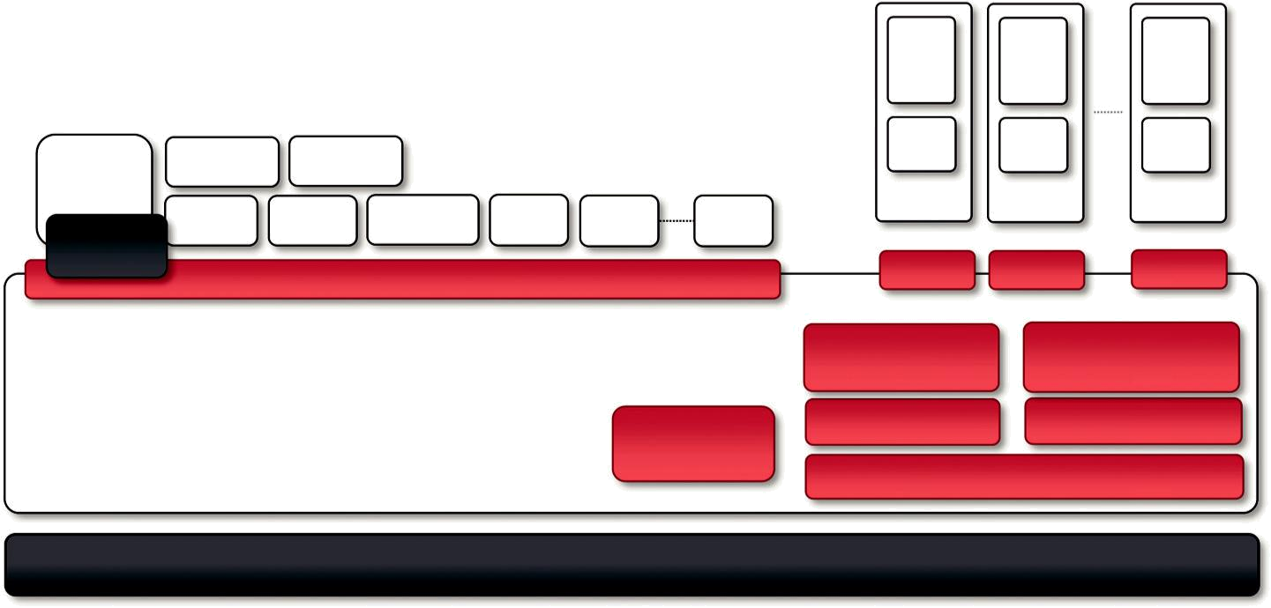

CIM | vxpa | SNMP
Broker |  |  |  |  |  |  | VM | VM | VM
 | hostd | DCUI | syslog | VMX | VMX | VMX | VM | VM | VM
Third-Party
CIM Plug-ins |  | User world API |  |  |  |  | VMM | VMM | VMM
 |  |  |  |  |  |  | Distributed VM | Virtual Ethernet
 |  |  |  |  |  |  | File System | Adapter and Switch
 |  |  |  |  |  | Resource | Storage Stack |  | Network Stack
 |  |  |  |  | Scheduling |  | Device Drivers
VMkernel

Hardware

FIGURE 3.15

VMware ESXi server architecture.

APIs are utilized by all the agents that provide supporting activities for the management of virtual machines. Remote management of an ESXi server is provided by the CIM Broker, a system agent that acts as a gateway to the VMkernel for clients by using the Common Information Model (CIM)⁸ proto-col. The ESXi installation can also be managed locally by a Direct Client User Interface (DCUI), which provides a BIOS-like interface for the management of local users.

Infrastructure virtualization and cloud computing solutions

VMware provides a set of products covering the entire stack of cloud computing, from infrastruc-ture management to Software-as-a-Service solutions hosted in the cloud. Figure 3.16 gives an overview of the different solutions offered and how they relate to each other.

ESX and ESXi constitute the building blocks of the solution for virtual infrastructure manage-ment: A pool of virtualized servers is tied together and remotely managed as a whole by VMware vSphere. As a virtualization platform it provides a set of basic services besides virtual compute ser-vices: Virtual file system, virtual storage, and virtual network constitute the core of the infrastruc-ture; application services, such as virtual machine migration, storage migration, data recovery, and
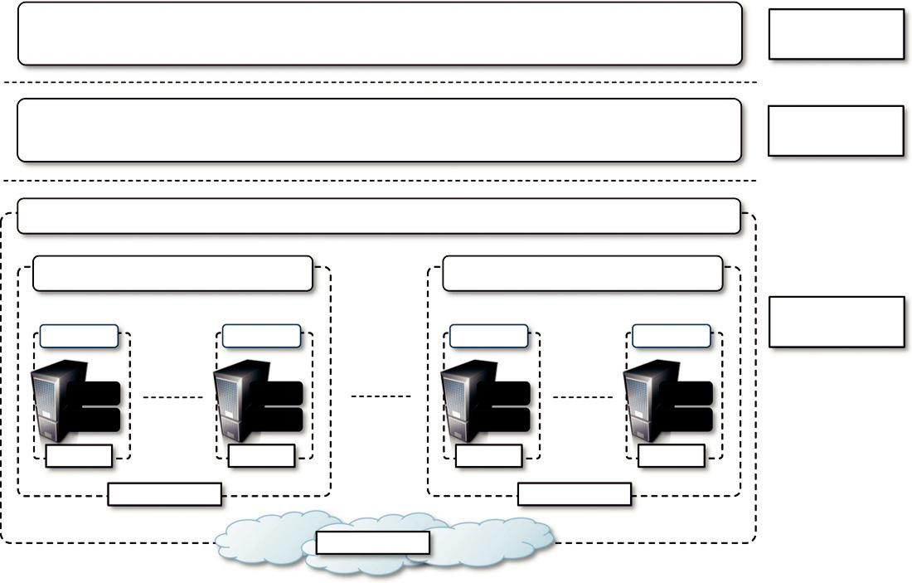

 |  | Zimbra |  | Application
 |  | Zimbra |  | Virtualization
 |  | vFabric |  | Platform
 |  | vFabric |  | Virtualization
 |  | vCloud
 | vCenter |  | vCenter
 |  |  |  | Infrastructure
vSphere | vSphere | vSphere | vSphere | Virtualization
ESXi | ESXi | ESXi | ESXi
ESX | ESX | ESX | ESX
Server | Server | Server | Server
 | Data Center |  | Data Center
 |  | Cloud

FIGURE 3.16

VMware Cloud Solution stack.

.

security zones, complete the services offered by vSphere. The management of the infrastructure is operated by VMware vCenter, which provides centralized administration and management of vSphere installations in a data center environment. A collection of virtualized data centers are turned into a Infrastructure-as-a-Service cloud by VMware vCloud, which allows service providers to make available to end users virtual computing environments on demand on a pay-per-use basis. A Web portal provides access to the provisioning services of vCloud, and end users can self-provision virtual machines by choosing from available templates and setting up virtual networks among virtual instances.

VMware also provides a solution for application development in the cloud with VMware vFabric, which is a set of components that facilitate the development of scalable Web applications on top of a virtualized infrastructure. vFabric is a collection of components for application monitor-ing, scalable data management, and scalable execution and provisioning of Java Web applications.

Finally, at the top of the cloud computing stack, VMware provides Zimbra, a solution for office automation, messaging, and collaboration that is completely hosted in the cloud and accessible from anywhere. This is an SaaS solution that integrates various features into a single software platform providing email and collaboration management.

Observations

Initially starting with a solution for fully virtualized x86 hardware, VMware has grown over time and now provides a complete offering for virtualizing hardware, infrastructure, applications, and services, thus covering every segment of the cloud computing market. Even though full x86 virtua-lization is the core technology of VMware, over time paravirtualization features have been inte-grated into some of the solutions offered by the vendor, especially after the introduction of hardware-assisted virtualization. For instance, the implementation of some device emulations and the VMware Tools suite that allows enhanced integration with the guest and the host operating environment. Also, VMware has strongly contributed to the development and standardization of a vendor-independent Virtual Machine Interface (VMI), which allows for a general and host-agnostic approach to paravirtualization.

Microsoft Hyper-V

Hyper-V is an infrastructure virtualization solution developed by Microsoft for server virtualization. As the name recalls, it uses a hypervisor-based approach to hardware virtualization, which leverages several techniques to support a variety of guest operating systems. Hyper-V is currently shipped as a component of Windows Server 2008 R2 that installs the hypervisor as a role within the server.

Architecture

Hyper-V supports multiple and concurrent execution of guest operating systems by means of parti-tions. A partition is a completely isolated environment in which an operating system is installed and run.

Figure 3.17 provides an overview of the architecture of Hyper-V. Despite its straightforward installation as a component of the host operating system, Hyper-V takes control of the hardware, and the host operating system becomes a virtual machine instance with special privileges, called
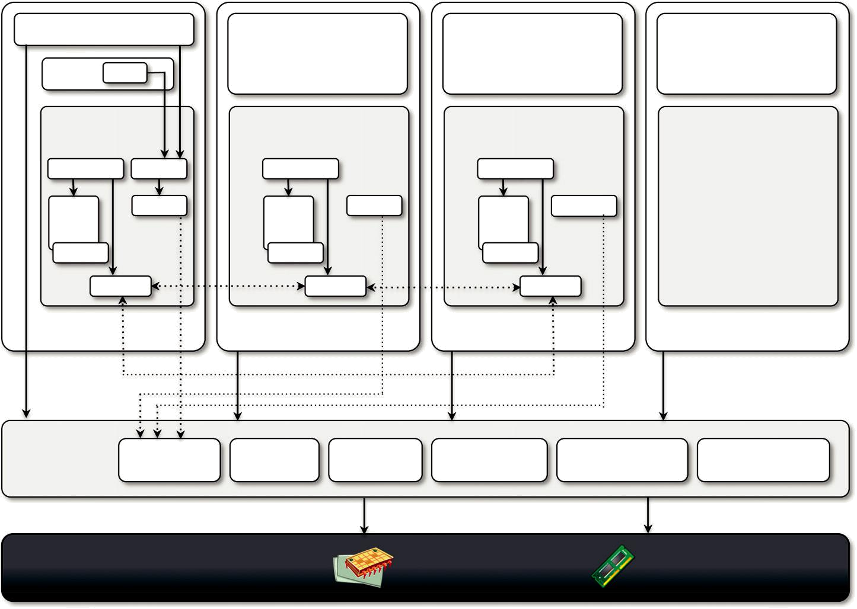
VMWPs
 |  | User Applications | User Applications | User Applications
VMMS | WMI | (Ring 3) | (Ring 3) | (Ring 3)
Hypervisor-aware |  | Hypervisor-aware | Hypervisor-aware | Hypervisor-unaware
Kernel (Ring 0) |  | Wndows Kernel (Ring 0) | Linux Kernel (Ring 0) | Kernel (Ring 0)
VSPs | VID | VSCs / ICs | VSCs / ICs
I/O | WinHv | WinHv | LinuxHv
I/O |  | I/O | I/O
Stack |  | Stack | Stack
Drivers |  | Drivers | Drivers
 | VMBus | VMBus | VMBus
Root / Parent Partition |  | Enlightened Child Partition | Enlightened Child Partition | Unenlightened Child
 |  | Enlightened Child Partition | Enlightened Child Partition | Partition

Hypervisor | Hypercalls | MSRs | APIC | Scheduler | Address | Partition
(Ring-1) |  |  |  |  | Management | Management

_{Hardware (x86)} Processor Memory

FIGURE 3.17

Microsoft Hyper-V architecture.

the parent partition. The parent partition (also called the root partition) is the only one that has direct access to the hardware. It runs the virtualization stack, hosts all the drivers required to configure guest operating systems, and creates child partitions through the hypervisor. Child parti-tions are used to host guest operating systems and do not have access to the underlying hardware, but their interaction with it is controlled by either the parent partition or the hypervisor itself.

Hypervisor

The hypervisor is the component that directly manages the underlying hardware (processors and memory). It is logically defined by the following components:

- Hypercalls interface. This is the entry point for all the partitions for the execution of sensitive instructions. This is an implementation of the paravirtualization approach already discussed with Xen. This interface is used by drivers in the partitioned operating system to contact the hypervisor using the standard Windows calling convention. The parent partition also uses this interface to create child partitions.

- Memory service routines (MSRs). These are the set of functionalities that control the memory and its access from partitions. By leveraging hardware-assisted virtualization, the hypervisor uses the Input/Output Memory Management Unit (I/O MMU or IOMMU) to fast-track access to devices from partitions by translating virtual memory addresses.

- Advanced programmable interrupt controller (APIC). This component represents the interrupt controller, which manages the signals coming from the underlying hardware when some event occurs (timer expired, I/O ready, exceptions and traps). Each virtual processor is equipped with a synthetic interrupt controller (SynIC), which constitutes an extension of the local APIC. The hypervisor is responsible of dispatching, when appropriate, the physical interrupts to the synthetic interrupt controllers.

- Scheduler. This component schedules the virtual processors to run on available physical processors. The scheduling is controlled by policies that are set by the parent partition.

- Address manager. This component is used to manage the virtual network addresses that are allocated to each guest operating system.

- Partition manager. This component is in charge of performing partition creation, finalization, destruction, enumeration, and configurations. Its services are available through the hypercalls interface API previously discussed.

The hypervisor runs in Ring -1 and therefore requires corresponding hardware technology that enables such a condition. By executing in this highly privileged mode, the hypervisor can support legacy operating systems that have been designed for x86 hardware. Operating systems of newer generations can take advantage of the new specific architecture of Hyper-V especially for the I/O operations performed by child partitions.

Enlightened I/O and synthetic devices

Enlightened I/O provides an optimized way to perform I/O operations, allowing guest operating systems to leverage an interpartition communication channel rather than traversing the hardware emulation stack provided by the hypervisor. This option is only available to guest operating sys-tems that are hypervisor aware. Enlightened I/O leverages VMBus, an interpartition communication

channel that is used to exchange data between partitions (child and parent) and is utilized mostly for the implementation of virtual device drivers for guest operating systems.

The architecture of Enlightened I/O is described in Figure 3.17. There are three fundamental components: VMBus, Virtual Service Providers (VSPs), and Virtual Service Clients (VSCs). VMBus implements the channel and defines the protocol for communication between partitions. VSPs are kernel-level drivers that are deployed in the parent partition and provide access to the corresponding hardware devices. These interact with VSCs, which represent the virtual device drivers (also called synthetic drivers) seen by the guest operating systems in the child partitions. Operating systems supported by Hyper-V utilize this preferred communication channel to perform I/O for storage, networking, graphics, and input subsystems. This also results in enhanced perfor-mance in child-to-child I/O as a result of virtual networks between guest operating systems. Legacy operating systems, which are not hypervisor aware, can still be run by Hyper-V but rely on device driver emulation, which is managed by the hypervisor and is less efficient.

Parent partition

The parent partition executes the host operating system and implements the virtualization stack that complements the activity of the hypervisor in running guest operating systems. This partition always hosts an instance of the Windows Server 2008 R2, which manages the virtualization stack made available to the child partitions. This partition is the only one that directly accesses device drivers and mediates the access to them by child partitions by hosting the VSPs.

The parent partition is also the one that manages the creation, execution, and destruction of child partitions. It does so by means of the Virtualization Infrastructure Driver (VID), which con-trols access to the hypervisor and allows the management of virtual processors and memory. For each child partition created, a Virtual Machine Worker Process (VMWP) is instantiated in the par-ent partition, which manages the child partitions by interacting with the hypervisor through the VID. Virtual Machine Management services are also accessible remotely through a WMI⁹ provider that allows remote hosts to access the VID.

Child partitions

Child partitions are used to execute guest operating systems. These are isolated environments that allow secure and controlled execution of guests. Two types of child partition exist, they differ on whether the guest operating system is supported by Hyper-V or not. These are called Enlightened and Unenlightened partitions, respectively. The first ones can benefit from Enlightened I/O; the other ones are executed by leveraging hardware emulation from the hypervisor.

Cloud computing and infrastructure management

Hyper-V constitutes the basic building block of Microsoft virtualization infrastructure. Other com-ponents contribute to creating a fully featured platform for server virtualization.

To increase the performance of virtualized environments, a new version of Windows Server 2008, called Windows Server Core, has been released. This is a specific version of the operating

system with a reduced set of features and a smaller footprint. In particular, Windows Server Core has been designed by removing those features, which are not required in a server environment, such as the GUI component and other bulky components such as the .NET Framework and all the applications developed on top of it (for example, PowerShell). This design decision has both advan-tages and disadvantages. On the plus side, it allows for reduced maintenance (i.e., fewer software patches), reduced attack surface, reduced management, and less disk space. On the negative side, the embedded features are reduced. Still, there is the opportunity to leverage all the “removed features” by means of remote management from a fully featured Windows installation. For instance, administrators can use the PowerShell to remotely manage the Windows Server Core installation through WMI.

Another component that provides advanced management of virtual machines is System Center Virtual Machine Manager (SCVMM) 2008. This is a component of the Microsoft System Center suite, which brings into the suite the virtual infrastructure management capabilities from an IT life-cycle point of view. Essentially, SCVMM complements the basic features offered by Hyper-V with management capabilities, including:

- Management portal for the creation and management of virtual instances

- Virtual to Virtual (V2V) and Physical to Virtual (P2V) conversions

- Delegated administration

- Library functionality and deep PowerShell integration

- Intelligent placement of virtual machines in the managed environment

- Host capacity management

SCVMM has also been designed to work with other virtualization platforms such as VMware vSphere (ESX servers) but benefits most from the virtual infrastructure management implemented with Hyper-V.

Observations

Compared with Xen and VMware, Hyper-V is a hybrid solution because it leverages both paravir-tualization techniques and full hardware virtualization.

The basic architecture of the hypervisor is based on paravirtualized architecture. The hypervisor exposes its services to the guest operating systems by means of hypercalls. Also, paravirtualized kernels can leverage VMBus for fast I/O operations. Moreover, partitions are conceptually similar to domains in Xen: The parent partition maps Domain 0, while child partitions map Domains U. The only difference is that the Xen hypervisor is installed on bare hardware and filters all the access to the underlying hardware, whereas Hyper-V is installed as a role in the existing operating system, and the way it interacts with partitions is quite similar to the strategy implemented by VMware, as we discussed.

The approach adopted by Hyper-V has both advantages and disadvantages. The advantages reside in a flexible virtualization platform supporting a wide range of guest operating systems. The disadvantages are represented by both hardware and software requirements. Hyper-V is compatible only with Windows Server 2008 and newer Windows Server platforms running on a x64 architec-ture. Moreover, it requires a 64-bit processor supporting hardware-assisted virtualization and data execution prevention. Finally, as noted above, Hyper-V is a role that can be installed on a existing operating system, while vSphere and Xen can be installed on the bare hardware.

Cloud Computing Architecture

The term cloud computing is a wide umbrella encompassing many different things; lately it has become a buzzword that is easily misused to revamp existing technologies and ideas for the public. What makes cloud computing so interesting to IT stakeholders and research practitioners? How does it introduce innovation into the field of distributed computing? This chapter addresses all these questions and characterizes the phenomenon. It provides a reference model that serves as a basis for discussion of cloud computing technologies.

Introduction

Utility-oriented data centers are the first outcome of cloud computing, and they serve as the infra-structure through which the services are implemented and delivered. Any cloud service, whether virtual hardware, development platform, or application software, relies on a distributed infrastruc-ture owned by the provider or rented from a third party. As noted in the previous definition, the characterization of a cloud is quite general: It can be implemented using a datacenter, a collection of clusters, or a heterogeneous distributed system composed of desktop PCs, workstations, and ser-vers. Commonly, clouds are built by relying on one or more datacenters. In most cases hardware resources are virtualized to provide isolation of workloads and to best exploit the infrastructure. According to the specific service delivered to the end user, different layers can be stacked on top of the virtual infrastructure: a virtual machine manager, a development platform, or a specific appli-cation middleware.

As noted in earlier chapters, the cloud computing paradigm emerged as a result of the conver-gence of various existing models, technologies, and concepts that changed the way we deliver and use IT services. A broad definition of the phenomenon could be as follows:

Cloud computing is a utility-oriented and Internet-centric way of delivering IT services on demand. These services cover the entire computing stack: from the hardware infrastructure pack-aged as a set of virtual machines to software services such as development platforms and distrib-uted applications.

This definition captures the most important and fundamental aspects of cloud computing. We now discuss a reference model that aids in categorization of cloud technologies, applications, and services.

The cloud reference model

Cloud computing supports any IT service that can be consumed as a utility and delivered through a network, most likely the Internet. Such characterization includes quite different aspects: infrastruc-ture, development platforms, application and services.

Architecture

It is possible to organize all the concrete realizations of cloud computing into a layered view cover-ing the entire stack (see Figure 4.1), from hardware appliances to software systems. Cloud resources are harnessed to offer “computing horsepower” required for providing services. Often, this layer is implemented using a datacenter in which hundreds and thousands of nodes are stacked together. Cloud infrastructure can be heterogeneous in nature because a variety of resources, such as clusters and even networked PCs, can be used to build it. Moreover, database systems and other storage services can also be part of the infrastructure.

The physical infrastructure is managed by the core middleware, the objectives of which are to provide an appropriate runtime environment for applications and to best utilize resources. At the bottom of the stack, virtualization technologies are used to guarantee runtime environment customi-zation, application isolation, sandboxing, and quality of service. Hardware virtualization is most commonly used at this level. Hypervisors manage the pool of resources and expose the distributed infrastructure as a collection of virtual machines. By using virtual machine technology it is possible to finely partition the hardware resources such as CPU and memory and to virtualize specific devices, thus meeting the requirements of users and applications. This solution is generally paired
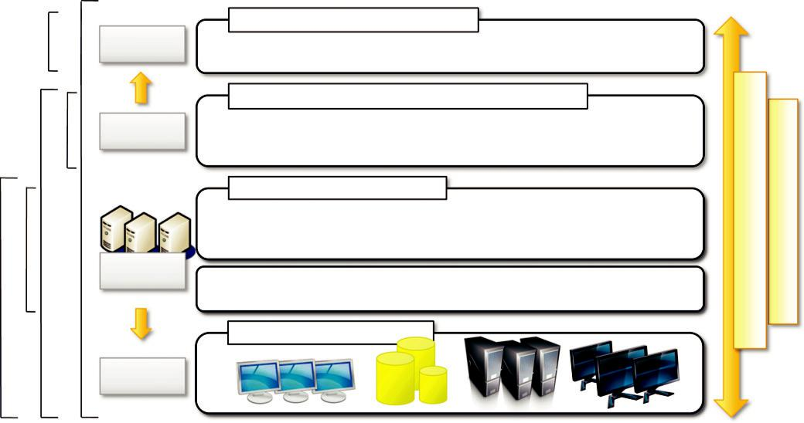

SaaS
PurePaaSPureSaaS

PaaS

IaaS(M)IaaS

User | Cloud Applications
User | Social Computing, Enterprise ISV, ScientificComputing, CDNs
Applications | Social Computing, Enterprise ISV, ScientificComputing, CDNs
 | Cloud Programming Environment and Tools
User-level | Web 2.0, Mashups, Concurrent and Distributed Programming,
Middleware | Web 2.0, Mashups, Concurrent and Distributed Programming,
Middleware | Workflows , Libraries, Scripting
 | Cloud Hosting Platforms
 | QoS Negotiation, Admission ControlPricing, SLA Management,
 | Monitoring, Execution Management, Metering, Accounting
Core
Middleware | Virtual Machine (VM), VM Management and Deployment
 | Cloud Resources
System
Infrastructure

ManagementAdaptive | EconomyCloudAutonomic

FIGURE 4.1

The cloud computing architecture.

with storage and network virtualization strategies, which allow the infrastructure to be completely virtualized and controlled. According to the specific service offered to end users, other virtualiza-tion techniques can be used; for example, programming-level virtualization helps in creating a portable runtime environment where applications can be run and controlled. This scenario generally implies that applications hosted in the cloud be developed with a specific technology or a program-ming language, such as Java, .NET, or Python. In this case, the user does not have to build its sys-tem from bare metal. Infrastructure management is the key function of core middleware, which supports capabilities such as negotiation of the quality of service, admission control, execution management and monitoring, accounting, and billing.

The combination of cloud hosting platforms and resources is generally classified as a Infrastructure-as-a-Service (IaaS) solution. We can organize the different examples of IaaS into two categories: Some of them provide both the management layer and the physical infrastructure; others provide only the management layer (IaaS (M)). In this second case, the management layer is often integrated with other IaaS solutions that provide physical infrastructure and adds value to them.

IaaS solutions are suitable for designing the system infrastructure but provide limited services to build applications. Such service is provided by cloud programming environments and tools, which form a new layer for offering users a development platform for applications. The range of tools include Web-based interfaces, command-line tools, and frameworks for concurrent and dis-tributed programming. In this scenario, users develop their applications specifically for the cloud by using the API exposed at the user-level middleware. For this reason, this approach is also known as Platform-as-a-Service (PaaS) because the service offered to the user is a development platform rather than an infrastructure. PaaS solutions generally include the infrastructure as well, which is bundled as part of the service provided to users. In the case of Pure PaaS, only the user-level mid-dleware is offered, and it has to be complemented with a virtual or physical infrastructure.

The top layer of the reference model depicted in Figure 4.1 contains services delivered at the application level. These are mostly referred to as Software-as-a-Service (SaaS). In most cases these are Web-based applications that rely on the cloud to provide service to end users. The horsepower of the cloud provided by IaaS and PaaS solutions allows independent software vendors to deliver their application services over the Internet. Other applications belonging to this layer are those that strongly leverage the Internet for their core functionalities that rely on the cloud to sustain a larger number of users; this is the case of gaming portals and, in general, social networking websites.

As a vision, any service offered in the cloud computing style should be able to adaptively change and expose an autonomic behavior, in particular for its availability and performance. As a reference model, it is then expected to have an adaptive management layer in charge of elastically scaling on demand. SaaS implementations should feature such behavior automatically, whereas PaaS and IaaS generally provide this functionality as a part of the API exposed to users.

The reference model described in Figure 4.1 also introduces the concept of everything as a Service (XaaS). This is one of the most important elements of cloud computing: Cloud services from different providers can be combined to provide a completely integrated solution covering all the computing stack of a system. IaaS providers can offer the bare metal in terms of virtual machines where PaaS solutions are deployed. When there is no need for a PaaS layer, it is possible to directly customize the virtual infrastructure with the software stack needed to run applications. This is the case of virtual Web farms: a distributed system composed of Web servers, database

servers, and load balancers on top of which prepackaged software is installed to run Web applica-tions. This possibility has made cloud computing an interesting option for reducing startups’ capital investment in IT, allowing them to quickly commercialize their ideas and grow their infrastructure according to their revenues.

Table 4.1 summarizes the characteristics of the three major categories used to classify cloud computing solutions. In the following section, we briefly discuss these characteristics along with some references to practical implementations.

Infrastructure- and hardware-as-a-service

Infrastructure- and Hardware-as-a-Service (IaaS/HaaS) solutions are the most popular and devel-oped market segment of cloud computing. They deliver customizable infrastructure on demand. The available options within the IaaS offering umbrella range from single servers to entire infra-structures, including network devices, load balancers, and database and Web servers.

The main technology used to deliver and implement these solutions is hardware virtualization: one or more virtual machines opportunely configured and interconnected define the distributed sys-tem on top of which applications are installed and deployed. Virtual machines also constitute the atomic components that are deployed and priced according to the specific features of the virtual hardware: memory, number of processors, and disk storage. IaaS/HaaS solutions bring all the bene-fits of hardware virtualization: workload partitioning, application isolation, sandboxing, and hard-ware tuning. From the perspective of the service provider, IaaS/HaaS allows better exploiting the IT infrastructure and provides a more secure environment where executing third party applications. From the perspective of the customer it reduces the administration and maintenance cost as well as the capital costs allocated to purchase hardware. At the same time, users can take advantage of the full customization offered by virtualization to deploy their infrastructure in the cloud; in most cases virtual machines come with only the selected operating system installed and the system can be


Table 4.1 Cloud Computing Services Classification

 |  |  |  | Vendors and
Category | Characteristics | Product Type |  | Products
SaaS | Customers are provided with applications that | Web applications and | SalesForce.com
 | are accessible anytime and from anywhere. | services (Web 2.0) | (CRM)
 |  |  | Clarizen.com (project
 |  |  | management)
 |  |  | Google Apps
PaaS | Customers are provided with a platform for | Programming APIs and |  | Google AppEngine
 | developing applications hosted in the cloud. | frameworks |  | Microsoft Azure
 |  | Deployment systems |  | Manjrasoft Aneka
 |  |  |  | Data Synapse
IaaS/HaaS | Customers are provided with virtualized | Virtual machine |  | Amazon EC2 and S3
 | hardware and storage on top of which they | management |  | GoGrid
 | can build their infrastructure. | infrastructure |  | Nirvanix
 |  | Storage management
 |  | Network management

configured with all the required packages and applications. Other solutions provide prepackaged system images that already contain the software stack required for the most common uses: Web servers, database servers, or LAMP¹ stacks. Besides the basic virtual machine management capabil-ities, additional services can be provided, generally including the following: SLA resource-based allocation, workload management, support for infrastructure design through advanced Web inter-faces, and the ability to integrate third-party IaaS solutions.

Figure 4.2 provides an overall view of the components forming an Infrastructure-as-a-Service solution. It is possible to distinguish three principal layers: the physical infrastructure, the software management infrastructure, and the user interface. At the top layer the user interface provides access to the services exposed by the software management infrastructure. Such an interface is
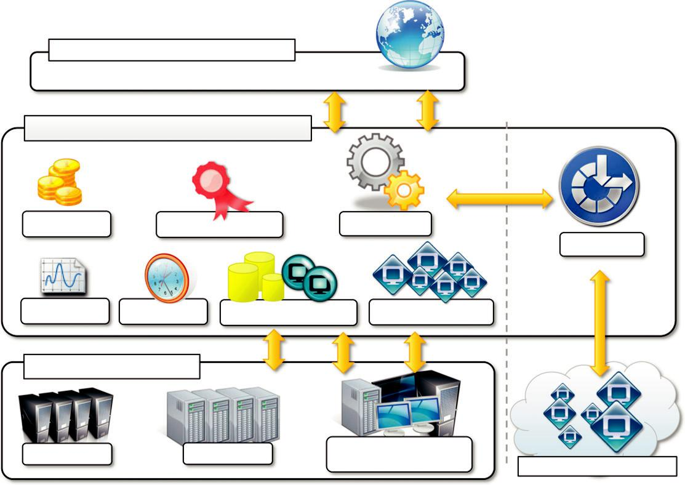

Web-Based Management Interface

Web Services, Portals, REST API

Infrastructure Management Software

Pricing / Billing QoS SLA Management Scheduling

Provisioning

Monitoring Reservation VM Image Repository VM Pool Management

Physical Infrastructure

Datacenter | Cluster | Desktop /
Datacenter | Cluster | Heterogeneous Resources | Third-Party IaaS Cloud

FIGURE 4.2

Infrastructure-as-a-Service reference implementation.

generally based on Web 2.0 technologies: Web services, RESTful APIs, and mash-ups. These tech-nologies allow either applications or final users to access the services exposed by the underlying infrastructure. Web 2.0 applications allow developing full-featured management consoles completely hosted in a browser or a Web page. Web services and RESTful APIs allow programs to interact with the service without human intervention, thus providing complete integration within a software system. The core features of an IaaS solution are implemented in the infrastructure management soft-ware layer. In particular, management of the virtual machines is the most important function performed by this layer. A central role is played by the scheduler, which is in charge of allocating the execution of virtual machine instances. The scheduler interacts with the other components that perform a variety of tasks:

- The pricing and billing component takes care of the cost of executing each virtual machine instance and maintains data that will be used to charge the user.

- The monitoring component tracks the execution of each virtual machine instance and maintains data required for reporting and analyzing the performance of the system.

- The reservation component stores the information of all the virtual machine instances that have been executed or that will be executed in the future.

- If support for QoS-based execution is provided, a QoS/SLA management component will maintain a repository of all the SLAs made with the users; together with the monitoring component, this component is used to ensure that a given virtual machine instance is executed with the desired quality of service.

- The VM repository component provides a catalog of virtual machine images that users can use to create virtual instances. Some implementations also allow users to upload their specific virtual machine images.

- A VM pool manager component is responsible for keeping track of all the live instances.

- Finally, if the system supports the integration of additional resources belonging to a third-party IaaS provider, a provisioning component interacts with the scheduler to provide a virtual machine instance that is external to the local physical infrastructure directly managed by the pool.

The bottom layer is composed of the physical infrastructure, on top of which the management layer operates. As previously discussed, the infrastructure can be of different types; the specific infrastructure used depends on the specific use of the cloud. A service provider will most likely use a massive datacenter containing hundreds or thousands of nodes. A cloud infrastructure developed in house, in a small or medium-sized enterprise or within a university department, will most likely rely on a cluster. At the bottom of the scale it is also possible to consider a heterogeneous environ-ment where different types of resources—PCs, workstations, and clusters—can be aggregated. This case mostly represents an evolution of desktop grids where any available computing resource (such as PCs and workstations that are idle outside of working hours) is harnessed to provide a huge com-pute power. From an architectural point of view, the physical layer also includes the virtual resources that are rented from external IaaS providers.

In the case of complete IaaS solutions, all three levels are offered as service. This is generally the case with public clouds vendors such as Amazon, GoGrid, Joyent, Rightscale, Terremark, Rackspace, ElasticHosts, and Flexiscale, which own large datacenters and give access to their com-puting infrastructures using an IaaS approach. Other solutions instead cover only the user interface

and the infrastructure software management layers. They need to provide credentials to access third-party IaaS providers or to own a private infrastructure in which the management software is installed. This is the case with Enomaly, Elastra, Eucalyptus, OpenNebula, and specific IaaS (M) solutions from VMware, IBM, and Microsoft.

The proposed architecture only represents a reference model for IaaS implementations. It has been used to provide general insight into the most common features of this approach for providing cloud computing services and the operations commonly implemented at this level. Different solu-tions can feature additional services or even not provide support for some of the features discussed here. Finally, the reference architecture applies to IaaS implementations that provide computing resources, especially for the scheduling component. If storage is the main service provided, it is still possible to distinguish these three layers. The role of infrastructure management software is not to keep track and manage the execution of virtual machines but to provide access to large infrastruc-tures and implement storage virtualization solutions on top of the physical layer.

Platform as a service

Platform-as-a-Service (PaaS) solutions provide a development and deployment platform for running applications in the cloud. They constitute the middleware on top of which applications are built. A general overview of the features characterizing the PaaS approach is given in Figure 4.3.
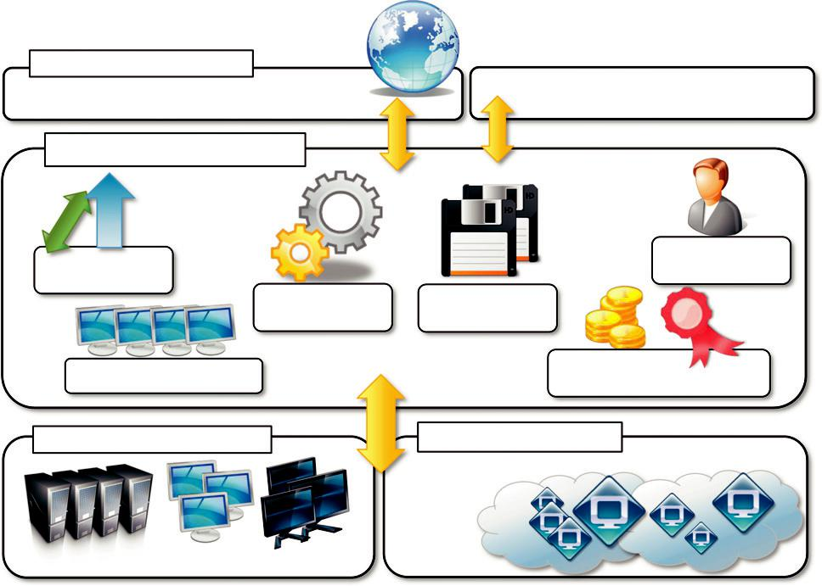

Web-Based Interface
Web Services, Portals, REST API | Programming API / Libraries
PaaS Core Middleware
Elasticity & | User
Elasticity & | Management
Scaling | Management
Scaling | Application
Runtime | Application
Runtime | Management
Resources Management | QoS / SLA Management &
Resources Management | Billing
Physical Infrastructure | IaaS Providers

FIGURE 4.3

The Platform-as-a-Service reference model.

Application management is the core functionality of the middleware. PaaS implementations pro-vide applications with a runtime environment and do not expose any service for managing the underlying infrastructure. They automate the process of deploying applications to the infrastructure, configuring application components, provisioning and configuring supporting technologies such as load balancers and databases, and managing system change based on policies set by the user. Developers design their systems in terms of applications and are not concerned with hardware (physical or virtual), operating systems, and other low-level services. The core middleware is in charge of managing the resources and scaling applications on demand or automatically, according to the commitments made with users. From a user point of view, the core middleware exposes interfaces that allow programming and deploying applications on the cloud. These can be in the form of a Web-based interface or in the form of programming APIs and libraries.

The specific development model decided for applications determines the interface exposed to the user. Some implementations provide a completely Web-based interface hosted in the cloud and offering a variety of services. It is possible to find integrated developed environments based on 4GL and visual programming concepts, or rapid prototyping environments where applications are built by assembling mash-ups and user-defined components and successively customized. Other implementations of the PaaS model provide a complete object model for representing an applica-tion and provide a programming language-based approach. This approach generally offers more flexibility and opportunities but incurs longer development cycles. Developers generally have the full power of programming languages such as Java, .NET, Python, or Ruby, with some restrictions to provide better scalability and security. In this case the traditional development environments can be used to design and develop applications, which are then deployed on the cloud by using the APIs exposed by the PaaS provider. Specific components can be offered together with the develop-ment libraries for better exploiting the services offered by the PaaS environment. Sometimes a local runtime environment that simulates the conditions of the cloud is given to users for testing their applications before deployment. This environment can be restricted in terms of features, and it is generally not optimized for scaling.

PaaS solutions can offer middleware for developing applications together with the infrastructure or simply provide users with the software that is installed on the user premises. In the first case, the PaaS provider also owns large datacenters where applications are executed; in the second case, referred to in this book as Pure PaaS, the middleware constitutes the core value of the offering. It is also possible to have vendors that deliver both middleware and infrastructure and ship only the middleware for private installations.

Table 4.2 provides a classification of the most popular PaaS implementations. It is possible to organize the various solutions into three wide categories: PaaS-I, PaaS-II, and PaaS-III. The first category identifies PaaS implementations that completely follow the cloud computing style for application development and deployment. They offer an integrated development environment hosted within the Web browser where applications are designed, developed, composed, and deployed. This is the case of Force.com and Longjump. Both deliver as platforms the combination of middleware and infrastructure. In the second class we can list all those solutions that are focused on providing a scalable infrastructure for Web application, mostly websites. In this case, developers generally use the providers’ APIs, which are built on top of industrial runtimes, to develop


Table 4.2 Platform-as-a-Service Offering Classification

 |  |  | Vendors and
Category | Description | Product Type | Products
PaaS-I | Runtime environment with Web-hosted | Middleware 1 Infrastructure | Force.com
 | application development platform. Rapid | Middleware 1 Infrastructure | Longjump
 | application prototyping.
PaaS-II | Runtime environment for scaling Web | Middleware 1 Infrastructure | Google AppEngine
 | applications. The runtime could be | Middleware | AppScale
 | enhanced by additional components that | Middleware 1 Infrastructure | Heroku
 | provide scaling capabilities. | Middleware 1 Infrastructure | Engine Yard
 |  | Middleware 1 Infrastructure | Joyent Smart
 |  | Middleware | Platform
 |  |  | GigaSpaces XAP
PaaS-III | Middleware and programming model for | Middleware 1 Infrastructure | Microsoft Azure
 | developing distributed applications in the | Middleware | DataSynapse
 | cloud. | Middleware | Cloud IQ
 |  | Middleware | Manjrasof Aneka
 |  | Middleware | Apprenda
 |  | Middleware | SaaSGrid
 |  |  | GigaSpaces
 |  |  | DataGrid

applications. Google AppEngine is the most popular product in this category. It provides a scalable runtime based on the Java and Python programming languages, which have been modified for pro-viding a secure runtime environment and enriched with additional APIs and components to support scalability. AppScale, an open-source implementation of Google AppEngine, provides interface-compatible middleware that has to be installed on a physical infrastructure. Joyent Smart Platform provides a similar approach to Google AppEngine. A different approach is taken by Heroku and Engine Yard, which provide scalability support for Ruby- and Ruby on Rails-based Websites. In this case developers design and create their applications with the traditional methods and then deploy them by uploading to the provider’s platform.

The third category consists of all those solutions that provide a cloud programming platform for any kind of application, not only Web applications. Among these, the most popular is Microsoft Windows Azure, which provides a comprehensive framework for building service-oriented cloud applications on top of the .NET technology, hosted on Microsoft’s datacenters. Other solutions in the same category, such as Manjrasoft Aneka, Apprenda SaaSGrid, Appistry Cloud IQ Platform, DataSynapse, and GigaSpaces DataGrid, provide only middleware with differ-ent services. Table 4.2 shows only a few options available in the Platform-as-a-Service market segment.

The PaaS umbrella encompasses a variety of solutions for developing and hosting applications in the cloud. Despite this heterogeneity, it is possible to identify some criteria that are expected to

be found in any implementation. As noted by Sam Charrington, product manager at Appistry.com,² there are some essential characteristics that identify a PaaS solution:

- Runtime framework. This framework represents the “software stack” of the PaaS model and the most intuitive aspect that comes to people’s minds when they refer to PaaS solutions. The runtime framework executes end-user code according to the policies set by the user and the provider.

- Abstraction. PaaS solutions are distinguished by the higher level of abstraction that they provide. Whereas in the case of IaaS solutions the focus is on delivering “raw” access to virtual or physical infrastructure, in the case of PaaS the focus is on the applications the cloud must support. This means that PaaS solutions offer a way to deploy and manage applications on the cloud rather than a bunch of virtual machines on top of which the IT infrastructure is built and configured.

- Automation. PaaS environments automate the process of deploying applications to the infrastructure, scaling them by provisioning additional resources when needed. This process is performed automatically and according to the SLA made between the customers and the provider. This feature is normally not native in IaaS solutions, which only provide ways to provision more resources.

- Cloud services. PaaS offerings provide developers and architects with services and APIs, helping them to simplify the creation and delivery of elastic and highly available cloud applications. These services are the key differentiators among competing PaaS solutions and generally include specific components for developing applications, advanced services for application monitoring, management, and reporting.

Another essential component for a PaaS-based approach is the ability to integrate third-party cloud services offered from other vendors by leveraging service-oriented architecture. Such inte-gration should happen through standard interfaces and protocols. This opportunity makes the development of applications more agile and able to evolve according to the needs of customers and users. Many of the PaaS offerings provide this facility, which is naturally built into the frame-work they leverage to provide a cloud computing solution.

One of the major concerns of leveraging PaaS solutions for implementing applications is vendor lock-in. Differently from IaaS solutions, which deliver bare virtual servers that can be fully custom-ized in terms of the software stack installed, PaaS environments deliver a platform for developing applications, which exposes a well-defined set of APIs and, in most cases, binds the application to the specific runtime of the PaaS provider. Even though a platform-based approach strongly simpli-fies the development and deployment cycle of applications, it poses the risk of making these appli-cations completely dependent on the provider. Such dependency can become a significant obstacle in retargeting the application to another environment and runtime if the commitments made with the provider cease. The impact of the vendor lock-in on applications obviously varies according to the various solutions. Some of them, such as Force.com, rely on a proprietary runtime framework, which makes the retargeting process very difficult. Others, such as Google AppEngine and Microsoft Azure, rely on industry-standard runtimes but utilize private data storage facilities and

computing infrastructure. In this case it is possible to find alternatives based on PaaS solutions implementing the same interfaces, with perhaps different performance. Others, such as Appistry Cloud IQ Platform, Heroku, and Engine Yard, completely rely on open standards, thus making the migration of applications easier.

Finally, from a financial standpoint, although IaaS solutions allow shifting the capital cost into operational costs through outsourcing, PaaS solutions can cut the cost across development, deploy-ment, and management of applications. It helps management reduce the risk of ever-changing tech-nologies by offloading the cost of upgrading the technology to the PaaS provider. This happens transparently for the consumers of this model, who can concentrate their effort on the core value of their business. The PaaS approach, when bundled with underlying IaaS solutions, helps even small start-up companies quickly offer customers integrated solutions on a hosted platform at a very mini-mal cost. These opportunities make the PaaS offering a viable option that targets different market segments.

Software as a service

Software-as-a-Service (SaaS) is a software delivery model that provides access to applications through the Internet as a Web-based service. It provides a means to free users from complex hard-ware and software management by offloading such tasks to third parties, which build applications accessible to multiple users through a Web browser. In this scenario, customers neither need install anything on their premises nor have to pay considerable up-front costs to purchase the software and the required licenses. They simply access the application website, enter their credentials and billing details, and can instantly use the application, which, in most of the cases, can be further customized for their needs. On the provider side, the specific details and features of each customer’s applica-tion are maintained in the infrastructure and made available on demand.

The SaaS model is appealing for applications serving a wide range of users and that can be adapted to specific needs with little further customization. This requirement characterizes SaaS as a “one-to-many” software delivery model, whereby an application is shared across multiple users. This is the case of CRM³ and ERP⁴ applications that constitute common needs for almost all enter-prises, from small to medium-sized and large business. Every enterprise will have the same requirements for the basic features concerning CRM and ERP; different needs can be satisfied with further customization. This scenario facilitates the development of software platforms that provide a general set of features and support specialization and ease of integration of new components. Moreover, it constitutes the perfect candidate for hosted solutions, since the applications delivered to the user are the same, and the applications themselves provide users with the means to shape the

applications according to user needs. As a result, SaaS applications are naturally multitenant. Multitenancy, which is a feature of SaaS compared to traditional packaged software, allows provi-ders to centralize and sustain the effort of managing large hardware infrastructures, maintaining and upgrading applications transparently to the users, and optimizing resources by sharing the costs among the large user base. On the customer side, such costs constitute a minimal fraction of the usage fee paid for the software.

As noted previously (see Section 1.2), the concept of software as a service preceded cloud com-puting, starting to circulate at the end of the 1990s, when it began to gain marketplace acceptance

- The acronym SaaS was then coined in 2001 by the Software Information & Industry Association (SIIA) [32] with the following connotation:

In the software as a service model, the application, or service, is deployed from a centralized datacenter across a network—Internet, Intranet, LAN, or VPN—providing access and use on a recurring fee basis. Users “rent,” “subscribe to,” “are assigned,” or “are granted access to” the applications from a central provider. Business models vary according to the level to which the software is streamlined, to lower price and increase efficiency, or value-added through cus-tomization to further improve digitized business processes.

The analysis carried out by SIIA was mainly oriented to cover application service providers (ASPs) and all their variations, which capture the concept of software applications consumed as a service in a broader sense. ASPs already had some of the core characteristics of SaaS:

- The product sold to customer is application access.

- The application is centrally managed.

- The service delivered is one-to-many.

- The service delivered is an integrated solution delivered on the contract, which means provided as promised.

Initially ASPs offered hosting solutions for packaged applications, which were served to multi-ple customers. Successively, other options, such as Web-based integration of third-party application services, started to gain interest and a new range of opportunities open up to independent software vendors and service providers. These opportunities eventually evolved into a more flexible model to deliver applications as a service: the SaaS model. ASPs provided access to packaged software solutions that addressed the needs of a variety of customers. Initially this approach was affordable for service providers, but it later became inconvenient when the cost of customizations and speciali-zations increased. The SaaS approach introduces a more flexible way of delivering application ser-vices that are fully customizable by the user by integrating new services, injecting their own components, and designing the application and information workflows. Such a new approach has also been possible with the support of Web 2.0 technologies, which allowed turning the Web browser into a full-featured interface, able even to support application composition and development.

How is cloud computing related to SaaS? According to the classification of services shown in Figure 4.1, the SaaS approach lays on top of the cloud computing stack. It fits into the cloud com-puting vision expressed by the XaaS acronym, Everything-as-a-Service; and with SaaS, applications

are delivered as a service. Initially the SaaS model was of interest only for lead users and early adopters. The benefits delivered at that stage were the following:

- Software cost reduction and total cost of ownership (TCO) were paramount

- Service-level improvements

- Rapid implementation

- Standalone and configurable applications

- Rudimentary application and data integration

- Subscription and pay-as-you-go (PAYG) pricing

With the advent of cloud computing there has been an increasing acceptance of SaaS as a viable software delivery model. This led to transition into SaaS 2.0 [40], which does not introduce a new technology but transforms the way in which SaaS is used.

In particular, SaaS 2.0 is focused on providing a more robust infrastructure and application plat-forms driven by SLAs. Rather than being characterized as a more rapid implementation and deploy-ment environment, SaaS 2.0 will focus on the rapid achievement of business objectives. This is why such evolution does not introduce any new technology: The existing technologies are com-posed together in order to achieve business goals efficiently. Fundamental to this perspective is the ability to leverage existing solutions and integrate value-added business services. The existing SaaS infrastructures not only allow the development and customization of applications, but they also facilitate the integration of services that are exposed by other parties. SaaS applications are then the result of the interconnection and the synergy of different applications and components that together provide customers with added value. This approach dramatically changes the software ecosystem of the SaaS market, which is no longer monopolized by a few vendors but is now a fully intercon-nected network of service providers, clustered around some “big hubs” that deliver the application to the customer. In this scenario, each single component integrated into the SaaS application becomes responsible to the user for ensuring the attached SLA and at the same time could be priced differently. Customers can then choose how to specialize their applications by deciding which com-ponents and services they want to integrate.

Software-as-a-Service applications can serve different needs. CRM, ERP, and social networking applications are definitely the most popular ones. SalesForce.com is probably the most successful and popular example of a CRM service. It provides a wide range of services for applications: customer relationship and human resource management, enterprise resource planning, and many other features. SalesForce.com builds on top of the Force.com platform, which provides a fully featured environment for building applications. It offers either a programming language or a visual environment to arrange components together for building applications. In addition to the basic features provided, the integra-tion with third-party-made applications enriches SalesForce.com’s value. In particular, through AppExchange customers can publish, search, and integrate new services and features into their exist-ing applications. This makes SalesForce.com applications completely extensible and customizable. Similar solutions are offered by NetSuite and RightNow. NetSuite is an integrated software business suite featuring financials,

CRM, inventory, and ecommerce functionalities integrated all together. RightNow is customer experience-centered SaaS application that integrates together different features, from chat to Web communities, to support the common activity of an enterprise.

Another important class of popular SaaS applications comprises social networking applications such as Facebook and professional networking sites such as LinkedIn. Other than providing the basic features of networking, they allow incorporating and extending their capabilities by integrat-ing third-party applications. These can be developed as plug-ins for the hosting platform, as hap-pens for Facebook, and made available to users, who can select which applications they want to add to their profile. As a result, the integrated applications get full access to the network of contacts and users’ profile data. The nature of these applications can be of different types: office automation components, games, or integration with other existing services.

Office automation applications are also an important representative for SaaS applications: Google Documents and Zoho Office are examples of Web-based applications that aim to address all user needs for documents, spreadsheets, and presentation management. They offer a Web-based interface for creating, managing, and modifying documents that can be easily shared among users and made accessible from anywhere.

It is important to note the role of SaaS solution enablers, which provide an environment in which to integrate third-party services and share information with others. A quite successful exam-ple is Box.net, an SaaS application providing users with a Web space and profile that can be enriched and extended with third-party applications such as office automation, integration with CRM-based solutions, social Websites, and photo editing.

Types of clouds

Clouds constitute the primary outcome of cloud computing. They are a type of parallel and distrib-uted system harnessing physical and virtual computers presented as a unified computing resource. Clouds build the infrastructure on top of which services are implemented and delivered to custo-mers. Such infrastructures can be of different types and provide useful information about the nature and the services offered by the cloud. A more useful classification is given according to the admin-istrative domain of a cloud: It identifies the boundaries within which cloud computing services are implemented, provides hints on the underlying infrastructure adopted to support such services, and qualifies them. It is then possible to differentiate four different types of cloud:

- Public clouds. The cloud is open to the wider public.

- Private clouds. The cloud is implemented within the private premises of an institution and generally made accessible to the members of the institution or a subset of them.

- Hybrid or heterogeneous clouds. The cloud is a combination of the two previous solutions and most likely identifies a private cloud that has been augmented with resources or services hosted in a public cloud.

- Community clouds. The cloud is characterized by a multi-administrative domain involving different deployment models (public, private, and hybrid), and it is specifically designed to address the needs of a specific industry.

Almost all the implementations of clouds can be classified in this categorization. In the follow-ing sections, we provide brief characterizations of these clouds.

Public clouds

Public clouds constitute the first expression of cloud computing. They are a realization of the canonical view of cloud computing in which the services offered are made available to anyone, from anywhere, and at any time through the Internet. From a structural point of view they are a dis-tributed system, most likely composed of one or more datacenters connected together, on top of which the specific services offered by the cloud are implemented. Any customer can easily sign in with the cloud provider, enter her credential and billing details, and use the services offered.

Historically, public clouds were the first class of cloud that were implemented and offered. They offer solutions for minimizing IT infrastructure costs and serve as a viable option for handling peak loads on the local infrastructure. They have become an interesting option for small enterprises, which are able to start their businesses without large up-front investments by completely relying on public infrastructure for their IT needs. What made attractive public clouds compared to the reshap-ing of the private premises and the purchase of hardware and software was the ability to grow or shrink according to the needs of the related business. By renting the infrastructure or subscribing to application services, customers were able to dynamically upsize or downsize their IT according to the demands of their business. Currently, public clouds are used both to completely replace the IT infrastructure of enterprises and to extend it when it is required.

A fundamental characteristic of public clouds is multitenancy. A public cloud is meant to serve a multitude of users, not a single customer. Any customer requires a virtual computing environment that is separated, and most likely isolated, from other users. This is a fundamental requirement to provide effective monitoring of user activities and guarantee the desired performance and the other QoS attributes negotiated with users. QoS management is a very important aspect of public clouds. Hence, a significant portion of the software infrastructure is devoted to monitoring the cloud resources, to bill them according to the contract made with the user, and to keep a complete history of cloud usage for each customer. These features are fundamental to public clouds because they help providers offer services to users with full accountability.

A public cloud can offer any kind of service: infrastructure, platform, or applications. For example, Amazon EC2 is a public cloud that provides infrastructure as a service; Google AppEngine is a public cloud that provides an application development platform as a service; and SalesForce.com is a public cloud that provides software as a service. What makes public clouds peculiar is the way they are con-sumed: They are available to everyone and are generally architected to support a large quantity of users. What characterizes them is their natural ability to scale on demand and sustain peak loads.

From an architectural point of view there is no restriction concerning the type of distributed sys-tem implemented to support public clouds. Most likely, one or more datacenters constitute the physical infrastructure on top of which the services are implemented and delivered. Public clouds can be composed of geographically dispersed datacenters to share the load of users and better serve them according to their locations. For example, Amazon Web Services has datacenters installed in the United States, Europe, Singapore, and Australia; they allow their customers to choose between three different regions: us-west-1, us-east-1, or eu-west-1. Such regions are priced differently and are further divided into availability zones, which map to specific datacenters. According to the spe-cific class of services delivered by the cloud, a different software stack is installed to manage the infrastructure: virtual machine managers, distributed middleware, or distributed applications.

Private clouds

Public clouds are appealing and provide a viable option to cut IT costs and reduce capital expenses, but they are not applicable in all scenarios. For example, a very common critique to the use of cloud computing in its canonical implementation is the loss of control. In the case of public clouds, the provider is in control of the infrastructure and, eventually, of the customers’ core logic and sen-sitive data. Even though there could be regulatory procedure in place that guarantees fair manage-ment and respect of the customer’s privacy, this condition can still be perceived as a threat or as an unacceptable risk that some organizations are not willing to take. In particular, institutions such as government and military agencies will not consider public clouds as an option for processing or storing their sensitive data. The risk of a breach in the security infrastructure of the provider could expose such information to others; this could simply be considered unacceptable.

In other cases, the loss of control of where your virtual IT infrastructure resides could open the way to other problematic situations. More precisely, the geographical location of a datacenter gen-erally determines the regulations that are applied to management of digital information. As a result, according to the specific location of data, some sensitive information can be made accessible to government agencies or even considered outside the law if processed with specific cryptographic techniques. For example, the USA PATRIOT Act⁵ provides its government and other agencies with virtually limitless powers to access information, including that belonging to any company that stores information in the U.S. territory. Finally, existing enterprises that have large computing infra-structures or large installed bases of software do not simply want to switch to public clouds, but they use the existing IT resources and optimize their revenue. All these aspects make the use of a public computing infrastructure not always possible. Yet the general idea supported by the cloud computing vision can still be attractive. More specifically, having an infrastructure able to deliver IT services on demand can still be a winning solution, even when implemented within the private premises of an institution. This idea led to the diffusion of private clouds, which are similar to pub-lic clouds, but their resource-provisioning model is limited within the boundaries of an organization.

Private clouds are virtual distributed systems that rely on a private infrastructure and provide internal users with dynamic provisioning of computing resources. Instead of a pay-as-you-go model as in public clouds, there could be other schemes in place, taking into account the usage of the cloud and proportionally billing the different departments or sections of an enterprise. Private clouds have the advantage of keeping the core business operations in-house by relying on the exist-ing IT infrastructure and reducing the burden of maintaining it once the cloud has been set up. In this scenario, security concerns are less critical, since sensitive information does not flow out of the private infrastructure. Moreover, existing IT resources can be better utilized because the private cloud can provide services to a different range of users. Another interesting opportunity that comes with private clouds is the possibility of testing applications and systems at a comparatively lower

price rather than public clouds before deploying them on the public virtual infrastructure. A Forrester report [34] on the benefits of delivering in-house cloud computing solutions for enter-prises highlighted some of the key advantages of using a private cloud computing infrastructure:

- Customer information protection. Despite assurances by the public cloud leaders about security, few provide satisfactory disclosure or have long enough histories with their cloud offerings to provide warranties about the specific level of security put in place on their systems. In-house security is easier to maintain and rely on.

- Infrastructure ensuring SLAs. Quality of service implies specific operations such as appropriate clustering and failover, data replication, system monitoring and maintenance, and disaster recovery, and other uptime services can be commensurate to the application needs. Although public cloud vendors provide some of these features, not all of them are available as needed.

- Compliance with standard procedures and operations. If organizations are subject to third-party compliance standards, specific procedures have to be put in place when deploying and executing applications. This could be not possible in the case of the virtual public infrastructure.

All these aspects make the use of cloud-based infrastructures in private premises an interesting option.

From an architectural point of view, private clouds can be implemented on more heterogeneous hardware: They generally rely on the existing IT infrastructure already deployed on the private pre-mises. This could be a datacenter, a cluster, an enterprise desktop grid, or a combination of them. The physical layer is complemented with infrastructure management software (i.e., IaaS (M); see Section 4.2.2) or a PaaS solution, according to the service delivered to the users of the cloud.

Different options can be adopted to implement private clouds. Figure 4.4 provides a compre-hensive view of the solutions together with some reference to the most popular software used to deploy private clouds. At the bottom layer of the software stack, virtual machine technologies such as Xen [35], KVM [36], and VMware serve as the foundations of the cloud. Virtual machine management technologies such as VMware vCloud, Eucalyptus [37], and OpenNebula

- can be used to control the virtual infrastructure and provide an IaaS solution. VMware vCloud is a proprietary solution, but Eucalyptus provides full compatibility with Amazon Web Services interfaces and supports different virtual machine technologies such as Xen, KVM, and VMware. Like Eucalyptus, OpenNebula is an open-source solution for virtual infrastructure man-agement that supports KVM, Xen, and VMware, which has been designed to easily integrate third-party IaaS providers. Its modular architecture allows extending the software with additional features such as the capability of reserving virtual machine instances by using Haizea [39] as scheduler.

Solutions that rely on the previous virtual machine managers and provide added value are OpenPEX [40] and InterGrid [41]. OpenPEX is Web-based system that allows the reservation of virtual machine instances and is designed to support different back ends (at the moment only the support for Xen is implemented). InterGrid provides added value on top of OpenNebula and Amazon EC2 by allowing the reservation of virtual machine instances and managing multi-administrative domain clouds. PaaS solutions can provide an additional layer and deliver a high-level service for private clouds. Among the options available for private deployment of clouds we can consider DataSynapse, Zimory Pools, Elastra, and Aneka. DataSynapse is a global provider of application virtualization software. By relying on the VMware virtualization technology,
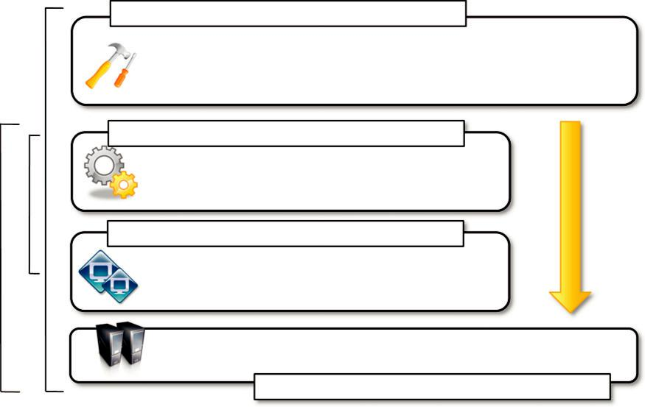

PaaS

IaaS(M)IaaS

Platform-as-a-Service Solutions

DataSynapse, Zimory Pools,

Elastra CloudServer, Aneka, ….

Infrastructure Management Software

Eucalyptus, OpenNebula, VMWare

vCloud, OpenPEX, InterGrid, …

Virtual Machine Technology

KVM, Xen, VMWare, …

Datacenters, Clusters, Desktop Grids

Physical Infrastructure

FIGURE 4.4

Private clouds hardware and software stack.

DataSynapse provides a flexible environment for building private clouds on top of datacenters. Elastra Cloud Server is a platform for easily configuring and deploying distributed application infrastructures on clouds. Zimory provides a software infrastructure layer that automates the use of resource pools based on Xen, KVM, and VMware virtualization technologies. It allows creating an internal cloud composed of sparse private and public resources and provides facilities for migrating applications within the existing infrastructure. Aneka is a software development platform that can be used to deploy a cloud infrastructure on top of heterogeneous hardware: datacenters, clusters, and desktop grids. It provides a pluggable service-oriented architecture that’s mainly devoted to supporting the execution of distributed applications with different programming models: bag of tasks, MapReduce, and others.

Private clouds can provide in-house solutions for cloud computing, but if compared to public clouds they exhibit more limited capability to scale elastically on demand.

Hybrid clouds

Public clouds are large software and hardware infrastructures that have a capability that is huge enough to serve the needs of multiple users, but they suffer from security threats and administra-tive pitfalls. Although the option of completely relying on a public virtual infrastructure is appeal-ing for companies that did not incur IT capital costs and have just started considering their IT needs (i.e., start-ups), in most cases the private cloud option prevails because of the existing IT infrastructure.

Private clouds are the perfect solution when it is necessary to keep the processing of informa-tion within an enterprise’s premises or it is necessary to use the existing hardware and software infrastructure. One of the major drawbacks of private deployments is the inability to scale on demand and to efficiently address peak loads. In this case, it is important to leverage capabilities of public clouds as needed. Hence, a hybrid solution could be an interesting opportunity for taking advantage of the best of the private and public worlds. This led to the development and diffusion of hybrid clouds.

Hybrid clouds allow enterprises to exploit existing IT infrastructures, maintain sensitive infor-mation within the premises, and naturally grow and shrink by provisioning external resources and releasing them when they’re no longer needed. Security concerns are then only limited to the public portion of the cloud that can be used to perform operations with less stringent constraints but that are still part of the system workload. Figure 4.5 provides a general overview of a hybrid cloud: It is a heterogeneous distributed system resulting from a private cloud that integrates additional services or resources from one or more public clouds. For this reason they are also called heterogeneous clouds. As depicted in the diagram, dynamic provisioning is a fundamental component in this sce-nario. Hybrid clouds address scalability issues by leveraging external resources for exceeding
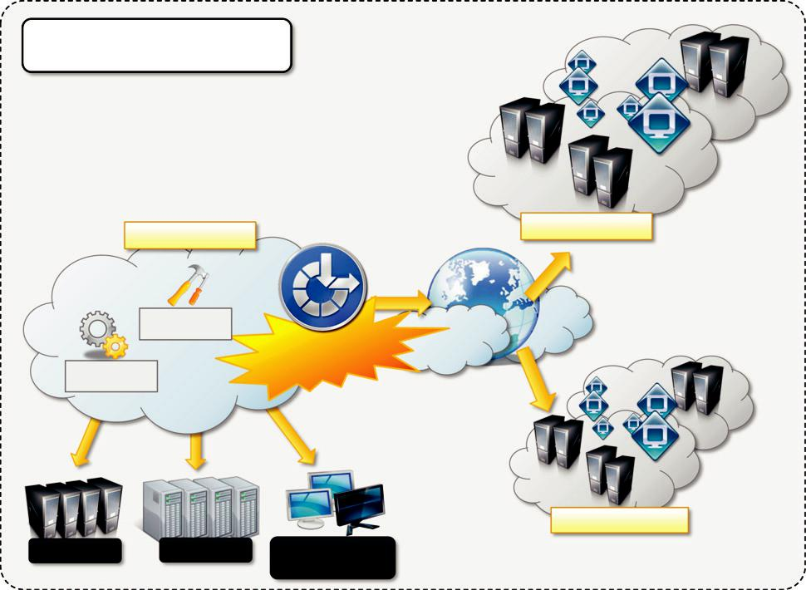

Hybrid / Heterogeneous Cloud

Private Cloud | Public Cloud
Paas | Dynamic
 | Provisioning
IaaS(M)

Public Cloud

Datacenter | Cluster | Desktop Grids /
 |  | NOWs

FIGURE 4.5

Hybrid/heterogeneous cloud overview.

capacity demand. These resources or services are temporarily leased for the time required and then released. This practice is also known as cloudbursting.⁶

Whereas the concept of hybrid cloud is general, it mostly applies to IT infrastructure rather than software services. Service-oriented computing already introduces the concept of integration of paid software services with existing application deployed in the private premises. In an IaaS scenario, dynamic provisioning refers to the ability to acquire on demand virtual machines in order to increase the capability of the resulting distributed system and then release them. Infrastructure man-agement software and PaaS solutions are the building blocks for deploying and managing hybrid clouds. In particular, with respect to private clouds, dynamic provisioning introduces a more com-plex scheduling algorithm and policies, the goal of which is also to optimize the budget spent to rent public resources.

Infrastructure management software such as OpenNebula already exposes the capability of inte-grating resources from public clouds such as Amazon EC2. In this case the virtual machine obtained from the public infrastructure is managed as all the other virtual machine instances main-tained locally. What is missing is then an advanced scheduling engine that’s able to differentiate these resources and provide smart allocations by taking into account the budget available to extend the existing infrastructure. In the case of OpenNebula, advanced schedulers such as Haizea can be integrated to provide cost-based scheduling. A different approach is taken by InterGrid. This is essentially a distributed scheduling engine that manages the allocation of virtual machines in a col-lection of peer networks. Such networks can be represented by a local cluster, a gateway to a public cloud, or a combination of the two. Once a request is submitted to one of the InterGrid gateways, it is served by possibly allocating virtual instances in all the peered networks, and the allocation of requests is performed by taking into account the user budget and the peering arrangements between networks.

Dynamic provisioning is most commonly implemented in PaaS solutions that support hybrid clouds. As previously discussed, one of the fundamental components of PaaS middleware is the mapping of distributed applications onto the cloud infrastructure. In this scenario, the role of dynamic provisioning becomes fundamental to ensuring the execution of applications under the QoS agreed on with the user. For example, Aneka provides a provisioning service that leverages different IaaS providers for scaling the existing cloud infrastructure [42]. The provisioning service cooperates with the scheduler, which is in charge of guaranteeing a specific QoS for applications. In particular, each user application has a budget attached, and the scheduler uses that budget to optimize the execution of the application by renting virtual nodes if needed. Other PaaS implemen-tations support the deployment of hybrid clouds and provide dynamic provisioning capabilities. Among those discussed for the implementation and management of private clouds we can cite Elastra CloudServer and Zimory Pools.

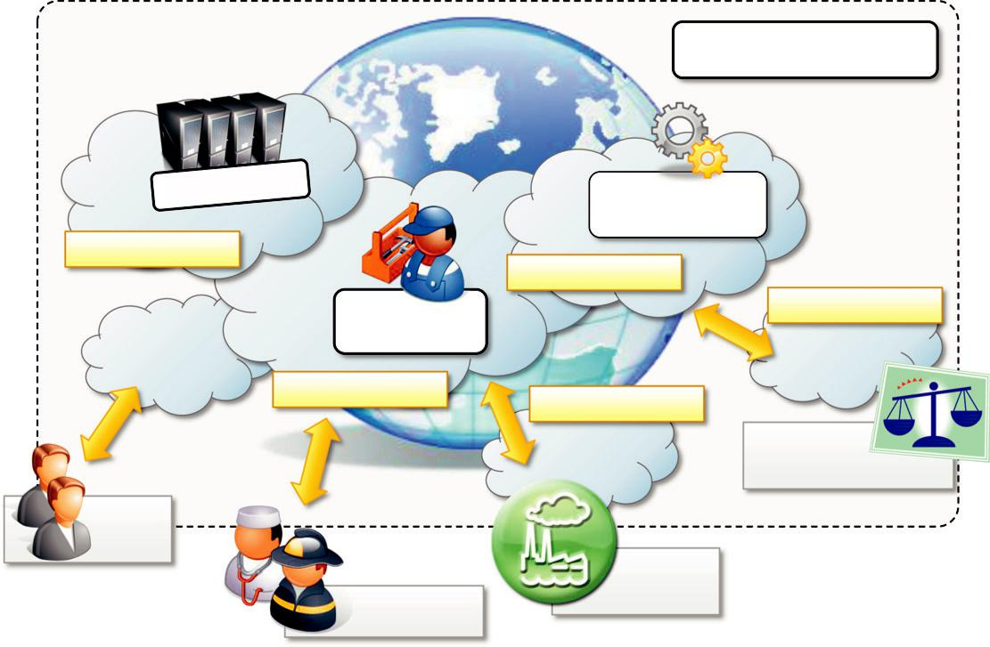

Community Cloud

 | Application
 | Services
Third-Party Cloud | Public Cloud
Development | Private Cloud
Platforms
Public Cloud | Private Cloud
 | Federal and
 | Government Bodies
Private
Users
 | Industries
Public Services | Enterprises

FIGURE 4.6

A community cloud.

Community clouds

Community clouds are distributed systems created by integrating the services of different clouds to address the specific needs of an industry, a community, or a business sector. The National Institute of Standards and Technologies (NIST) [43] characterizes community clouds as follows:

The infrastructure is shared by several organizations and supports a specific community that has shared concerns (e.g., mission, security requirements, policy, and compliance considerations). It may be managed by the organizations or a third party and may exist on premise or off premise.

Figure 4.6 provides a general view of the usage scenario of community clouds, together with reference architecture. The users of a specific community cloud fall into a well-identified commu-nity, sharing the same concerns or needs; they can be government bodies, industries, or even simple users, but all of them focus on the same issues for their interaction with the cloud. This is a differ-ent scenario than public clouds, which serve a multitude of users with different needs. Community clouds are also different from private clouds, where the services are generally delivered within the institution that owns the cloud.

From an architectural point of view, a community cloud is most likely implemented over multi-ple administrative domains. This means that different organizations such as government bodies,

private enterprises, research organizations, and even public virtual infrastructure providers contrib-ute with their resources to build the cloud infrastructure.

Candidate sectors for community clouds are as follows:

- Media industry. In the media industry, companies are looking for low-cost, agile, and simple solutions to improve the efficiency of content production. Most media productions involve an extended ecosystem of partners. In particular, the creation of digital content is the outcome of a collaborative process that includes movement of large data, massive compute-intensive rendering tasks, and complex workflow executions. Community clouds can provide a shared environment where services can facilitate business-to-business collaboration and offer the horsepower in terms of aggregate bandwidth, CPU, and storage required to efficiently support media production.

- Healthcare industry. In the healthcare industry, there are different scenarios in which community clouds could be of use. In particular, community clouds can provide a global platform on which to share information and knowledge without revealing sensitive data maintained within the private infrastructure. The naturally hybrid deployment model of community clouds can easily support the storing of patient-related data in a private cloud while using the shared infrastructure for noncritical services and automating processes within hospitals.

- Energy and other core industries. In these sectors, community clouds can bundle the comprehensive set of solutions that together vertically address management, deployment, and orchestration of services and operations. Since these industries involve different providers, vendors, and organizations, a community cloud can provide the right type of infrastructure to create an open and fair market.

- Public sector. Legal and political restrictions in the public sector can limit the adoption of public cloud offerings. Moreover, governmental processes involve several institutions and agencies and are aimed at providing strategic solutions at local, national, and international administrative levels. They involve business-to-administration, citizen-to-administration, and possibly business-to-business processes. Some examples include invoice approval, infrastructure planning, and public hearings. A community cloud can constitute the optimal venue to provide a distributed environment in which to create a communication platform for performing such operations.

- Scientific research. Science clouds are an interesting example of community clouds. In this case, the common interest driving different organizations sharing a large distributed infrastructure is scientific computing.

The term community cloud can also identify a more specific type of cloud that arises from con-cern over the controls of vendors in cloud computing and that aspire to combine the principles of digital ecosystems⁷ [44] with the case study of cloud computing. A community cloud is formed by harnessing the underutilized resources of user machines [45] and providing an infrastructure in

which each can be at the same time a consumer, a producer, or a coordinator of the services offered by the cloud. The benefits of these community clouds are the following:

- Openness. By removing the dependency on cloud vendors, community clouds are open systems in which fair competition between different solutions can happen.

- Community. Being based on a collective that provides resources and services, the infrastructure turns out to be more scalable because the system can grow simply by expanding its user base.

- Graceful failures. Since there is no single provider or vendor in control of the infrastructure, there is no single point of failure.

- Convenience and control. Within a community cloud there is no conflict between convenience and control because the cloud is shared and owned by the community, which makes all the decisions through a collective democratic process.

- Environmental sustainability. The community cloud is supposed to have a smaller carbon footprint because it harnesses underutilized resources. Moreover, these clouds tend to be more organic by growing and shrinking in a symbiotic relationship to support the demand of the community, which in turn sustains it.

This is an alternative vision of a community cloud, focusing more on the social aspect of the clouds that are formed as an aggregation of resources of community members. The idea of a hetero-geneous infrastructure built to serve the needs of a community of people is also reflected in the pre-vious definition, but in that case the attention is focused on the commonality of interests that aggregates the users of the cloud into a community. In both cases, the concept of community is fundamental.

Economics of the cloud

The main drivers of cloud computing are economy of scale and simplicity of software delivery and its operation. In fact, the biggest benefit of this phenomenon is financial: the pay-as-you-go model offered by cloud providers. In particular, cloud computing allows:

- Reducing the capital costs associated to the IT infrastructure

- Eliminating the depreciation or lifetime costs associated with IT capital assets

- Replacing software licensing with subscriptions

- Cutting the maintenance and administrative costs of IT resources

A capital cost is the cost occurred in purchasing an asset that is useful in the production of goods or the rendering of services. Capital costs are one-time expenses that are generally paid up front and that will contribute over the long term to generate profit. The IT infrastructure and the software are capital assets because enterprises require them to conduct their business. At present it does not matter whether the principal business of an enterprise is related to IT, because the business will definitely have an IT department that is used to automate many of the activities that are per-formed within the enterprise: payroll, customer relationship management, enterprise resource plan-ning, tracking and inventory of products, and others. Hence, IT resources constitute a capital cost for any kind of enterprise. It is good practice to try to keep capital costs low because they introduce

expenses that will generate profit over time; more than that, since they are associated with material things they are subject to depreciation over time, which in the end reduces the profit of the enterprise because such costs are directly subtracted from the enterprise revenues. In the case of IT capital costs, the depreciation costs are represented by the loss of value of the hardware over time and the aging of software products that need to be replaced because new features are required.

Before cloud computing diffused within the enterprise, the budget spent on IT infrastructure and software constituted a significant expense for medium-sized and large enterprises. Many enterprises own a small or medium-sized datacenter that introduces several operational costs in terms of main-tenance, electricity, and cooling. Additional operational costs are occurred in maintaining an IT department and an IT support center. Moreover, other costs are triggered by the purchase of potentially expensive software. With cloud computing these costs are significantly reduced or sim-ply disappear according to its penetration. One of the advantages introduced by the cloud comput-ing model is that it shifts the capital costs previously allocated to the purchase of hardware and software into operational costs inducted by renting the infrastructure and paying subscriptions for the use of software. These costs can be better controlled according to the business needs and pros-perity of the enterprise. Cloud computing also introduces reductions in administrative and mainte-nance costs. That is, there is no or limited need for having administrative staff take care of the management of the cloud infrastructure. At the same time, the cost of IT support staff is also reduced. When it comes to depreciation costs, they simply disappear for the enterprise, since in a scenario where all the IT needs are served by the cloud there are no IT capital assets that depreciate over time.

The amount of cost savings that cloud computing can introduce within an enterprise is related to the specific scenario in which cloud services are used and how they contribute to generate a profit for the enterprise. In the case of a small startup, it is possible to completely leverage the cloud for many aspects, such as:

- IT infrastructure

- Software development

- CRM and ERP

In this case it is possible to completely eliminate capital costs because there are no initial IT assets. The situation is completely different in the case of enterprises that already have a consider-able amount of IT assets. In this case, cloud computing, especially IaaS-based solutions, can help manage unplanned capital costs that are generated by the needs of the enterprise in the short term. In this case, by leveraging cloud computing, these costs can be turned into operational costs that last as long as there is a need for them. For example, IT infrastructure leasing helps more effi-ciently manage peak loads without inducing capital expenses. As soon as the increased load does not justify the use of additional resources, these can be released and the costs associated with them disappear. This is the most adopted model of cloud computing because many enterprises already have IT facilities. Another option is to make a slow transition toward cloud-based solutions while the capital IT assets get depreciated and need to be replaced. Between these two cases there is a wide variety of scenarios in which cloud computing could be of help in generating profits for enterprises.

Another important aspect is the elimination of some indirect costs that are generated by IT assets, such as software licensing and support and carbon footprint emissions. With cloud comput-ing, an enterprise uses software applications on a subscription basis, and there is no need for any licensing fee because the software providing the service remains the property of the provider. Leveraging IaaS solutions allows room for datacenter consolidation that in the end could result in a smaller carbon footprint. In some countries such as Australia, the carbon footprint emissions are taxable, so by reducing or completely eliminating such emissions, enterprises can pay less tax.

In terms of the pricing models introduced by cloud computing, we can distinguish three differ-ent strategies that are adopted by the providers:

Tiered pricing. In this model, cloud services are offered in several tiers, each of which offers a fixed computing specification and SLA at a specific price per unit of time. This model is used by Amazon for pricing the EC2 service, which makes available different server configurations in terms of computing capacity (CPU type and speed, memory) that have different costs per hour.

Per-unit pricing. This model is more suitable to cases where the principal source of revenue for the cloud provider is determined in terms of units of specific services, such as data transfer and memory allocation. In this scenario customers can configure their systems more efficiently according to the application needs. This model is used, for example, by GoGrid, which makes customers pay according to RAM/hour units for the servers deployed in the GoGrid cloud.

Subscription-based pricing. This is the model used mostly by SaaS providers in which users pay a periodic subscription fee for use of the software or the specific component services that are integrated in their applications.

All of these costs are based on a pay-as-you-go model, which constitutes a more flexible solu-tion for supporting the delivery on demand of IT services. This is what actually makes possible the conversion of IT capital costs into operational costs, since the cost of buying hardware turns into a cost for leasing it and the cost generated by the purchase of software turns into a subscription fee paid for using it.

Open challenges

Still in its infancy, cloud computing presents many challenges for industry and academia. There is a significant amount of work in academia focused on defining the challenges brought by this phe-nomenon [46 49]. In this section, we highlight the most important ones: the definition and the for-malization of cloud computing, the interoperation between different clouds, the creation of standards, security, scalability, fault tolerance, and organizational aspects.

Cloud definition

As discussed earlier, there have been several attempts made to define cloud computing and to pro-vide a classification of all the services and technologies identified as such. One of the most com-prehensive formalizations is noted in the NIST working definition of cloud computing [43]. It characterizes cloud computing as on-demand self-service, broad network access, resource-pooling,

rapid elasticity, and measured service; classifies services as SaaS, PaaS, and IaaS; and categorizes deployment models as public, private, community, and hybrid clouds. The view is in line with our discussion and shared by many IT practitioners and academics.

Despite the general agreement on the NIST definition, there are alternative taxonomies for cloud services. David Linthicum, founder of BlueMountains Labs, provides a more detailed classifica-tion,⁸ which comprehends 10 different classes and better suits the vision of cloud computing within the enterprise. A different approach has been taken at the University of California, Santa Barbara (UCSB) [50], which departs from the XaaS concept and tries to define an ontology for cloud com-puting. In their work the concept of a cloud is dissected into five main layers: applications, soft-ware environments, software infrastructure, software kernel, and hardware. Each layer addresses the needs of a different class of users within the cloud computing community and most likely builds on the underlying layers. According to the authors, this work constitutes the first effort to provide a more robust interaction model between the different cloud entities on both the functional level and the semantic level.

These characterizations and taxonomies reflect what is meant by cloud computing at the present time, but being in its infancy the phenomenon is constantly evolving, and the same will happen to the attempts to capture the real nature of cloud computing. It is interesting to note that the principal characterization used in this book as a reference for introducing and explaining cloud computing is considered a working definition, which by nature identifies something that continuously changes over time by becoming refined.

Cloud interoperability and standards

Cloud computing is a service-based model for delivering IT infrastructure and applications like util-ities such as power, water, and electricity. To fully realize this goal, introducing standards and allowing interoperability between solutions offered by different vendors are objectives of funda-mental importance. Vendor lock-in constitutes one of the major strategic barriers against the seam-less adoption of cloud computing at all stages. In particular there is major fear on the part of enterprises in which IT constitutes the significant part of their revenues. Vendor lock-in can prevent a customer from switching to another competitor’s solution, or when this is possible, it happens at considerable conversion cost and requires significant amounts of time. This can occur either because the customer wants to find a more suitable solution for customer needs or because the ven-dor is no longer able to provide the required service. The presence of standards that are actually implemented and adopted in the cloud computing community could give room for interoperability and then lessen the risks resulting from vendor lock-in.

The current state of standards and interoperability in cloud computing resembles the early Internet era, when there was no common agreement on the protocols and technologies used and each organization had its own network. Yet the first steps toward a standardization process have been made, and a few organizations, such as the Cloud Computing Interoperability Forum (CCIF),⁹

the Open Cloud Consortium,¹⁰ and the DMTF Cloud Standards Incubator,¹¹ are leading the path. Another interesting initiative is the Open Cloud Manifesto,¹² which embodies the point of view of various stakeholders on the benefits of open standards in the field.

The standardization efforts are mostly concerned with the lower level of the cloud computing architecture, which is the most popular and developed. In particular, in the IaaS market, the use of a proprietary virtual machine format constitutes the major reasons for the vendor lock-in, and efforts to provide virtual machine image compatibility between IaaS vendors can possibly improve the level of interoperability among them. The Open Virtualization Format (OVF) [51] is an attempt to provide a common format for storing the information and metadata describing a virtual machine image. Even though the OVF provides a full specification for packaging and distributing virtual machine images in completely platform-independent fashion, it is supported by few vendors that use it to import static virtual machine images. The challenge is providing standards for supporting the migration of running instances, thus allowing the real ability of switching from one infrastruc-ture vendor to another in a completely transparent manner.

Another direction in which standards try to move is devising a general reference architecture for cloud computing systems and providing a standard interface through which one can interact with them. At the moment the compatibility between different solutions is quite restricted, and the lack of a common set of APIs make the interaction with cloud-based solutions vendor specific. In the IaaS market, Amazon Web Services plays a leading role, and other IaaS solutions, mostly open source, provide AWS-compatible APIs, thus constituting themselves as valid alternatives. Even in this case, there is no consistent trend in devising some common APIs for interfacing with IaaS (and, in general, XaaS), and this constitutes one of the areas in which a considerable improvement can be made in the future.

Scalability and fault tolerance

The ability to scale on demand constitutes one of the most attractive features of cloud computing. Clouds allow scaling beyond the limits of the existing in-house IT resources, whether they are infrastructure (compute and storage) or applications services. To implement such a capability, the cloud middleware has to be designed with the principle of scalability along different dimensions in mind—for example, performance, size, and load. The cloud middleware manages a huge number of resource and users, which rely on the cloud to obtain the horsepower that they cannot obtain within the premises without bearing considerable administrative and maintenance costs. These costs are a reality for whomever develops, manages, and maintains the cloud middleware and offers the service to customers. In this scenario, the ability to tolerate failure becomes fundamental, sometimes even more important than providing an extremely efficient and optimized system. Hence, the challenge in this case is designing highly scalable and fault-tolerant systems that are easy to manage and at the same time provide competitive performance.

Security, trust, and privacy

Security, trust, and privacy issues are major obstacles for massive adoption of cloud computing. The traditional cryptographic technologies are used to prevent data tampering and access to sensi-tive information. The massive use of virtualization technologies exposes the existing system to new threats, which previously were not considered applicable. For example, it might be possible that applications hosted in the cloud can process sensitive information; such information can be stored within a cloud storage facility using the most advanced technology in cryptography to protect data and then be considered safe from any attempt to access it without the required permissions. Although these data are processed in memory, they must necessarily be decrypted by the legitimate application, but since the application is hosted in a managed virtual environment it becomes acces-sible to the virtual machine manager that by program is designed to access the memory pages of such an application. In this case, what is experienced is a lack of control over the environment in which the application is executed, which is made possible by leveraging the cloud. It then happens that a new way of using existing technologies creates new opportunities for additional threats to the security of applications. The lack of control over their own data and processes also poses severe problems for the trust we give to the cloud service provider and the level of privacy we want to have for our data.

On one side we need to decide whether to trust the provider itself; on the other side, specific regulations can simply prevail over the agreement the provider is willing to establish with us con-cerning the privacy of the information managed on our behalf. Moreover, cloud services delivered to the end user can be the result of a complex stack of services that are obtained by third parties via the primary cloud service provider. In this case there is a chain of responsibilities in terms of service delivery that can introduce more vulnerability for the secure management of data, the enforcement of privacy rules, and the trust given to the service provider. In particular, when a vio-lation of privacy or illegal access to sensitive information is detected, it could become difficult to identify who is liable for such violations. The challenges in this area are, then, mostly concerned with devising secure and trustable systems from different perspectives: technical, social, and legal.

Organizational aspects

Cloud computing introduces a significant change in the way IT services are consumed and man-aged. More precisely, storage, compute power, network infrastructure, and applications are deliv-ered as metered services over the Internet. This introduces a billing model that is new within typical enterprise IT departments, which requires a certain level of cultural and organizational pro-cess maturity. In particular, a wide acceptance of cloud computing will require a significant change to business processes and organizational boundaries. Some interesting questions arise in considering the role of the IT department in this new scenario. In particular, the following questions have to be considered:

- What is the new role of the IT department in an enterprise that completely or significantly relies on the cloud?

- How will the compliance department perform its activity when there is a considerable lack of control over application workflows?

- What are the implications (political, legal, etc.) for organizations that lose control over some aspects of their services?

- What will be the perception of the end users of such services?

From an organizational point of view, the lack of control over the management of data and pro-cesses poses not only security threats but also new problems that previously did not exist. Traditionally, when there was a problem with computer systems, organizations developed strategies and solutions to cope with them, often by relying on local expertise and knowledge. One of the major advantages of moving IT infrastructure and services to the cloud is to reduce or completely remove the costs related to maintenance and support. As a result, users of such infrastructure and services lose a reference to deal with for IT troubleshooting. At the same time, the existing IT staff is required to have a different kind of competency and, in general, fewer skills, thus reducing their value. These are the challenges from an organizational point of view that must be faced and that will significantly change the relationships within the enterprise itself among the various groups of people working together.

RT

Cloud Application
Programming and
the Aneka Platform

CHAPTER
Aneka
Cloud Application Platform

Aneka is Manjrasoft Pty. Ltd.’s solution for developing, deploying, and managing cloud applica-tions. Aneka consists of a scalable cloud middleware that can be deployed on top of heterogeneous computing resources. It offers an extensible collection of services coordinating the execution of applications, helping administrators monitor the status of the cloud, and providing integration with existing cloud technologies. One of Aneka’s key advantages is its extensible set of application pro-gramming interfaces (APIs) associated with different types of programming models—such as Task, Thread, and MapReduce—used for developing distributed applications, integrating new capabilities into the cloud, and supporting different types of cloud deployment models: public, private, and hybrid (see Figure 5.1). These features differentiate Aneka from infrastructure management soft-ware and characterize it as a platform for developing, deploying, and managing execution of appli-cations on various types of clouds.

This chapter provides a complete overview of the framework by first describing the architecture of the system. It introduces Aneka’s components and the fundamental services that make up the Aneka Cloud and discusses some common deployment scenarios.

Framework overview

Aneka is a software platform for developing cloud computing applications. It allows harnessing of disparate computing resources and managing them into a unique virtual domain—the Aneka Cloud—in which applications are executed. According to the Cloud Computing Reference Model presented in Chapter 1, Aneka is a pure PaaS solution for cloud computing. Aneka is a cloud mid-dleware product that can be deployed on a heterogeneous set of resources: a network of computers, a multicore server, datacenters, virtual cloud infrastructures, or a mixture of these. The framework provides both middleware for managing and scaling distributed applications and an extensible set of APIs for developing them.

Figure 5.2 provides a complete overview of the components of the Aneka framework. The core infrastructure of the system provides a uniform layer that allows the framework to be deployed over different platforms and operating systems. The physical and virtual resources representing the bare metal of the cloud are managed by the Aneka container, which is installed on each node and constitutes the basic building block of the middleware. A collection of interconnected containers constitute the Aneka Cloud: a single domain in which services are made available to users and

Multiple Applications
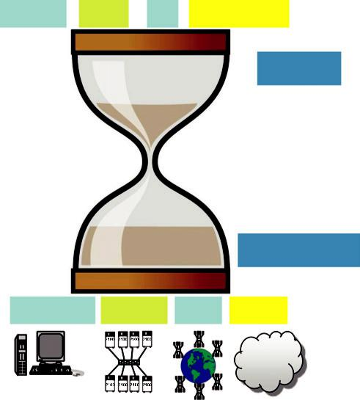

Thread Task ... MapReduce

1. SDK

Aneka

2. Runtime

Multicore Cluster Grid Cloud

Multiple Infrastructures

FIGURE 5.1

Aneka’s capabilities at a glance.

developers. The container features three different classes of services: Fabric Services, Foundation Services, and Execution Services. These take care of infrastructure management, supporting ser-vices for the Aneka Cloud, and application management and execution, respectively. These services are made available to developers and administrators by means of the application management and development layer, which includes interfaces and APIs for developing cloud applications and the management tools and interfaces for controlling Aneka Clouds.

Aneka implements a service-oriented architecture (SOA), and services are the fundamental com-ponents of an Aneka Cloud. Services operate at container level and, except for the platform abstrac-tion layer, they provide developers, users, and administrators with all features offered by the framework. Services also constitute the extension and customization point of Aneka Clouds: The infrastructure allows for the integration of new services or replacement of the existing ones with a different implementation. The framework includes the basic services for infrastructure and node management, application execution, accounting, and system monitoring; existing services can be extended and new features can be added to the cloud by dynamically plugging new ones into the container. Such extensible and flexible infrastructure enables Aneka Clouds to support different programming and execution models for applications. A programming model represents a collection of abstractions that developers can use to express distributed applications; the runtime support for a programming model is constituted by a collection of execution and foundation services interacting together to carry out application execution. Thus, the implementation of a new model requires the development of the specific programming abstractions used by application developers and the
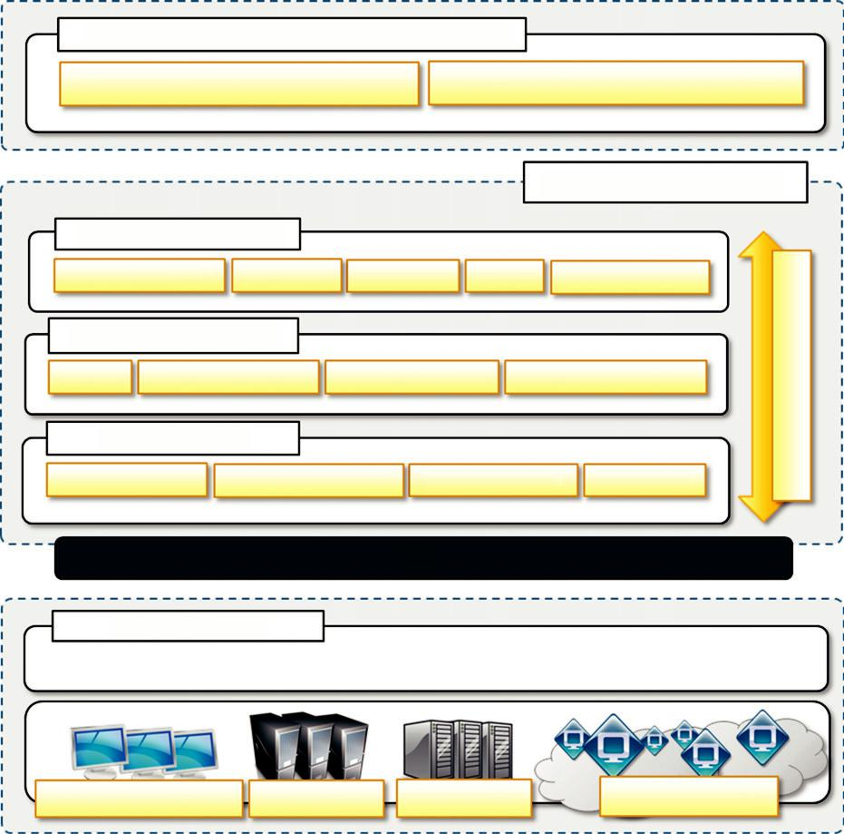

Application Development & Management

Management: Tools, Interfaces and APls Software Development kit: APIs & Tools

Middleware - Container

Application Services

Distributed Threads MapReduce Bag of Tasks PSM Other models...

Foundation Services

Storage Resource Reservation Billing & Reporting Licensing & Accounting

Fabric Services

High-Availability Resource Provisioning Hardware Profiling Membership

PAL – Platform Abstraction Layer

Presistence & Security

infrastructure

Enterprise Desktop Grid Data Centers Clusters Public Cloud

FIGURE 5.2

Aneka framework overview.

services, providing runtime support for them. Programming models are just one aspect of applica-tion management and execution. Within an Aneka Cloud environment, there are different aspects involved in providing a scalable and elastic infrastructure and distributed runtime for applications. These services involve:

- Elasticity and scaling. By means of the dynamic provisioning service, Aneka supports dynamically upsizing and downsizing of the infrastructure available for applications.

- Runtime management. The runtime machinery is responsible for keeping the infrastructure up and running and serves as a hosting environment for services. It is primarily represented by the container and a collection of services that manage service membership and lookup, infrastructure maintenance, and profiling.

- Resource management. Aneka is an elastic infrastructure in which resources are added and removed dynamically according to application needs and user requirements. To provide

QoS-based execution, the system not only allows dynamic provisioning but also provides capabilities for reserving nodes for exclusive use by specific applications.

- Application management. A specific subset of services is devoted to managing applications. These services include scheduling, execution, monitoring, and storage management.

- User management. Aneka is a multitenant distributed environment in which multiple applications, potentially belonging to different users, are executed. The framework provides an extensible user system via which it is possible to define users, groups, and permissions. The services devoted to user management build up the security infrastructure of the system and constitute a fundamental element for accounting management.

- QoS/SLA management and billing. Within a cloud environment, application execution is metered and billed. Aneka provides a collection of services that coordinate together to take into account the usage of resources by each application and to bill the owning user accordingly.

All these services are available to specific interfaces and APIs on top of which the software development kit (SDK) and management kit are built. The SDK mainly relates to application devel-opment and modeling; it provides developers with APIs to develop applications with the existing programming models and an object model for creating new models. The management kit is mostly focused on interacting with the runtime services for managing the infrastructure, users, and applica-tions. The management kit gives a complete view of Aneka Clouds and allows monitoring Aneka’s status, whereas the SDK is more focused on the single application and provides means to control its execution from a single user. Both components are meant to provide an easy-to-use interface via which to interact and manage containers that are the core component of the Aneka framework.

Anatomy of the Aneka container

The Aneka container constitutes the building blocks of Aneka Clouds and represents the runtime machinery available to services and applications. The container, the unit of deployment in Aneka Clouds, is a lightweight software layer designed to host services and interact with the underlying operating system and hardware. The main role of the container is to provide a lightweight environ-ment in which to deploy services and some basic capabilities such as communication channels through which it interacts with other nodes in the Aneka Cloud. Almost all operations performed within Aneka are carried out by the services managed by the container. The services installed in the Aneka container can be classified into three major categories:

Fabric Services

Foundation Services

Application Services

The services stack resides on top of the Platform Abstraction Layer (PAL), representing the interface to the underlying operating system and hardware. It provides a uniform view of the soft-ware and hardware environment in which the container is running. Persistence and security traverse all the services stack to provide a secure and reliable infrastructure. In the following sections we discuss the components of these layers in more detail.

From the ground up: the platform abstraction layer

The core infrastructure of the system is based on the .NET technology and allows the Aneka container to be portable over different platforms and operating systems. Any platform featuring an ECMA-334

- and ECMA-335 [53] compatible environment can host and run an instance of the Aneka container. The Common Language Infrastructure (CLI), which is the specification introduced in the

ECMA-334 standard, defines a common runtime environment and application model for executing programs but does not provide any interface to access the hardware or to collect performance data from the hosting operating system. Moreover, each operating system has a different file system organization and stores that information differently. The Platform Abstraction Layer (PAL) addresses this heterogeneity and provides the container with a uniform interface for accessing the relevant hardware and operating system information, thus allowing the rest of the container to run unmodified on any supported platform.

The PAL is responsible for detecting the supported hosting environment and providing the cor-responding implementation to interact with it to support the activity of the container. The PAL pro-vides the following features:

- Uniform and platform-independent implementation interface for accessing the hosting platform

- Uniform access to extended and additional properties of the hosting platform

- Uniform and platform-independent access to remote nodes

- Uniform and platform-independent management interfaces

The PAL is a small layer of software that comprises a detection engine, which automatically configures the container at boot time, with the platform-specific component to access the above information and an implementation of the abstraction layer for the Windows, Linux, and Mac OS X operating systems.

The collectible data that are exposed by the PAL are the following:

Number of cores, frequency, and CPU usage

Memory size and usage

Aggregate available disk space

Network addresses and devices attached to the node

Moreover, additional custom information can be retrieved by querying the properties of the hard-ware. The PAL interface provides means for custom implementations to pull additional information by using name-value pairs that can host any kind of information about the hosting platform. For example, these properties can contain additional information about the processor, such as the model and family, or additional data about the process running the container.

Fabric services

Fabric Services define the lowest level of the software stack representing the Aneka Container. They provide access to the resource-provisioning subsystem and to the monitoring facilities imple-mented in Aneka. Resource-provisioning services are in charge of dynamically providing new nodes on demand by relying on virtualization technologies, while monitoring services allow for hardware profiling and implement a basic monitoring infrastructure that can be used by all the ser-vices installed in the container.

Profiling and monitoring

Profiling and monitoring services are mostly exposed through the Heartbeat, Monitoring, and Reporting Services. The first makes available the information that is collected through the PAL; the other two implement a generic infrastructure for monitoring the activity of any service in the Aneka Cloud.

The Heartbeat Service periodically collects the dynamic performance information about the node and publishes this information to the membership service in the Aneka Cloud. These data are collected by the index node of the Cloud, which makes them available for services such as reserva-tions and scheduling in order to optimize the use of a heterogeneous infrastructure. As already dis-cussed, basic information about memory, disk space, CPU, and operating system is collected. Moreover, additional data are pulled into the “alive” message, such as information about the installed software in the system and any other useful information. More precisely, the infrastructure has been designed to carry over any type of data that can be expressed by means of text-valued properties. As previously noted, the information published by the Heartbeat Service is mostly con-cerned with the properties of the node. A specific component, called Node Resolver, is in charge of collecting these data and making them available to the Heartbeat Service. Aneka provides different implementations for such component in order to cover a wide variety of hosting environments. A variety of operating systems are supported with different implementations of the PAL, and differ-ent node resolvers allow Aneka to capture other types of data that do not strictly depend on the hosting operating system. For example, the retrieval of the public IP of the node is different in the case of physical machines or virtual instances hosted in the infrastructure of an IaaS provider such as EC2 or GoGrid. In virtual deployment, a different node resolver is used so that all other compo-nents of the system can work transparently.

The set of built-in services for monitoring and profiling is completed by a generic monitoring infrastructure, which allows any custom service to report its activity. This infrastructure is com-posed of the Reporting and Monitoring Services. The Reporting Service manages the store for mon-itored data and makes them accessible to other services or external applications for analysis purposes. On each node, an instance of the Monitoring Service acts as a gateway to the Reporting Service and forwards to it all the monitored data that has been collected on the node. Any service that wants to publish monitoring data can leverage the local monitoring service without knowing the details of the entire infrastructure. Currently several built-in services provide information through this channel:

- The Membership Catalogue tracks the performance information of nodes.

- The Execution Service monitors several time intervals for the execution of jobs.

- The Scheduling Service tracks the state transitions of jobs.

- The Storage Service monitors and makes available information about data transfer, such as upload and download times, filenames, and sizes.

- The Resource Provisioning Service tracks the provisioning and lifetime information of virtual nodes.

All this information can be stored on a relational database management system (RDBMS) or a flat file and can be further analyzed by specific applications. For example, the Management Console provides a view on such data for administrative purposes.

Resource management

Resource management is another fundamental feature of Aneka Clouds. It comprises several tasks: resource membership, resource reservation, and resource provisioning. Aneka provides a collection of services that are in charge of managing resources. These are the Index Service (or Membership Catalogue), Reservation Service, and Resource Provisioning Service.

The Membership Catalogue is Aneka’s fundamental component for resource management; it keeps track of the basic node information for all the nodes that are connected or disconnected. The Membership Catalogue implements the basic services of a directory service, allowing the search for services using attributes such as names and nodes. During container startup, each instance publishes its information to the Membership Catalogue and updates it constantly during its lifetime. Services and external applications can query the membership catalogue to discover the available services and inter-act with them. To speed up and enhance the performance of queries, the membership catalogue is orga-nized as a distributed database: All the queries that pertain to information maintained locally are resolved locally; otherwise the query is forwarded to the main index node, which has a global knowl-edge of the entire Cloud. The Membership Catalogue is also the collector of the dynamic performance data of each node, which are then sent to the local monitoring service to be persisted in the long term.

Indexing and categorizing resources are fundamental to resource management. On top of the basic indexing service, provisioning completes the set of features that are available for resource management within Aneka. Deployment of container instances and their configuration are per-formed by the infrastructure management layer and are not part of the Fabric Services.

Dynamic resource provisioning allows the integration and management of virtual resources leased from IaaS providers into the Aneka Cloud. This service changes the structure of the Aneka Cloud by allowing it to scale up and down according to different needs: handling node failures, ensuring the quality of service for applications, or maintaining a constant performance and throughput of the Cloud. Aneka defines a very flexible infrastructure for resource provisioning whereby it is possible to change the logic that triggers provisioning, support several back-ends, and change the runtime strategy with which a specific back-end is selected for provisioning. The resource-provisioning infra-structure built into Aneka is mainly concentrated in the Resource Provisioning Service, which includes all the operations that are needed for provisioning virtual instances. The implementation of the service is based on the idea of resource pools. A resource pool abstracts the interaction with a specific IaaS provider by exposing a common interface so that all the pools can be managed uni-formly. A resource pool does not necessarily map to an IaaS provider but can be used to expose as dynamic resources a private cloud managed by a Xen Hypervisor or a collection of physical resources that are only used sporadically. The system uses an open protocol, allowing for the use of metadata to provide additional information for describing resource pools and to customize provision-ing requests. This infrastructure simplifies the implementation of additional features and the support of different implementations that can be transparently integrated into the existing system.

Resource provisioning is a feature designed to support QoS requirements-driven execution of applications. Therefore, it mostly serves requests coming from the Reservation Service or the Scheduling Services. Despite this, external applications can directly leverage Aneka’s resource-provisioning capabilities by dynamically retrieving a client to the service and interacting with the infrastructure to it. This extends the resource-provisioning scenarios that can be handled by Aneka, which can also be used as a virtual machine manager.

Foundation services

Fabric Services are fundamental services of the Aneka Cloud and define the basic infrastructure management features of the system. Foundation Services are related to the logical management of the distributed system built on top of the infrastructure and provide supporting services for the exe-cution of distributed applications. All the supported programming models can integrate with and leverage these services to provide advanced and comprehensive application management. These services cover:

- Storage management for applications

- Accounting, billing, and resource pricing

- Resource reservation

Foundation Services provide a uniform approach to managing distributed applications and allow developers to concentrate only on the logic that distinguishes a specific programming model from the others. Together with the Fabric Services, Foundation Services constitute the core of the Aneka middleware. These services are mostly consumed by the execution services and Management Consoles. External applications can leverage the exposed capabilities for providing advanced appli-cation management.

Storage management

Data management is an important aspect of any distributed system, even in computing clouds. Applications operate on data, which are mostly persisted and moved in the format of files. Hence, any infrastructure that supports the execution of distributed applications needs to provide facilities for file/data transfer management and persistent storage. Aneka offers two different facilities for storage management: a centralized file storage, which is mostly used for the execution of compute-intensive applications, and a distributed file system, which is more suitable for the execution of data-intensive applications. The requirements for the two types of applications are rather different. Compute-intensive applications mostly require powerful processors and do not have high demands in terms of storage, which in many cases is used to store small files that are easily transferred from one node to another. In this scenario, a centralized storage node, or a pool of storage nodes, can constitute an appropriate solution. In contrast, data-intensive applications are characterized by large data files (gigabytes or terabytes), and the processing power required by tasks does not constitute a performance bottleneck. In this scenario, a distributed file system harnessing the storage space of all the nodes belonging to the cloud might be a better and more scalable solution.

Centralized storage is implemented through and managed by Aneka’s Storage Service. The ser-vice constitutes Aneka’s data-staging facilities. It provides distributed applications with the basic file transfer facility and abstracts the use of a specific protocol to end users and other components of the system, which are dynamically configured at runtime according to the facilities installed in the cloud. The option that is currently installed by default is normal File Transfer Protocol (FTP).

To support different protocols, the system introduces the concept of a file channel that identifies a pair of components: a file channel controller and a file channel handler. The file channel control-ler constitutes the server component of the channel, where files are stored and made available; the file channel handler represents the client component, which is used by user applications or other components of the system to upload, download, or browse files. The storage service uses the

configured file channel factory to first create the server component that will manage the storage and then create the client component on demand. User applications that require support for file transfer are automatically configured with the appropriate file channel handler and transparently upload input files or download output files during application execution. In the same way, worker nodes are configured by the infrastructure to retrieve the required files for the execution of the jobs and to upload their results.

An interesting property of the file channel abstraction is the ability to chain two different chan-nels to move files by using two different protocols. Each file in Aneka contains metadata that helps the infrastructure select the appropriate channel for moving the file. For example, an output file whose final location is an S3 bucket can be moved from the worker node to the Storage Service using the internal FTP protocol and then can be staged out on S3 by the FTP channel controller managed by the service. The Storage Service supports the execution of task-based programming such as the Task and the Thread Model as well as Parameter Sweep-based applications.

Storage support for data-intensive applications is provided by means of a distributed file system. The reference model for the distributed file system is the Google File System [54], which features a highly scalable infrastructure based on commodity hardware. The architecture of the file system is based on a master node, which contains a global map of the file system and keeps track of the status of all the storage nodes, and a pool of chunk servers, which provide distributed storage space in which to store files. Files are logically organized into a directory structure but are persisted on the file system using a flat namespace based on a unique ID. Each file is organized as a collection of chunks that are all of the same size. File chunks are assigned unique IDs and stored on different servers, eventually replicated to provide high availability and failure tolerance. The model proposed by the Google File System provides optimized support for a specific class of applications that expose the following characteristics:

- Files are huge by traditional standards (multi-gigabytes).

- Files are modified by appending new data rather than rewriting existing data.

- There are two kinds of major workloads: large streaming reads and small random reads.

- It is more important to have a sustained bandwidth than a low latency.

Moreover, given the huge number of commodity machines that the file system harnesses together, failure (process or hardware failure) is the norm rather than an exception. These character-istics strongly influenced the design of the storage, which provides the best performance for appli-cations specifically designed to operate on data as described. Currently, the only programming model that makes use of the distributed file system is MapReduce [55], which has been the primary reason for the Google File System implementation. Aneka provides a simple distributed file system (DFS), which relies on the file system services of the Windows operating system.

Accounting, billing, and resource pricing

Accounting Services keep track of the status of applications in the Aneka Cloud. The collected information provides a detailed breakdown of the distributed infrastructure usage and is vital for the proper management of resources.

The information collected for accounting is primarily related to infrastructure usage and applica-tion execution. A complete history of application execution and storage as well as other resource

utilization parameters is captured and minded by the Accounting Services. This information consti-tutes the foundation on which users are charged in Aneka.

Billing is another important feature of accounting. Aneka is a multitenant cloud programming platform in which the execution of applications can involve provisioning additional resources from commercial IaaS providers. Aneka Billing Service provides detailed information about each user’s usage of resources, with the associated costs. Each resource can be priced differently according to the set of services that are available on the corresponding Aneka container or the installed software in the node. The accounting model provides an integrated view of budget spent for each applica-tion, a summary view of the costs associated to a specific user, and the detailed information about the execution cost of each job.

The accounting capabilities are concentrated within the Accounting Service and the Reporting Service. The former keeps track of the information that is related to application execution, such as the distribution of jobs among the available resources, the timing of each of job, and the associated cost. The latter makes available the information collected from the monitoring services for account-ing purposes: storage utilization and CPU performance. This information is primarily consumed by the Management Console.

Resource reservation

Aneka’s Resource Reservation supports the execution of distributed applications and allows for reserving resources for exclusive use by specific applications. Resource reservation is built out of two different kinds of services: Resource Reservation and the Allocation Service. Resource Reservation keeps track of all the reserved time slots in the Aneka Cloud and provides a unified view of the system. The Allocation Service is installed on each node that features execution ser-vices and manages the database of information regarding the allocated slots on the local node. Applications that need to complete within a given deadline can make a reservation request for a specific number of nodes in a given timeframe. If it is possible to satisfy the request, the Reservation Service will return a reservation identifier as proof of the resource booking. During application execution, such an identifier is used to select the nodes that have been reserved, and they will be used to execute the application. On each reserved node, the execution services will check with the Allocation Service that each job has valid permissions to occupy the execution time-line by verifying the reservation identifier. Even though this is the general reference model for the reservation infrastructure, Aneka allows for different implementations of the service, which mostly vary in the protocol that is used to reserve resources or the parameters that can be specified while making a reservation request. Different protocol and strategies are integrated in a completely trans-parent manner, and Aneka provides extensible APIs for supporting advanced services. At the moment, the framework supports three different implementations:

Basic Reservation. Features the basic capability to reserve execution slots on nodes and implements the alternate offers protocol, which provides alternative options in case the initial reservation requests cannot be satisfied.

Libra Reservation. Represents a variation of the previous implementation that features the ability to price nodes differently according to their hardware capabilities.

Relay Reservation. Constitutes a very thin implementation that allows a resource broker to reserve nodes in Aneka Clouds and control the logic with which these nodes are reserved. This

implementation is useful in integration scenarios in which Aneka operates in an intercloud environment.

Resource reservation is fundamental to ensuring the quality of service that is negotiated for applications. It allows Aneka to have a predictable environment in which applications can complete within the deadline or not be executed at all. The assumptions made by the reservation service for accepting reservation requests are based on the static allocation of such requests to the existing physical (or virtual) infrastructure available at the time of the requests and by taking into account the current and future load. This solution is sensitive to node failures that could make Aneka unable to fulfill the service-level agreement (SLA) made with users. Specific implementations of the ser-vice tend to delay the allocation of nodes to reservation requests as late as possible in order to cope with temporary failures or limited outages, but in the case of serious outages in which the remain-ing available nodes are not able to cover the demand, this strategy is not enough. In this case, resource provisioning can provide an effective solution: Additional nodes can be provisioned from external resource providers in order to cover the outage and meet the SLA defined for applications. The current implementation of the resource reservation infrastructure leverages the provisioning capabilities of the fabric layer when the current availability in the system is not able to address the reservation requests already confirmed. Such behavior solves the problems of both insufficient resources and temporary failures.

Application services

Application Services manage the execution of applications and constitute a layer that differentiates according to the specific programming model used for developing distributed applications on top of Aneka. The types and the number of services that compose this layer for each of the programming models may vary according to the specific needs or features of the selected model. It is possible to identify two major types of activities that are common across all the supported models: scheduling and execution. Aneka defines a reference model for implementing the runtime support for program-ming models that abstracts these two activities in corresponding services: the Scheduling Service and the Execution Service. Moreover, it also defines base implementations that can be extended in order to integrate new models.

Scheduling

Scheduling Services are in charge of planning the execution of distributed applications on top of Aneka and governing the allocation of jobs composing an application to nodes. They also constitute the integration point with several other Foundation and Fabric Services, such as the Resource Provisioning Service, the Reservation Service, the Accounting Service, and the Reporting Service. Common tasks that are performed by the scheduling component are the following:

- Job to node mapping

- Rescheduling of failed jobs

- Job status monitoring

- Application status monitoring

Aneka does not provide a centralized scheduling engine, but each programming model features its own scheduling service that needs to work in synergy with the existing services of the middle-ware. As already mentioned, these services mostly belong to the fabric and the foundation layers of the architecture shown in Figure 5.2. The possibility of having different scheduling engines for dif-ferent models gives great freedom in implementing scheduling and resource allocation strategies but, at the same time, requires a careful design of use of shared resources. In this scenario, common situations that have to be appropriately managed are the following: multiple jobs sent to the same node at the same time; jobs without reservations sent to reserved nodes; and jobs sent to nodes where the required services are not installed. Aneka’s Foundation Services provide sufficient infor-mation to avoid these cases, but the runtime infrastructure does not feature specific policies to detect these conditions and provide corrective action. The current design philosophy in Aneka is to keep the scheduling engines completely separate from each other and to leverage existing services when needed. As a result, it is possible to enforce that only one job per programming model is run on each node at any given time, but the execution of applications is not mutually exclusive unless Resource Reservation is used.

Execution

Execution Services control the execution of single jobs that compose applications. They are in charge of setting up the runtime environment hosting the execution of jobs. As happens for the scheduling services, each programming model has its own requirements, but it is possible to iden-tify some common operations that apply across all the range of supported models:

- Unpacking the jobs received from the scheduler

- Retrieval of input files required for job execution

- Sandboxed execution of jobs

- Submission of output files at the end of execution

- Execution failure management (i.e., capturing sufficient contextual information useful to identify the nature of the failure)

- Performance monitoring

- Packing jobs and sending them back to the scheduler

Execution Services constitute a more self-contained unit with respect to the corresponding scheduling services. They handle less information and are required to integrate themselves only with the Storage Service and the local Allocation and Monitoring Services. Aneka provides a refer-ence implementation of execution services that has built-in integration with all these services, and currently two of the supported programming models specialize on the reference implementation.

Application Services constitute the runtime support of the programming model in the Aneka Cloud. Currently there are several supported models:

- Task Model. This model provides the support for the independent “bag of tasks” applications and many computing tasks. In this model, an application is modeled as a collection of tasks that are independent from each other and whose execution can be sequenced in any order.

- Thread Model. This model provides an extension to the classical multithreaded programming to a distributed infrastructure and uses the abstraction of Thread to wrap a method that is executed remotely.

- MapReduce Model. This is an implementation of MapReduce as proposed by Google on top of Aneka.

- Parameter Sweep Model. This model is a specialization of the Task Model for applications that can be described by a template task whose instances are created by generating different combinations of parameters, which identify a specific point into the domain of interest.

Other programming models have been developed for internal use and are at an experimental stage. These are the Dataflow Model [56], the Message-Passing Interface, and the Actor Model [57].

Building Aneka clouds

Aneka is primarily a platform for developing distributed applications for clouds. As a software plat-form it requires infrastructure on which to be deployed; this infrastructure needs to be managed. Infrastructure management tools are specifically designed for this task, and building clouds is one of the primary tasks of administrators. Aneka supports various deployment models for public, pri-vate, and hybrid clouds.

Infrastructure organization

Figure 5.3 provides an overview of Aneka Clouds from an infrastructure point of view. The sce-nario is a reference model for all the different deployments Aneka supports. A central role is played by the Administrative Console, which performs all the required management operations. A funda-mental element for Aneka Cloud deployment is constituted by repositories. A repository provides storage for all the libraries required to lay out and install the basic Aneka platform. These libraries constitute the software image for the node manager and the container programs. Repositories can make libraries available through a variety of communication channels, such as HTTP, FTP, com-mon file sharing, and so on. The Management Console can manage multiple repositories and select the one that best suits the specific deployment. The infrastructure is deployed by harnessing a col-lection of nodes and installing on them the Aneka node manager, also called the Aneka daemon. The daemon constitutes the remote management service used to deploy and control container instances. The collection of resulting containers identifies the Aneka Cloud.

From an infrastructure point of view, the management of physical or virtual nodes is performed uniformly as long as it is possible to have an Internet connection and remote administrative access to the node. A different scenario is constituted by the dynamic provisioning of virtual instances; these are generally created by prepackaged images already containing an installation of Aneka, which only need to be configured to join a specific Aneka Cloud. It is also possible to simply install the container or install the Aneka daemon, and the selection of the proper solution mostly depends on the lifetime of virtual resources.

Logical organization

The logical organization of Aneka Clouds can be very diverse, since it strongly depends on the con-figuration selected for each of the container instances belonging to the Cloud. The most common

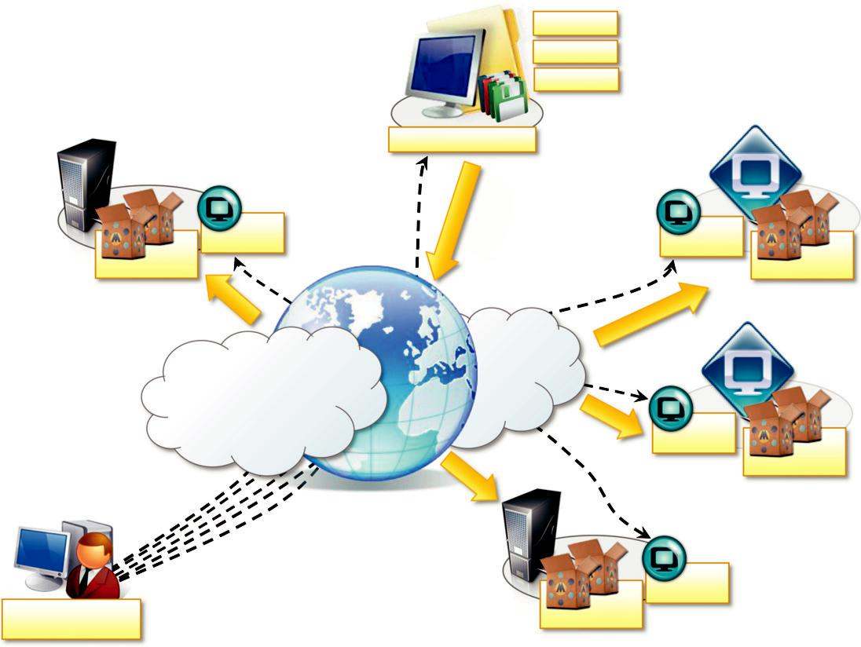

HTTP

File Share

……

Aneka Repository

Node | Node
Manager | Manager | Aneka
Aneka |  | Aneka
Containers |  | Containers

Aneka
Management
Containers
Console

FIGURE 5.3

Aneka cloud infrastructure overview.

Node

Manager

Node

Manager

Aneka Containers

scenario is to use a master-worker configuration with separate nodes for storage, as shown in Figure 5.4.

The master node features all the services that are most likely to be present in one single copy and that provide the intelligence of the Aneka Cloud. What specifically characterizes a node as a master node is the presence of the Index Service (or Membership Catalogue) configured in master mode; all the other services, except for those that are mandatory, might be present or located in other nodes. A common configuration of the master node is as follows:

- Index Service (master copy)

- Heartbeat Service

- Logging Service

- Reservation Service

- Resource Provisioning Service

- Accounting Service

- Reporting and Monitoring Service

- Scheduling Services for the supported programming models

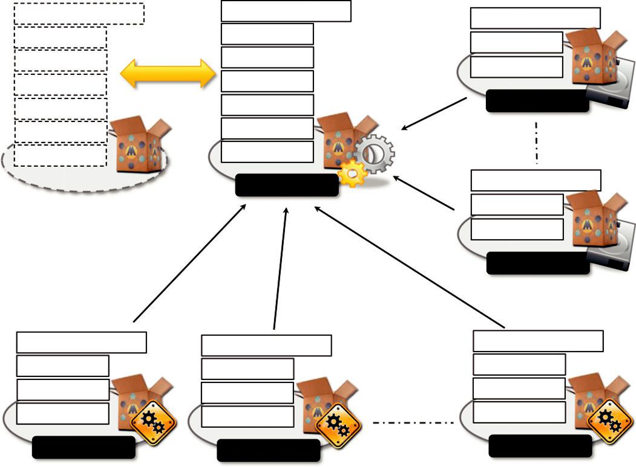

Index (master) |  | Index (master) | Index (slave)
Scheduling |  | Scheduling | Storage
 |  | Accounting | Storage
Accounting | Failover | Accounting | Mandatory
 |  | Reporting | Mandatory
Reporting |  | Reporting
Reservation |  | Reservation | Storage Node
Provisioning |  | Provisioning
Mandatory |  | Mandatory
 |  | Master Node | Index (slave)
 |  |  | Storage
 |  |  | Mandatory
 |  |  | Storage Node

Index (slave) | Index (slave) | Index (slave)
Execution | Execution | Execution
Allocation | Allocation | Allocation
Mandatory | Mandatory | Mandatory
Worker Node | Worker Node | Worker Node

FIGURE 5.4

Logical organization of an Aneka cloud.

The master node also provides connection to an RDBMS facility where the state of several ser-vices is maintained. For the same reason, all the scheduling services are maintained in the master node. They share the application store that is normally persisted on the RDBMS in order to provide a fault-tolerant infrastructure. The master configuration can then be replicated in several nodes to provide a highly available infrastructure based on the failover mechanism.

The worker nodes constitute the workforce of the Aneka Cloud and are generally configured for the execution of applications. They feature the mandatory services and the specific execution ser-vices of each of the supported programming models in the Cloud. A very common configuration is the following:

- Index Service

- Heartbeat Service

- Logging Service

- Allocation Service

- Monitoring Service

- Execution Services for the supported programming models

A different option is to partition the pool of worker nodes with a different selection of execution services in order to balance the load between programming models and reserve some nodes for a specific class of applications.

Storage nodes are optimized to provide storage support to applications. They feature, among the mandatory and usual services, the presence of the Storage Service. The number of storage nodes strictly depends on the predicted workload and storage consumption of applications. Storage nodes mostly reside on machines that have considerable disk space to accommodate a large quantity of files. The common configuration of a storage node is the following:

- Index Service

- Heartbeat Service

- Logging Service

- Monitoring Service

- Storage Service

In specific cases, when the data transfer requirements are not demanding, there might be only one storage node. In some cases, for very small deployments, there is no need to have a separate storage node, and the Storage Service is installed and hosted on the master node.

All nodes are registered with the master node and transparently refer to any failover partner in the case of a high-availability configuration.

Private cloud deployment mode

A private deployment mode is mostly constituted by local physical resources and infrastructure management software providing access to a local pool of nodes, which might be virtualized. In this scenario Aneka Clouds are created by harnessing a heterogeneous pool of resources such has desk-top machines, clusters, or workstations. These resources can be partitioned into different groups, and Aneka can be configured to leverage these resources according to application needs. Moreover, leveraging the Resource Provisioning Service, it is possible to integrate virtual nodes provisioned from a local resource pool managed by systems such as XenServer, Eucalyptus, and OpenStack.

Figure 5.5 shows a common deployment for a private Aneka Cloud. This deployment is acceptable for a scenario in which the workload of the system is predictable and a local virtual machine manager can easily address excess capacity demand. Most of the Aneka nodes are constituted of physi-cal nodes with a long lifetime and a static configuration and generally do not need to be reconfigured often. The different nature of the machines harnessed in a private environment allows for specific poli-cies on resource management and usage that can be accomplished by means of the Reservation Service. For example, desktop machines that are used during the day for office automation can be exploited outside the standard working hours to execute distributed applications. Workstation clusters might have some specific legacy software that is required for supporting the execution of applications and should be preferred for the execution of applications with special requirements.

Public cloud deployment mode

Public Cloud deployment mode features the installation of Aneka master and worker nodes over a completely virtualized infrastructure that is hosted on the infrastructure of one or more resource

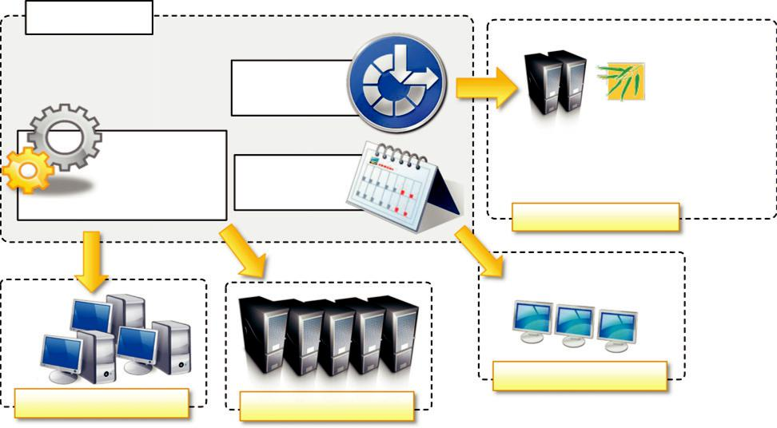

Master Node

Resource | Eucalyptus
Resource | Systems
Provisioning | Systems

Application
Management & ^{Resource}
_{Scheduling} Reservation

Virtual Clusters

Desktop Machines

Workstations Clusters

FIGURE 5.5

Private cloud deployment.

providers such as Amazon EC2 or GoGrid. In this case it is possible to have a static deployment where the nodes are provisioned beforehand and used as though they were real machines. This deployment merely replicates a classic Aneka installation on a physical infrastructure without any dynamic provisioning capability. More interesting is the use of the elastic features of IaaS providers and the creation of a Cloud that is completely dynamic. Figure 5.6 provides an overview of this scenario.

The deployment is generally contained within the infrastructure boundaries of a single IaaS pro-vider. The reasons for this are to minimize the data transfer between different providers, which is generally priced at a higher cost, and to have better network performance. In this scenario it is pos-sible to deploy an Aneka Cloud composed of only one node and to completely leverage dynamic provisioning to elastically scale the infrastructure on demand. A fundamental role is played by the Resource Provisioning Service, which can be configured with different images and templates to instantiate. Other important services that have to be included in the master node are the Accounting and Reporting Services. These provide details about resource utilization by users and applications and are fundamental in a multitenant Cloud where users are billed according to their consumption of Cloud capabilities.

Dynamic instances provisioned on demand will mostly be configured as worker nodes, and, in the specific case of Amazon EC2, different images featuring a different hardware setup can be made available to instantiate worker containers. Applications with specific requirements for com-puting capacity or memory can provide additional information to the scheduler that will trigger the appropriate provisioning request. Application execution is not the only use of dynamic instances; any service requiring elastic scaling can leverage dynamic provisioning. Another example is the Storage Service. In multitenant Clouds, multiple applications can leverage the support for storage; in this
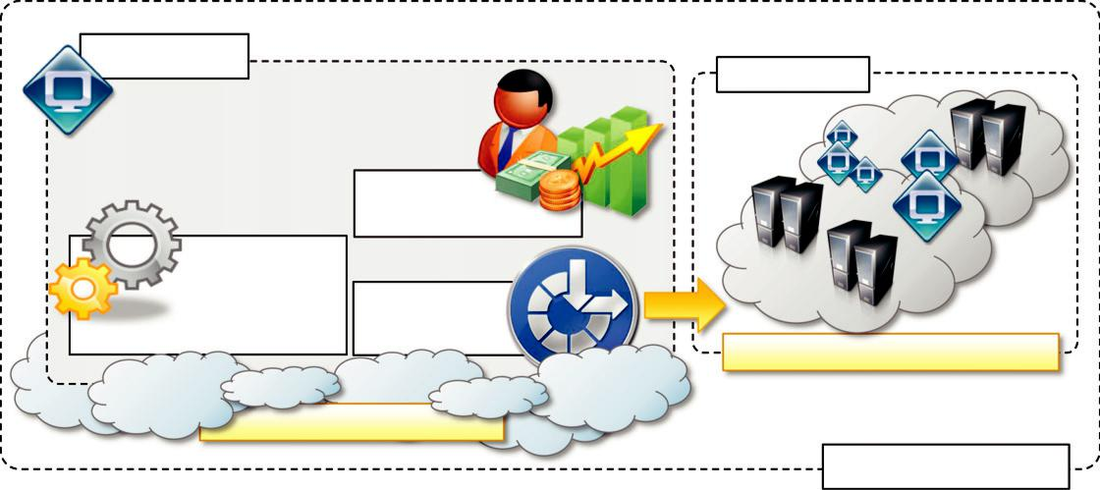

Master Node
Slave Nodes

Reporting,

Billing, Accounting

Application
Management & _{Resource}
^{Scheduling} Provisioning

Amazon EC2 Instances

Amazon EC2 Instance

EC2 Boundaries

FIGURE 5.6

Public Aneka cloud deployment.

scenario it is then possible to introduce bottlenecks or simply reach the quota limits allocated for storage on the node. Dynamic provisioning can easily solve this issue as it does for increasing the computing capability of an Aneka Cloud.

Deployments using different providers are unlikely to happen because of the data transfer costs among providers, but they might be a possible scenario for federated Aneka Clouds [58]. In this scenario resources can be shared or leased among providers under specific agreements and more convenient prices. In this case the specific policies installed in the Resource Provisioning Service can discriminate among different resource providers, mapping different IaaS providers to provide the best solution to a provisioning request.

Hybrid cloud deployment mode

The hybrid deployment model constitutes the most common deployment of Aneka. In many cases, there is an existing computing infrastructure that can be leveraged to address the computing needs of applications. This infrastructure will constitute the static deployment of Aneka that can be elasti-cally scaled on demand when additional resources are required. An overview of this deployment is presented in Figure 5.7.

This scenario constitutes the most complete deployment for Aneka that is able to leverage all the capabilities of the framework:

Dynamic Resource Provisioning

Resource Reservation

Workload Partitioning

Accounting, Monitoring, and Reporting
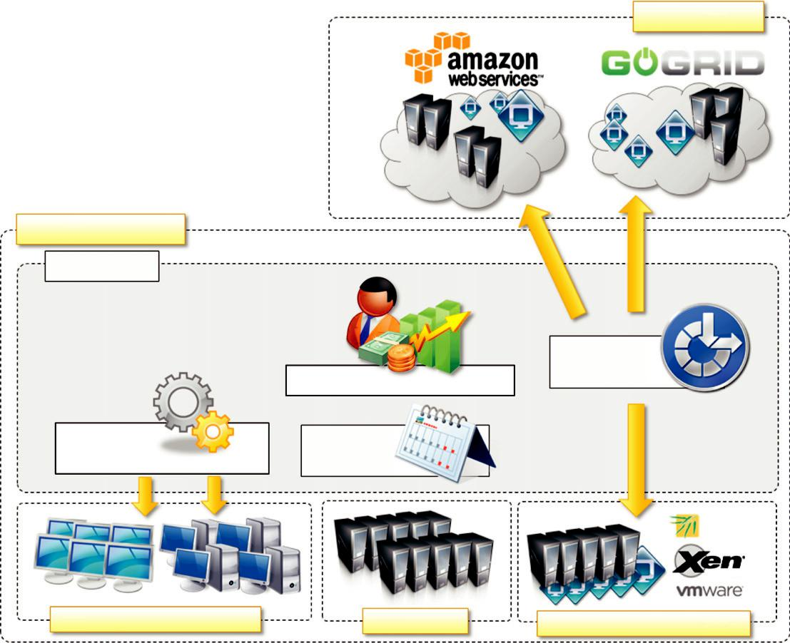

Public Clouds

Local Infrastructure

Master Node

Provisioning
Service
Reporting, Billing, Accounting

Application

Management & Scheduling

Resource

Reservation

Eucalyptus

Systems

Desktops & Workstations Clusters _{Virtual Cluster Resources}

FIGURE 5.7

Hybrid cloud deployment.

Moreover, if the local premises offer some virtual machine management capabilities, it is possible to provide a very efficient use of resources, thus minimizing the expenditure for application execution.

In a hybrid scenario, heterogeneous resources can be used for different purposes. As we discussed in the case of a private cloud deployment, desktop machines can be reserved for low priority work-load outside the common working hours. The majority of the applications will be executed on work-stations and clusters, which are the nodes that are constantly connected to the Aneka Cloud. Any additional computing capability demand can be primarily addressed by the local virtualization facili-ties, and if more computing power is required, it is possible to leverage external IaaS providers.

Different from the Aneka Public Cloud deployment is the case in which it makes more sense to leverage a variety of resource providers to provision virtual resources. Since part of the infrastructure is local, a cost in data transfer to the external IaaS infrastructure cannot be avoided. It is then impor-tant to select the most suitable option to address application needs. The Resource Provisioning

Service implemented in Aneka exposes the capability of leveraging several resource pools at the same time and configuring specific policies to select the most appropriate pool for satisfying a provi-sioning request. These features simplify the development of custom policies that can better serve the needs of a specific hybrid deployment.

Cloud programming and management

Aneka’s primary purpose is to provide a scalable middleware product in which to execute distrib-uted applications. Application development and management constitute the two major features that are exposed to developers and system administrators. To simplify these activities, Aneka provides developers with a comprehensive and extensible set of APIs and administrators with powerful and intuitive management tools. The APIs for development are mostly concentrated in the Aneka SDK; management tools are exposed through the Management Console.

Aneka SDK

Aneka provides APIs for developing applications on top of existing programming models, imple-menting new programming models, and developing new services to integrate into the Aneka Cloud. The development of applications mostly focuses on the use of existing features and leveraging the services of the middleware, while the implementation of new programming models or new services enriches the features of Aneka. The SDK provides support for both programming models and ser-vices by means of the Application Model and the Service Model. The former covers the develop-ment of applications and new programming models; the latter defines the general infrastructure for service development.

Application model

Aneka provides support for distributed execution in the Cloud with the abstraction of programming models. A programming model identifies both the abstraction used by the developers and the run-time support for the execution of programs on top of Aneka. The Application Model represents the minimum set of APIs that is common to all the programming models for representing and program-ming distributed applications on top of Aneka. This model is further specialized according to the needs and the particular features of each of the programming models.

An overview of the components that define the Aneka Application Model is shown in Figure 5.8. Each distributed application running on top of Aneka is an instance of the ApplicationBase , M . class, where M identifies the specific type of application manager used to control the application. Application classes constitute the developers’ view of a distributed applica-tion on Aneka Clouds, whereas application managers are internal components that interact with Aneka Clouds in order to monitor and control the execution of the application. Application man-agers are also the first element of specialization of the model and vary according to the specific programming model used.

Whichever the specific model used, a distributed application can be conceived as a set of tasks for which the collective execution defines the execution of the application on the Cloud. Aneka fur-ther specializes applications into two main categories: (1) applications whose tasks are generated
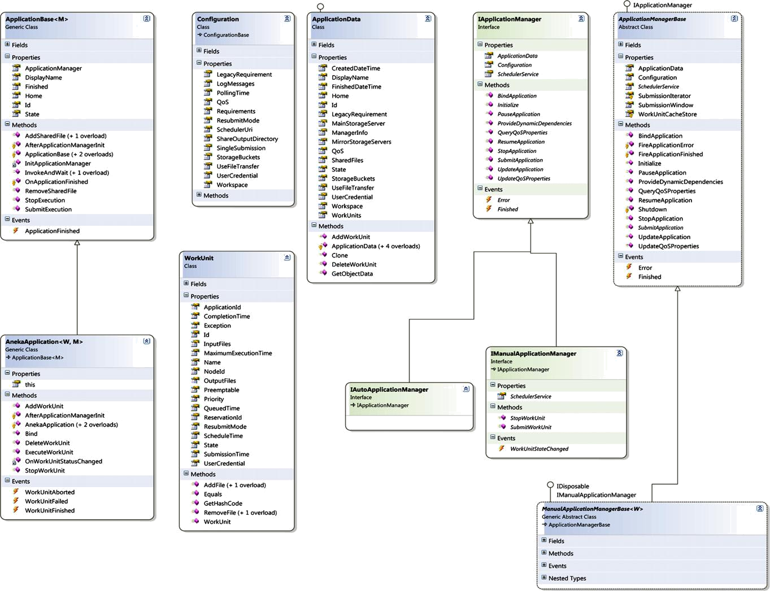

FIGURE 5.8

The Aneka application model.

by the user and (2) applications whose tasks are generated by the runtime infrastructure. These two categories generally correspond to different application base classes and different implementations of the application manager.

The first category is the most common and it is used as a reference for several programming models supported by Aneka: the Task Model, the Thread Model, and the Parameter Sweep Model. Applications that fall into this category are composed of a collection of units of work submitted by the user and represented by the WorkUnit class. Each unit of work can have input and output files, the transfer of which is transparently managed by the runtime. The specific type of WorkUnit class used to represent the unit of work depends on the programming model used (AnekaTask for the Task Model and AnekaThread for the Thread Model). All the applications that fall into this cate-gory inherit or are instances of AnekaApplication , W,M ., where W is the specific type of WorkUnit class used, and M is the type of application manager used to implement the IManualApplicationManager interface.

The second category covers the case of MapReduce and all those other scenarios in which the units of work are generated by the runtime infrastructure rather than the user. In this case there is no common unit-of-work class used, and the specific classes used by application developers strictly depend on the requirements of the programming model used. For example, in the case of the MapReduce programming model, developers express their distributed applications in terms of two functions, map and reduce; hence, the MapReduceApplication class provides an interface for speci-fying the Mapper , K,V . and Reducer , K,V . types and the input files required by the applica-tion. Other programming models might have different requirements and expose different interfaces. For this reason there are no common base types for this category except for ApplicationBase , M ., where M implements IAutoApplicationManager.

A set of additional classes completes the object model. Among these classes, the most notable are the Configuration class, which is used to specify the settings required to initialize the application and customize its behavior, and the ApplicationData class, which contains the runtime information of the application.

Table 5.1 summarizes the features that are available in the Aneka Application Model and the way they reflect into the supported programming model. The model has been designed to be exten-sible, and these classes can be used as a starting point to implement a new programming model. This can be done by augmenting the features (or specializing) an existing implementation of a


Table 5.1 Aneka’s Application Model Features

 |  |  | Work | Programming
Category | Description | Base Application Type | Units? | Models
Manual | Units of work are generated | AnekaApplication ,W,M . | Yes | Task Model
 | by the user and submitted | IManualApplicationManager ,W . |  | Thread Model
 | through the application. | ManualApplicationManager , W . |  | Parameter
 |  |  |  | Sweep Model
Auto | Units of work are generated | ApplicationBase ,M . | No | MapReduce
 | by the runtime infrastructure | IAutoApplicationManager |  | Model
 | and managed internally.

programming model or by using the base classes to define new models and abstractions. For exam-ple, the Parameter Sweep Model is a specialization of the Task Model, and it has been implemented in the context of management of applications on Aneka. It is achieved by providing a different interface to end users who just need to define a template task and the parameters that customize it.

Service model

The Aneka Service Model defines the basic requirements to implement a service that can be hosted in an Aneka Cloud. The container defines the runtime environment in which services are hosted. Each service that is hosted in the container must be compliant with the IService interface, which exposes the following methods and properties:

- Name and status

- Control operations such as Start, Stop, Pause, and Continue methods

- Message handling by means of the HandleMessage method

Specific services can also provide clients if they are meant to directly interact with end users. Examples of such services might be Resource Provisioning and Resource Reservation Services, which ship their own clients for allowing resource provisioning and reservation. Apart from control operations, which are used by the container to set up and shut down the service during the container life cycle, the core logic of a service resides in its message-processing functionalities that are con-tained in the HandleMessage method. Each operation that is requested to a service is triggered by a specific message, and results are communicated back to the caller by means of messages.

Figure 5.9 describes the reference life cycle of each service instance in the Aneka container. The shaded balloons indicate transient states; the white balloons indicate steady states. A service instance can initially be in the Unknown or Initialized state, a condition that refers to the creation of the service instance by invoking its constructor during the configuration of the container. Once the container is started, it will iteratively call the Start method on each service method. As a result the service instance is expected to be in a Starting state until the startup process is completed, after which it will exhibit the Running state. This is the condition in which the service will last as long as the container is active and running. This is the only state in which the service is able to process messages. If an exception occurs while starting the service, it is expected that the service will fall back to the Unknown state, thus signaling an error.

When a service is running it is possible to pause its activity by calling the Pause method and resume it by calling Continue. As described in the figure, the service moves first into the Pausing state, thus reaching the Paused state. From this state, it moves into the Resuming state while restor-ing its activity to return to the Running state. Not all the services need to support the pause/con-tinue operations, and the current implementation of the framework does not feature any service with these capabilities.

When the container shuts down, the Stop method is iteratively called on each service running, and services move first into the transient Stopping state to reach the final Stopped state, where all resources that were initially allocated have been released.

Aneka provides a default base class for simplifying service implementation and a set of guide-lines that service developers should follow to design and implement services that are compliant with Aneka. In particular, the guidelines define a ServiceBase class that can be further extended to
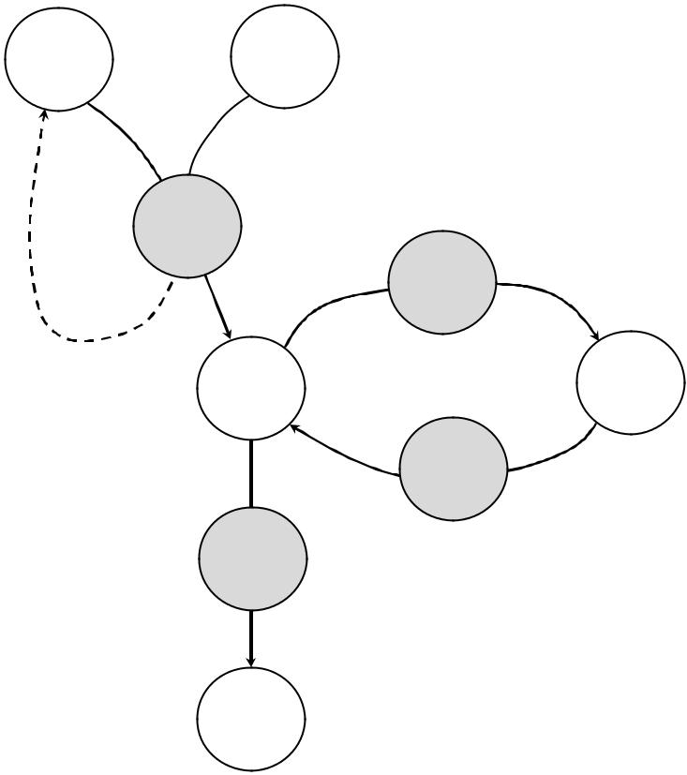

_{Unknown} Initialized

IService.Start()

Starting

Pausing

<Error> |  | IService.Pause()
<Error> | Running | Paused

Resuming

Stopping IService.Continue()

IService.Stop()

Stopped

FIGURE 5.9

Service life cycle.

provide a proper implementation. This class is the base class of several services in the framework and provides some built-in features:

- Implementation of the basic properties exposed by IService

- Implementation of the control operations with logging capabilities and state control

- Built-in infrastructure for delivering a service specific client

- Support for service monitoring

Developers are provided with template methods for specializing the behavior of control opera-tions, implementing their own message-processing logic, and providing a service-specific client.

Aneka uses a strongly typed message-passing communication model, whereby each service defines its own messages, which are in turn the only ones that the service is able to process. As a result, developers who implement new services in Aneka need also to define the type of messages that the services will use to communicate with services and clients. Each message type inherits from the base class Message defining common properties such as:

- Source node and target node

- Source service and target service

- Security credentials

Additional properties are added to carry the specific information for each type. Messages are generally used inside the Aneka infrastructure. In case the service exposes features directly used by applications, they may expose a service client that provides an object-oriented interface to the operations exposed by the service. Aneka features a ready-to-use infrastructure for dynamically injecting service clients into applications by querying the middleware. Services inheriting from the ServiceBase class already support such a feature and only need to define an interface and a specific implementation for the service client. Service clients are useful to integrate Aneka services into existing applications that do not necessarily need support for the execution of distributed applica-tions or require access to additional services.

Aneka also provides advanced capabilities for service configuration. Developers can define edi-tors and configuration classes that allow Aneka’s management tools to integrate the configuration of services within the common workflow required by the container configuration.

Management tools

Aneka is a pure PaaS implementation and requires virtual or physical hardware to be deployed. Hence, infrastructure management, together with facilities for installing logical clouds on such infrastructure, is a fundamental feature of Aneka’s management layer. This layer also includes capabilities for managing services and applications running in the Aneka Cloud.

Infrastructure management

Aneka leverages virtual and physical hardware in order to deploy Aneka Clouds. Virtual hardware is generally managed by means of the Resource Provisioning Service, which acquires resources on demand according to the need of applications, while physical hardware is directly managed by the Administrative Console by leveraging the Aneka management API of the PAL. The management features are mostly concerned with the provisioning of physical hardware and the remote installa-tion of Aneka on the hardware.

Platform management

Infrastructure management provides the basic layer on top of which Aneka Clouds are deployed. The creation of Clouds is orchestrated by deploying a collection of services on the physical infra-structure that allows the installation and the management of containers. A collection of connected containers defines the platform on top of which applications are executed. The features available for platform management are mostly concerned with the logical organization and structure of Aneka Clouds. It is possible to partition the available hardware into several Clouds variably config-ured for different purposes. Services implement the core features of Aneka Clouds and the manage-ment layer exposes operations for some of them, such as Cloud monitoring, resource provisioning and reservation, user management, and application profiling.

Application management

Applications identify the user contribution to the Cloud. The management APIs provide administra-tors with monitoring and profiling features that help them track the usage of resources and relate them to users and applications. This is an important feature in a cloud computing scenario in which

users are billed for their resource usage. Aneka exposes capabilities for giving summary and detailed information about application execution and resource utilization.

All these features are made accessible through the Aneka Cloud Management Studio, which constitutes the main Administrative Console for the Cloud.

